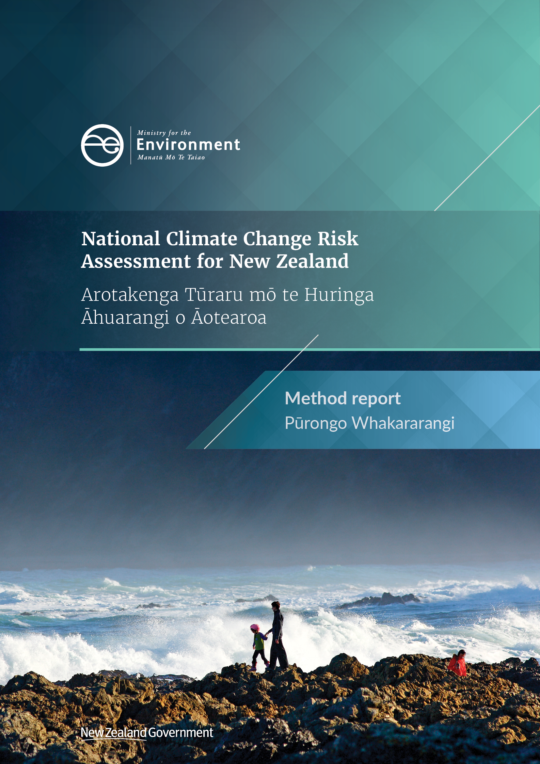

This document may be cited as: Ministry for the Environment. 2020. National Climate Change Risk Assessment for New Zealand – Arotakenga Tūraru mō te Huringa Āhuarangi o Aotearoa: Method report – Pūrongo whakararangi. Wellington: Ministry for the Environment.

Disclaimer
The information in this publication is, according to the Ministry for the Environment’s best efforts, accurate at the time of publication. The information provided does not alter the laws of New Zealand and other official guidelines or requirements. Users should take specific advice from qualified professional people before undertaking any action as a result of information obtained from this publication.
The Ministry for the Environment does not accept any responsibility or liability whether in contract, tort, equity or otherwise, for any action taken as a result of reading, or reliance placed on the Ministry for the Environment because of having read any part, or all, of the information in this publication or for any error, or inadequacy, deficiency, flaw in or omission from the information provided in this publication.
Acknowledgements
Prepared for the Ministry for the Environment by a consortium led by AECOM, including Tonkin + Taylor Ltd, NIWA and Latitude and a number of independent contractors.

Published in August 2020 by the
Ministry for the Environment
Manatū Mō Te Taiao
PO Box 10362, Wellington 6143, New Zealand
ISBN: 978-1-98-857994-8 (online)
Publication number: ME 1507
© Crown copyright New Zealand 2020
This document is available on the Ministry for the Environment website: www.mfe.govt.nz.
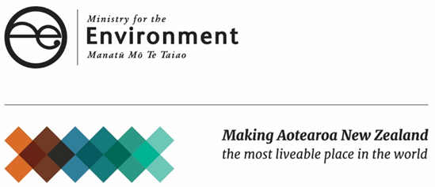

Contents
1 Introduction 5
1.1. Purpose of this report 5
1.2. The NCCRA project team 5
2 Risk assessment approach 10
2.1 Setting the context 10
2.2 Stage 1: First-pass risk screen 18
2.3 Stage 2: Detailed risk assessment 21
2.4 Stage 3: Adaptation and decision urgency 24
3 Engagement approach 28
3.1 Stakeholder identification 28
3.2 Engagement methods: stage 1 30
3.3 Engagement methods: stage 2 34
4 Results of engagement 39
4.1 National workshop: stage 1 39
4.2 Māori engagement hui: stage 1 40
4.3 Online survey: stage 1 43
4.4 Focused meetings: stage 1 43
4.5 Supplementary engagement: stage 1 43
4.6 Response to participant feedback: stage 1 43
4.7 Risk workshops: stage 2 44
4.8 Local hui: stage 2 45
4.9 Online survey: stage 2 46
4.10 Focused meetings: stage 2 46
4.11 Summary of engagement reach 48
Appendix A: Glossary 50
Appendix B: Te reo Māori glossary 55
Appendix C: Assessment criteria 57
Appendix D: References 67
Appendix E: Organisations and groups contacted 69
Appendix F: NCCRA project team 73

Tables
Table 1: How the NCCRA applied ngā mātāpono o Te Arotakenga Huringa Āhuarangi (Guiding Principles for the National Climate Change Risk Assessment Framework) 6
Table 2: The three stages of the NCCRA 10
Table 3: Description of value domains 12
Table 4: Elements at risk in each domain 12
Table 5: Risk assessment timeframes 14
Table 6: Representative concentration pathways used in this assessment 14
Table 7: Sub-national zones and definitions (Ministry for the Environment, 2019) 16
Table 8: Criteria for evaluating risks 17
Table 9: Logic and process for identifying climate change risks 19
Table 10: Focused outreach summary 46
Table 11: Magnitude of consequence criteria 57
Table 12: Confidence scale 60
Table 13: Urgency criteria from the 2017 UK Climate Change Risk Assessment (Committee on Climate Change, 2017) 60
Table 14: Vulnerability and exposure criteria 61
Table 15: Sensitivity and adaptive capacity in the natural environment domain 61
Table 16: Sensitivity and adaptive capacity in the human domain 63
Table 17: Sensitivity and adaptive capacity in the economy domain 64
Table 18: Sensitivity and adaptive capacity in the built environment domain 64

Figures
Figure 1: NCCRA process overview 9
Figure 2: Sub-national zones map (Ministry for the Environment, 2019) 15
Figure 3: Interaction between the physical climate system, exposure and vulnerability producing risk (IPCC, 2014a) 17
Figure 4: Overview of stage 3, as outlined in the NCCRA framework (Ministry for the Environment, 2019) 24
Figure 5: Application of urgency categories in the NCCRA 26
Figure 6: Stakeholder level of influence on the NCCRA project, based on the IAP2 model (iap2.org.au) 29

Introduction

Purpose of this report
The first National Climate Change Risk Assessment for New Zealand: Arotakenga Tūraru mō te Huringa Āhuarangi o Aotearoa (NCCRA) was delivered for the New Zealand Government between September 2019 and May 2020. The NCCRA focused on the risks to New Zealand from hazards that are caused, exacerbated or influenced by the physical impacts of climate change. Some consideration was also given to any potential or beneficial consequences (opportunities) arising from a changing climate.
The assessment sought to build an understanding of the risks and opportunities posed by long-term trends in the climate (ongoing gradual change) and changes in extreme weather, to inform the development of a national adaptation plan (NAP).
The Climate Change Response (Zero Carbon) Amendment Act 2019 requires the Climate Change Commission (the Commission) to prepare an NCCRA at least once every six years. The current NCCRA lays the groundwork for the next by documenting the assessment and engagement method in detail, and providing the Ministry for the Environment (the Ministry) and the Commission with the tools (spreadsheets and engagement materials) as well as raw data and records of engagement. This gives the Ministry and the Commission the option of building on the outputs from this NCCRA, to develop the information and evidence base for the next one. These records may also be of use for other national and local/regional risk assessments.

The NCCRA project team
New Zealand’s first NCCRA was delivered by a consortium led by AECOM, with support from Tonkin + Taylor, NIWA, Latitude, Victoria University of Wellington, Lincoln University and several independent consultants.
The NCCRA examined risks across all of New Zealand. To enable the assessment to cover this broad scope adequately, it was structured around five ‘value domains’: governance, economy, human, natural environment and built environment. These represent groups of values, assets and systems that may be at risk from exposure to climate change-related hazards, or that could benefit from them (opportunities).
Domain leads were appointed to lead the identification and analysis of risks for each domain. They are recognised as leaders with deep experience in considering the risks and opportunities from the physical impacts of climate change in their domain. They brought a wealth of knowledge and relationships, which allowed for thorough engagement, given the short timeframe. The domain leads were:
- Dr Paula Blackett, NIWA: Human Domain Lead
- Dr Anita Wreford, Lincoln University: Economy Domain Lead
- Dr Judy Lawrence, Victoria University of Wellington: Governance Domain Lead
- James Hughes, Tonkin + Taylor: Built Environment Domain Lead
- Dr John Leathwick, independent consultant: Natural Environment Domain Lead.
There was also an extensive team of technical advisors and reviewers, including:
- Sir John Clarke, Kaumātua, who provided guidance on mātauranga Māori, and on seeking input and consideration from a Māori perspective at each stage
- Will Symons, Practice Leader, Sustainability and Resilience, AECOM, as a technical advisor and lead verifier
- Dr Andrew Tait, Chief Scientist – Climate, Atmosphere and Hazards, NIWA, as a technical advisor
- Paul Watkiss, Director Watkiss Associates, who has led or contributed to all three UK Climate Change Risk Assessments, as a technical advisor.
Appendix F sets out the project team structure.

Guiding principles – ngā mātāpono
The NCCRA framework provided a set of guiding principles, ngā mātāpono, which informed the assessment and engagement work. They are based on the principles in the National Disaster Resilience Strategy (NDRS) (Ministry of Civil Defence and Emergency Management, 2019), with the addition of ōhanga (prosperity) from the Treasury’s Living Standards Framework (LSF) (The Treasury, 2018). The mātāpono are additional to Te Tiriti o Waitangi principles (partnership, protection, participation and potential). Table 1 lists the principles and how they apply in the NCCRA.
Table 1: How the NCCRA applied ngā mātāpono o Te Arotakenga Huringa Āhuarangi (Guiding Principles for the National Climate Change Risk Assessment Framework)
Ngā Mātāpono o Te Arotakenga Huringa Āhuarangi – Guiding Principles for the National Climate Change Risk Assessment Framework (Ministry for the Environment, 2019) | Application in the NCCRA
Manaakitanga (Care and reciprocity)  - Respect and care for others and the environment.  - Responsibility to prioritise wellbeing and health.  - Recognition that people and the environment are inextricably connected. | The wide range of climate change impacts demonstrates how inextricably we are linked to our environment. The NCCRA process prioritised risks and opportunities relating to the wellbeing and health of people and the environment.  The NCCRA has been a reciprocal process between the Ministry for the Environment, Māori leaders, stakeholders and the project team. The engagement design has provided a basis for a mutual exchange of information (section 3).  The risk assessment method held the natural environment and human domains, rohe taiao and rohe tangata, as central focus points, along with a recognition of the interconnectedness of all the domains.
Kaitiakitanga (Intergenerational sustainability)  - Protect and guard our taonga (environmental assets).  - Recognise the mauri (life force and essence) of the environment (ie, personification of landmarks and waterways).  - Guardianship of the environment for future generations. | Climate change is an intergenerational issue for all communities. The intent of the NCCRA was to begin to identify key national-level risks and opportunities that will manifest over the next 80 years to support decision-making.  The natural environment domain, rohe taiao, was a key focus for the assessment. Twelve priority risks were identified for action to acknowledge and restore the mauri of the environment and support the protection of our taonga (treasured biodiversity and all ecologies) for future generations.
Whanaungatanga (Connectedness and relationships)  - Recognition of Crown–Māori partnership through Te Tiriti o Waitangi.  - Engagement, communication and shared experiences.  - Collaboration and collective action with marae, hapū, iwi and communities. | The NCCRA process recognised the importance of the principles of Te Tiriti o Waitangi, which provide the basis for Crown–Māori partnership.  The NCCRA Project Kaumātua, Sir John Clarke, has a deep understanding of tikanga Māori and has supported the project team by providing strategic advice and guidance in this regard.  Under the guidance of Sir John and the Māori engagement advisors, the approach has been to engage with Māori directly involved in climate change-related matters and decision-making. This approach was necessary due to the timeframes available. The project team also sought input from Māori leaders on the design of the engagement at the beginning of stage 1.  Recognising that this is the beginning of an ongoing conversation about climate change, the project team’s intention was to foster communication and shared experiences, and to develop a broad cohort of engaged stakeholders and Māori who will be able and willing to support future work with the Ministry in this area.  Please see below for the approach to the principle of kia mahi ngātahi (engagement and participation).
Ōhanga (Prosperity)  - Recognition of intergenerational equity.  - Promotion of secure, stable and diverse livelihoods.  - Minimising negative externalities to our taonga from economic activities. | The importance of future generations, and the thread of connectivity between whenua (land), people and the environment, were discussed in the engagement activities and emphasised in the risk assessment.  The NCCRA identifies priority risks and opportunities to support adaptation planning, to safeguard the wellbeing of New Zealand into the future, promoting secure and stable livelihoods and intergenerational equity.
Rangatiratanga (Leadership and autonomy)  - Recognise, interweave and live Te Tiriti o Waitangi and its principles.  - Respect the notions of mana whenua, mana moana and mana taiao.  - Be guided by scientific, historical and local knowledge and mātauranga Māori. | Strong leadership from the Government, private sector and communities will be critical in responding to climate change in New Zealand. This risk assessment is a first step in that process.  The approach to engagement has been to engage with Māori representatives directly involved in climate change-related matters and decision-making, in a way that recognises:  - the principles of Te Tiriti o Waitangi and Te Tiriti partnership between Māori/iwi and the Crown  - the importance of Māori decision-making over matters that affect Māori  - the value of mātauranga Māori (Māori knowledge) in supporting decision-making and effective action.  While the NCCRA has been informed by existing iwi/hapū climate change strategies and plans, consideration of how mātauranga Māori might inform future climate science and policy-making has been limited. The main report and technical report acknowledge this as a knowledge gap (see section 7.2, main report and section 4.5, technical report).
Kia mahi ngātahi (Engagement and participation)  - National, regional and local agencies, including pan-Māori, Māori and iwi/hapū representatives affected by the risk assessment and its outcomes, will be involved in the risk assessment process.  - Contributors to the risk assessment will have the opportunity to contribute to the development of the national adaptation plan (NAP) (which will undergo a consultation process).  - The engagement process will seek input from participants in designing how they participate. | Our approach was grounded in engagement across the key value domains of New Zealand society, including with national, regional and local agencies, Māori groups and iwi. Over 500 individual participants were engaged during the process.  The project timeframe limited the extent to which the engagement process could be co-designed with partners and stakeholders. For this reason, the project sought to enable participants to engage in a variety of ways including workshops, hui, online surveys and focused individual meetings and phone calls.  The engagement approach emphasised that the NCCRA was the beginning of an engagement that will be carried forward into the NAP and future NCCRAs.
Kia āwhina (Support)  - Participation in the risk assessment will recognise the needs and interests of all participants, including decision-makers.  - Participants will be given the information they need to participate in a meaningful way; their views will be respected and given due consideration.  - The outcomes will be communicated to participants, along with how their input affected decisions. | The NCCRA used a variety of techniques and platforms to allow broad engagement with diverse stakeholders and communities. This included providing information before engagements, and follow-up after the engagements to detail next steps.  The project team was committed to creating a collaborative and respectful process and environment. Stakeholder and Māori views and observations were carefully considered, with clear communication of next steps in the process.

Figure 1: NCCRA process overview
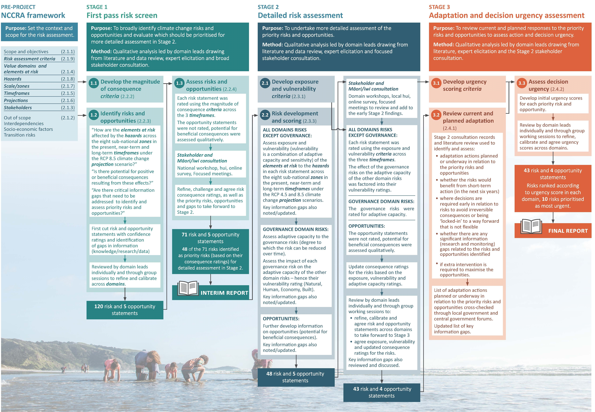

Risk assessment approach
The method for the first NCCRA was based on Arotakenga Huringa Āhuarangi: A Framework for the National Climate Change Risk Assessment for Aotearoa New Zealand (the NCCRA framework). Developed by an expert panel, the NCCRA framework sets out methods to use for the NCCRA. It takes a values-based approach, weaving in te ao Māori and engagement principles, to produce a comprehensive knowledge and skill base for understanding climate change risks. The process combined scientific, technical and expert information with mātauranga Māori, local knowledge and experience (Ministry for the Environment, 2019).
The diverse, multidisciplinary team of academics and consultants followed three stages. Table 2 gives an overview, while details are in figure 1.
Before stage 1, the project team set the context: the objectives, scope and method. This section gives a brief summary of each stage, including an overview of the method and key concepts related to it. Engagement informed all three stages.
Table 2: The three stages of the NCCRA
Stage | Objective | Tasks | Output
Stage 1 | Undertake a high-level assessment of climate change risks to New Zealand; determine risks to consider in stage 2. | Task 1: Establish context and scope  Task 2: Identify climate risks  Task 3: Analyse and evaluate risks | Identification of extreme and major risks to consider in detail in stage 2.
Stage 2 | Further examine extreme and major risks to identify priority risks for the NAP. | Task 1: Establish context and scope  Task 2: Exposure, vulnerability and consequence assessment  Task 3: Rate exposure, vulnerability and consequence | More detailed assessment of risks to inform identification of the top 10 most urgent risks.
Stage 3 | Consider current and planned adaptation, highlighting the most urgent risks, to inform the NAP. | Task 1: Consider current and planned adaptation  Task 2: Rate adaptation urgency | Adaptation urgency ratings to identify the 10 most urgent risks to address in the NAP.  Produce the main report, method report and technical report.

Setting the context
This section outlines the following context and scope for the NCCRA:
- scope and objectives
- out of scope
- value domains and elements at risk
- timeframes
- climate change projections
- scale: sub-national climate zones
- climate change hazards
- risk assessment criteria
- stakeholders.
The NCCRA framework has more detail on these elements.

Scope and objectives
The NCCRA had the following objectives.
- Provide a national overview of how New Zealand may be affected by various hazards and threats that are caused, exacerbated or influenced by climate change, and the risks and opportunities this brings as well as any gaps in evidence for further consideration.
- Support decision-makers to better understand the wide range of risks that New Zealand will face due to climate change, and which risks need to be addressed most urgently.
- Provide the best available evidence, information and assessment of risks to directly inform the development of an NAP.

National adaptation plan (NAP)
The NAP will define the Government's objectives for adapting to climate change and how the Government will meet these. It will establish a planned approach to adaptation and put in place a forward-looking, holistic plan to respond to the priority risks, opportunities and gaps identified in the NCCRA.
To support adaptation planning in the NAP, the NCCRA focused on understanding where there might be shortfalls in adapting to the risks, which could benefit from additional action.

Urgency ratings
The assessment uses decision urgency ratings informed by the UK Climate Change Risk Assessment 2017 (Committee on Climate Change, 2017) to signal the need for adaptation decision-making. Urgency is defined as “a measure of the degree to which further action is needed in the next five years to reduce a risk or realise an opportunity from climate change” (Committee on Climate Change, 2017).

National assessment
The NCCRA is a national-scale assessment to inform the NAP by systematically examining climate risks and opportunities to New Zealand, and the urgency for addressing them. Climate impacts on different parts of New Zealand were considered, using seven sub-national climate zones and two zones for the marine environment (Territorial Sea and Exclusive Economic Zone).
However, in line with the NCCRA framework, risks were ultimately aggregated to the national scale with qualitative descriptions where they may be higher in one or more zones. The NCCRA methodology could apply at the regional, catchment, district or city scale as part of future assessments. These would focus more on informing regional, district and city councils and their local plans (Ministry for the Environment, 2019).

Value domains and elements at risk
The NCCRA framework outlined five ‘value domains’ for assessing risks and opportunities. These represent groups of values, assets and systems that may be at risk from climate change-related hazards, or could benefit from them. They are a hybrid of The Treasury’s Living Standards Framework (The Treasury, 2018) and those used in the National Disaster Resilience Strategy (Ministry of Civil Defence and Emergency Management, 2019). The domains are interconnected and apply at individual, community and national levels. They include tangible and intangible values.
Table 3 has descriptions of each value domain. These come from the NCCRA framework, with review and revision from domain leads. Each domain consists of a series of ‘elements at risk’, as detailed in table 4. Where similar risks were identified in several domains, they were noted in each domain if the consequence or pathway for adaptation was considered materially different. This is not duplication as the consequences of these risks vary between domains.
Table 3: Description of value domains
Value domain | Description
Natural environment | All aspects of the natural environment that support the full range of our indigenous species, he kura taiao – living treasures, and the ecosystems which they form in terrestrial, freshwater and marine environments.
Human | People’s skills, knowledge and physical and mental health (human); the norms, rules and institutions of society (social); and the knowledge, heritage, beliefs, arts, morals, laws, customs that infuse society (cultural).
Economy | The set and arrangement of inter-related production, distribution, trade and consumption that allocate scarce resources.
Built environment | The set and configuration of physical infrastructure, transport and buildings.
Governance | The governing architecture and processes of interaction and decision-making that exist in and between governments, economic and social institutions. Institutions are the rules and norms held by social actors that shape interactions and decision-making, and the agents that act within the institutional frameworks.
Table 4: Elements at risk in each domain
Value domain | Elements at risk
Natural environment | New Zealand’s indigenous species, including he kura taiao – living treasures, terrestrial ecosystems, freshwater ecosystems, coastal, estuarine and marine ecosystems, biosecurity.
Human | Community wellbeing, social cohesion and social welfare (urban communities, rural communities), coastal communities, health, education, sports, recreation, cultural heritage (archaeological sites, museums, arts, theatre), ahurea Māori, tikanga Māori – Māori culture, values and principles, cultural taonga.
Economy | Primary industries (forestry, agriculture, horticulture, arable land, viticulture, pastoral farming and fisheries aquaculture and marine farming); land use, tourism, technology and business, whakatipu rawa – Māori enterprise; insurance and banking.
Built environment | Built infrastructure across sectors including housing, public amenity, water, wastewater, stormwater, energy, transport, communications, waste and coastal defences.
Governance | Treaty partnerships, adaptive capacity, all governing and institutional systems, all population groups, including vulnerable groups in society.

Interdependencies, cascading and direct and indirect impacts
The value domains and their elements at risk are highly interconnected and interdependent. For example, if the primary sector is affected by an extreme weather event or drought, this will have flow-on effects for the financial sector, and for communities that depend on the primary sector for their food. This is because the elements are interdependent, rather than being directly exposed to a hazard.
Because of these interdependencies the NCCRA examined both direct and indirect risks. Most direct risks occur in the natural environment, economy, human and built environment domains. However, the economy, human and governance domains also include indirect risks because they rely on, or interact with, elements in other domains that are directly exposed to climate hazards.
The main report recognises the significance of cascading impacts, but the NCCRA did not include a full assessment of them. A study on cascading impacts in New Zealand was completed for the Deep South Challenge – a case study from this report is included in the main report (Lawrence et al, 2018). Otherwise, there has been little research on how climate change impacts cascade across human systems, and even less on how to consider such cascades in a national risk assessment.
In stage 1 engagement, cascading impacts were explored with stakeholders, to introduce and discuss the concept. The NCCRA also addressed them by:
- assessing the effect of priority governance risks on priority risks in other domains. In particular, the consultants examined the impact of governance risks on the ability to adapt to risks in the other value domains. See section 2.3.2 for further information
- illustrating the effect of cascading impacts through a case study on Risk B2: Risks to buildings due to extreme weather events, drought, increased fire weather and ongoing sea-level rise (section 5, main report)
- describing interdependencies between risks in each risk profile (sections 3–7, ‘Interacting risks’ sub-section, technical report).

International and transboundary issues
The NCCRA recognised that climate change will affect people and economies around the world. This will have flow-on effects for New Zealand. This first NCCRA limits the exploration of international and transboundary issues to specific risks. As many international impacts will be inextricably tied to socio-economic projections, a broader exploration of international and transboundary issues may feature in future NCCRAs where socio-economic projections are also explored.

Transition risks
Risks may emerge from the transition to a lower-carbon global economy, the most common of which relate to policy and legal actions, technology changes, market responses and reputational considerations (Task Force on Climate-related Financial Disclosures, 2017). Transition risks may compound with physical risks to affect different sectors.
The NCCRA framework excluded transition risks from the first NCCRA. The New Zealand Government is currently addressing them through other regulatory mechanisms, such as the relevant reporting requirements of the Climate Change Response (Zero Carbon) Amendment Act 2019. It is also proposing to require financial firms and listed companies to report on the impacts for their business and investments, in line with guidance from the Task Force on Climate-related Financial Disclosures.

Timeframes for assessing risks
Most risks were assessed across three timeframes, outlined in table 5, in line with the NCCRA framework.
Table 5: Risk assessment timeframes
Timeframe | Description
Present | Risks already occurring, including those observed over the past 10–20 years.
Near term (2050) | Risks that may manifest around 2050.
Long term (2100) | Risks that may manifest around 2100.

Climate change projections to consider
New Zealand is already experiencing the impacts of a changing climate. Due to historical greenhouse gas emissions, the climate will continue to change well into the future. Changes already being experienced are outlined in the technical report. To develop climate projections, several models are used. These relate to different scenarios that represent different possible atmospheric greenhouse gas concentrations and radiative forcing, out to the year 2100.

Representative concentration pathways (RCPs)
The Intergovernmental Panel on Climate Change (IPCC) Assessment Report 5 (AR5) outlines four scenarios, called representative concentration pathways: RCP8.5, RCP6.0, RCP4.5 and RCP2.6. The NCCRA framework considers RCP8.5 and RCP4.5; see table 6.
Table 6: Representative concentration pathways used in this assessment
RCP | Summary of pathway | Change in NZ mean annual temperature | Project stage
8.5 | A high concentration pathway characterised by increasing greenhouse gas emissions due to a lack of policy changes to reduce emissions. There is use of land for agriculture, a heavy reliance on fossil fuels and a high energy intensity with low rate of technology development (NIWA, 2019). | 0.9–1.1°C by 2031–2050 | 1 and 2
 |  | 2.8–3.1°C by 2081–2100
4.5 | A moderate concentration pathway consistent with low levels of emissions due to ambitious reduction strategies. It represents stringent climate policies, with a lower energy intensity, strong reforestation and decreased land for agriculture due to improvements in crop yields and dietary changes (NIWA, 2019). | 0.7–0.9°C by 2031–2050 | 2
 |  | 1.3–1.4°C by 2081–2100

RCP8.5
The NCCRA framework, and therefore this assessment, adopted RCP8.5 as the benchmark to provide insights into potential risks that are ongoing, high or cumulative. These will continue throughout this century and beyond, requiring adaptation action in the near term.

RCP4.5
This scenario presents a lower level of warming, but the changes will still create risks that need early action.
This assessment focused mainly on the central estimate (50th percentile) of the climate models for the two RCPs. It did not assess the uncertainty range of each RCP (for example, by using the 10th and 90th percentiles), unless otherwise stated. Given the limited information and data available on impacts of climate change across the five domains, a granular assessment of potential impacts across the uncertainty range of each RCP was not possible. Where there was relevant information, this is expressly stated in the project reports.

Scale: sub-national climate zones
Although this was a national-scale assessment, it considered climate projections, related hazards and resulting risks and opportunities across seven sub-national climate zones (figure 2 and table 7). Where information was available, sub-national climate zones were also taken into account in the identification of risks. However, all risks were aggregated to the national level for assessment.
Climate change risks for the marine environment were considered in two categories: Territorial Sea and the Exclusive Economic Zone (EEZ).
The Territorial Sea is an area of water not exceeding 12 nautical miles in width that is measured seaward from the Territorial Sea baseline.
The EEZ is an area of sea beyond and adjacent to the Territorial Sea. The outer limit cannot exceed 200 nautical miles from the Territorial Sea baseline. Coastal and marine climate change risks in the Territorial Sea of zone 1 (upper North Island) were considered separately for the west coast and Tasman Sea (zone 1A), and the east coast, Pacific Ocean and Hauraki Gulf (zone 1B), due to their different ocean and climate conditions.
Figure 2: Sub-national zones map (Ministry for the Environment, 2019)
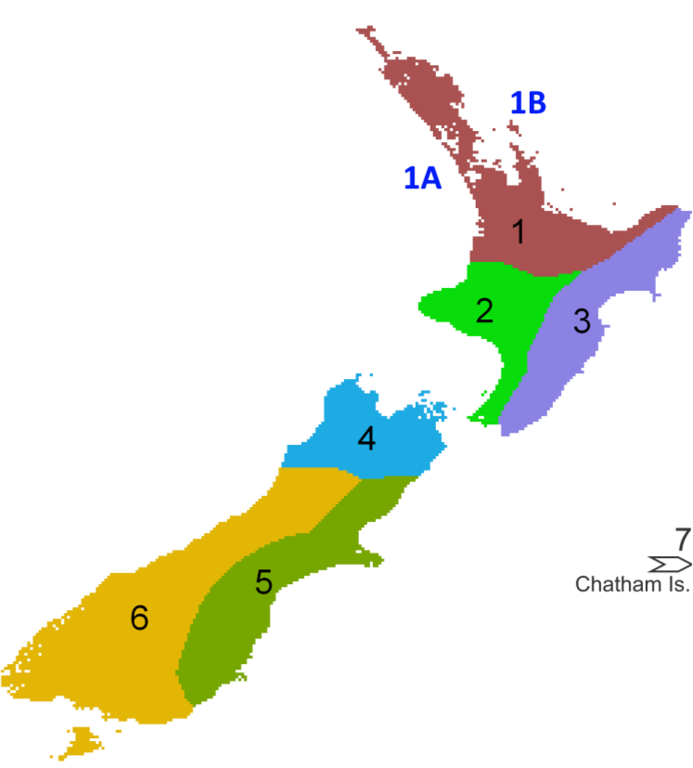

Table 7: Sub-national zones and definitions (Ministry for the Environment, 2019)
Sub-national zone | Definition
Region 1: Upper North Island (Te Ika ā Māui) | Extends to Mōkau on the west coast and Lottin Point (Wakatiri) in eastern Bay of Plenty and covers the northern part of Lake Taupō. For assessing impacts on coastal and marine activities or elements, split the west coast and Tasman Sea (zone 1A) from the east coast, Pacific Ocean and Hauraki Gulf (zone 1B). Includes Northland, Auckland, Waikato and Bay of Plenty.
Region 2: Western lower North Island (Te Ika ā Māui) | Covers Taranaki to Wellington (Te Whanga-nui-a-Tara) and includes National Park and southern Lake Taupō. Includes Taranaki, Manawatū–Whanganui (Horizons) and Wellington.
Region 3: Eastern lower North Island (Te Ika ā Māui) | Extends from Hicks Bay (Wharekahika) to Palliser Bay (Te Waha o te Ika ā Māui) and back to the Ruahine and Kaweka ranges. Includes Gisborne, Hawke’s Bay and the Wairarapa catchment of Wellington.
Region 4: Northern South Island (Te Wai Pounamu) | Covers Marlborough (from Kaikōura north), Nelson (Whakatū) and Punakaiki on the West Coast. Includes Tasman, Nelson, Marlborough and Buller District.
Region 5: Eastern South Island (Te Wai Pounamu) | From Kaikōura to Owaka (South Otago) and includes Central Otago and the Mackenzie Basin including Lakes Tekapo to Ōhau to the east of the Southern Alps. Includes the West Coast, inland Otago and Southland.
Region 6: Western and southern South Island (Te Wai Pounamu) | Covers the West Coast, Fiordland, Southland and Stewart Island (Te Punga o Te Waka ā Māui) and includes the Southern Alps and southern lakes. Includes Canterbury and Otago.
Region 7: Chatham Islands (Wharekauri – Rēkohu) and Pitt Island (Rangiauria –Rangiaotea) | At longitude 183–184ºE.

Climate change hazards to consider
The term ‘hazard’ describes the potential occurrence of a natural or human-induced physical event or trend or physical impact that may cause loss of life, injury or other health impacts, as well as damage and loss to property, infrastructure, livelihoods, services, ecosystems and environmental resources. In this context the term hazard usually refers to climate change-related physical events or trends, or their physical impacts. This is related to either:
- a change in magnitude, persistence and frequency of natural hazard events, such as more intense short-duration rainfall, or
- a gradual-onset ‘stressor’ or ‘trend’ in climatic conditions, such as change in seasonal rainfall patterns, receding snowlines, or increasing ocean acidity.
The NCCRA framework lists the hazards most likely to contribute to substantial risks, driven by primary and secondary climate variables that contribute to the hazard.
Data on climate change hazards, including the magnitude and direction of change as determined by primary and secondary variables, have been provided for the timeframes (section 2.1.7). They apply to the climate change projections (section 2.1.8) and to each of the seven sub-national zones (section 2.1.9). These data informed the identification, analysis and evaluation of risks in stages 1 and 2 of this study (see the appendix of the stage 1 report).

Risk assessment and prioritisation
The NCCRA uses the conceptual framework for climate change risks in the IPCC AR5. Risk is framed using the elements of hazard, exposure and vulnerability, with the overlap defining risks, as figure 3 shows.
Figure 3: Interaction between the physical climate system, exposure and vulnerability producing risk (IPCC, 2014a)
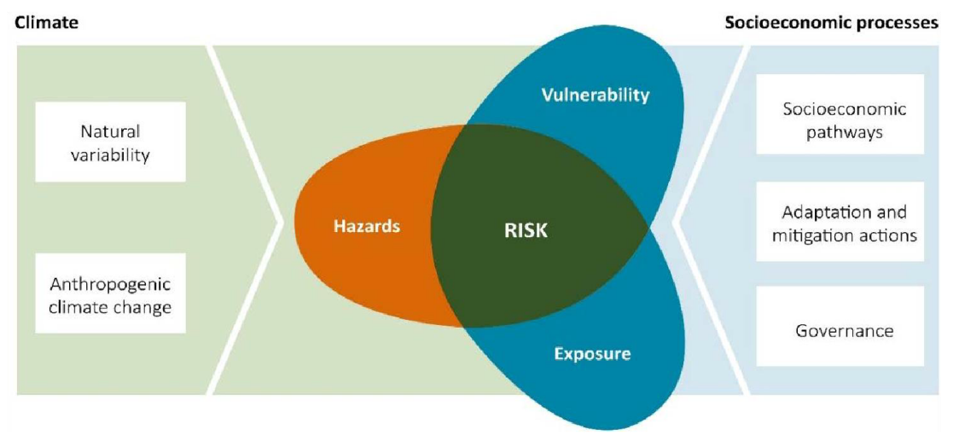
According to this framework, risk is a function of climate hazards, the degree to which assets and values are exposed to the hazard, and their vulnerability to its effects. Vulnerability and exposure are influenced by socio-economic and cultural processes, which can increase or decrease the consequences of exposure.
Rating risks with this framework relies mainly on assessing and rating the magnitude of the consequences from the interaction of hazards, vulnerability and exposure. This is distinct from the industry standards for assessing risks (ISO 31000:2010 and AS/NZ4553), which use both the magnitude and likelihood of consequences. This is because climate change creates cascading and ongoing changes when an ongoing trend such as sea-level rise, atmospheric temperature rise or ocean acidification, among other environmental changes, reaches various thresholds within a given system.
The associated risks at a national level are not event-based, so it is not useful to estimate the likelihood of an event as a major component of the risk. The changing risk environment requires more emphasis on consequences. The risks and opportunities identified are considered to have the most potential for damage or benefit to New Zealand.
To support the magnitude of consequence rating, more criteria were considered in stage 2 than in stage 1, reflecting the differences between a first-pass screen and a detailed assessment. Table 8 sets out the criteria and the stage when each one was applied. The full criteria are in appendix C.
Table 8: Criteria for evaluating risks
Criterion | Purpose | Stage applied
Magnitude of consequence | To evaluate magnitude of potential consequences arising from the risks. Magnitude of consequence criteria have been developed for each value domain, building on the consequence table in the NCCRA framework. | 1 and 2
Confidence | To support the evaluation of risks by rating confidence in the robustness or agreement about the evidence. | 1 and 2
Vulnerability | To support the evaluation of climate change risks by rating the level of vulnerability of the ‘element at risk’. | 2
Exposure | To support the evaluation of risks by rating the level of exposure of the ‘element at risk’. | 2
Urgency | To evaluate where adaptation action is most urgently required in the short term for risks that may not otherwise be managed to an acceptable level. | 3

Stakeholder engagement planning
The NCCRA engaged a range of stakeholders and Māori/iwi representatives who provided input at each stage. Engagement was designed to be reciprocal, provide a basis for a mutual exchange of information and engender support for future work. Further information is in section 3.

Stage 1: First-pass risk screen
The tasks in this stage were:
- task 1: Establish context and scope for stage 1
- task 2: Identify climate risks and opportunities
- task 3: Analyse and evaluate risks and opportunities.

Task 1: Establish context and scope
The purpose was to:
- broadly examine where risks and opportunities might arise from the interaction between elements at risk, hazards, exposure and vulnerability across the seven sub-national zones, Territorial Sea and the EEZ
- identify climate change risks
- evaluate which risks and opportunities to prioritise for more detailed assessment in stage 2.
The first pass considered, at a high level, how elements at risk across the five value domains were affected by hazards across the seven sub-national zones, Territorial Sea and EEZ in the present, near term and long term under RCP8.5 (see table 6).
Only risks relevant at a national level or with a potential for significant magnitude of consequence across multiple sub-national zones were carried through for assessment.
Stage 1 was informed by literature and data review, expert elicitation and analysis (led by domain leads) and the engagement detailed in section 3.
In line with the NCCRA framework, the screen was mainly a qualitative analysis to develop a preliminary understanding of the extent and relative consequence of risks to and opportunities for each element at risk. Risks and opportunities identified in stage 1 were evaluated using the magnitude of consequence criteria in appendix C.

Magnitude of consequence criteria
Magnitude of consequence criteria were developed at the beginning of stage 1. This set of calibrated criteria for each domain plays a significant role in moderating risk ratings across domains, allowing comparison of magnitude between them. The domain leads (referred to as the leads) and the risk assessment team (referred to as the RA team) developed the criteria through the following process.
- Domain leads reviewed the example criteria in the NCCRA framework, to draft more detailed criteria for the value domains.
- They discussed and calibrated the criteria for consistency across all domains, and to ensure that each domain’s criteria covered the breadth and depth of potential impacts.
- Each domain lead reviewed the criteria.
- The RA team reviewed and revised the criteria to ensure the consequences for each domain were at a comparable level (eg, the consequence ‘Significant alteration of biologically important attributes throughout New Zealand’ is equal to ‘Financial losses equivalent to >3 per cent of GDP’, which is equal to ‘More than 1000 residential dwellings require assessments for immediate relocation’).
- The domain leads held a final review, and developed guidance for using the consequence descriptors.

Task 2: Identify climate risks and opportunities
Climate change risks and opportunities were identified by considering elements across the five value domains, how they interact with potential hazards, and the range of time periods and regions in which a consequence could arise. The identification was informed by the following tasks.
- The RA team conducted a literature review of over 100 documents on climate change impacts across value domains, with literature recommended by domain leads and Māori engagement advisors (for literature specific to impacts on Māori).
- The team developed initial risk statements and consequence descriptions. The statements were captured in a Microsoft Excel workbook. A confidence rating was also included for each risk, for the level of evidence available to support the risk, and the level of expert agreement about the risk. References informing each statement and any additional comments were also captured in the workbook. Table 9 shows the logic and process for identifying risks.
Table 9: Logic and process for identifying climate change risks
Logic | Information | Example | Source
A receptor… | Value domain/element (pre-set list) | Human/coastal communities | NCCRA framework, domain leads
…May be affected by… | Hazard (pre-set list) | Flooding – coastal | NCCRA framework, domain leads, NIWA
…This can result in… | Risk description (free text) | Risk of flooding to coastal communities | Literature review, stakeholder engagement
…In the following… | Sub-regions (pre-set list) | 1, 2, 5, 6 | Literature review, stakeholder engagement
…Which could happen in… | Timeframes (pre-set list) | Present, 2050, 2100 | Literature review, stakeholder engagement
…This impact can be described as… | Consequence description | Large number of people and communities affected, steep increase in injuries, casualties, displacement | NCCRA framework, domain leads
- The RA team consolidated and calibrated risk statements, to remove duplication and encourage consistency where possible, and to align risks in terms of detail and scope. The original list of risks was kept for reference. Aggregation of risks followed these rules.
- Use the same format for writing risks: Risks to (element) from (process, if the risk is mediated by a process) due to (climate hazard).
- Group risks to assets/values of the same character resulting from hazards that occur as a gradual-onset stress. These are high likelihood trends, such as sea-level rise, coastal erosion, increased mean air temperature, higher atmospheric carbon dioxide concentration, ocean acidification and ocean warming.
- Group risks to assets/values of the same character resulting from hazards that occur as a shock event and for which the frequency or intensity is likely to be affected by climate change. These include drought, storm, flooding and heatwave.
- Domain leads individually reviewed and edited consolidated risks in a half-day working session with the RA team. They completed the following tasks.
- They compared groupings of risks to moderate across all domains and encourage consistency as much as possible in the scope and detail of risks, including reviewing and making consistent:
- the level of detail of risks in each value domain
- the syntax of risks
- the number, scope and breadth of risks (ensuring as much as possible that all sub-sectors within each value domain have been considered and, where significant, are included in the list of risks).
- They considered whether risks are disaggregated enough to allow analysis of consequences in this stage of the assessment, and adaptation measures in stages 2 and 3. Given this, similar risks may appear across several domains where the consequence and the pathway for adaptation is materially different in the domain.
- They reviewed consequence descriptions for each risk. Where risks have either particular or significant consequence for Māori, these were highlighted, with commentary included in the description.
- They reviewed confidence ratings to provide any further commentary or references supporting the risks.

Task 3: Analyse and evaluate risks and opportunities
Identified climate change risks were evaluated by considering exposure and vulnerability across three timeframes, using the magnitude of consequence criteria. The following tasks were undertaken.
- The RA team completed the first-pass rating of the magnitude of consequence for each risk. Each risk was rated using the magnitude of consequence criteria across three timeframes – present day, 2050 and 2100 – based on impacts that could result under RCP8.5 (see table 6). Given that stage 1 did not consider adaptation, risks were rated assuming no adaptation action. The first-pass rating was informed by the literature review in task 2.
- Domain leads and technical reviewers, including the Māori engagement advisors, reviewed risk ratings. Reviewers were asked to consider the scope and breadth of risks, language of the risks and any gaps.
- A working meeting (stage 1, prioritisation meeting 1) was held with the RA team, leads and technical reviewers. The purpose was to:
- review, discuss and ‘challenge’ risk ratings as a group, referring to the magnitude of consequence criteria (opportunities were not rated for consequence)
- consider whether risks were disaggregated enough to allow analysis of consequences in this stage and for adaptation in stages 2 and 3
- identify and agree priority risks in each domain, based on the confirmed risk ratings.
- Risks and opportunities were then discussed with different stakeholders through:
- a national multi-stakeholder workshop attended by 128 people
- a stage 1 hui, which invited representation of Māori organisations and iwi throughout New Zealand, and was attended by 25 people
- focused meetings with targeted stakeholders and groups
- a web-based survey, provided to about 300 people (30 per cent response rate)
- supplementary opportunistic engagement at conferences and other forums, including the Climate Change and Business Conference, the Lifelines Conference, the Aotearoa Circle Event, a roundtable on Insurance and Climate Change hosted by the British High Commissioner, a meeting of the Local Government New Zealand Special Interest Group (Natural Hazards) and the New Zealand Coastal Society Conference.
- Workshop materials were designed so that the RA team could easily review, consider and incorporate stakeholder input from the engagement activities into the risk assessment. The RA team and domain leads considered outputs and adjusted risks as required.
- A meeting (stage 1, prioritisation meeting 2) was held with the RA team, domain leads and lead verifier. The purpose was to:
- discuss stakeholder feedback and make additions and changes to the wording, grouping, scope and breadth of risks and opportunities
- look across all priority risks, and review the extreme and major risks in each domain, and the breadth of risks across each domain
- review, refine, challenge and agree priority risks in each domain to move to stage 2. Each domain lead presented their priority risks and opportunities for discussion and ‘challenge’.
- The project team drafted the interim report, which proposed a list of priority risks to the Ministry for agreement, before moving into stage 2.
Stage 1 resulted in a set of 48 priority risks and four opportunities. These were taken to stages 2 and 3 for detailed assessment and consideration of adaptation urgency.

Stage 2: Detailed risk assessment
The tasks in this stage were:
- task 1: Establish context and scope for stage 2
- task 2: Assess exposure, vulnerability and consequence
- task 3: Score risks.

Task 1: Establish context and scope
The purpose of stage 2 was to refine knowledge about the 48 risks rated extreme or major at the end of stage 1. For risks taken to stage 2, there was further investigation of vulnerability and exposure, to support an understanding of the magnitude of consequences under RCP4.5 and RCP8.5 (see table 6) in the present, near term and long term.
Stage 2 was informed by literature and data review, expert elicitation and analysis (led by domain leads) and the engagement detailed in section 3.

Stage 2 approach to the governance domain
Governance-related climate risks are distinct from those in the other domains because they are cross-cutting and indirect, emerging from and influencing other domain risks. In particular, they have the effect of reducing or enhancing the ability of actors to address risks in the other domains by reducing adaptive capacity (Lawrence et al, 2018). Although cross-cutting and indirect risks were also identified in other domains, governance risks were considered to represent significant barriers to or enablers of climate action relevant to all domains. Given this, the elements at risk from the governance domain were assessed differently.
The concept of adaptive capacity was used to understand how governance risks affect the risks in other domains and vice versa, and to prioritise governance risks with the greatest influence. A stepwise approach to the stage 2 assessment of risks in the governance domain is expanded on below.

Exposure and vulnerability criteria
The exposure and vulnerability criteria in the NCCRA framework were reviewed and refined at the beginning of stage 2. This enabled a more detailed consideration of the magnitude of consequence rating assigned to each priority risk in stage 1. The analysis of exposure and vulnerability was mostly qualitative, and played an important role in supporting the moderation and comparison of risk ratings across domains. This involved the following tasks.
- The domain leads met to review the detailed stage 2 method.
- The RA team reviewed the exposure and vulnerability criteria and added guidance on definitions and their application for each domain. It developed domain-specific guidance on the sensitivity and adaptive capacity components of vulnerability. For the governance domain, this focused on adaptive capacity (exposure and sensitivity were not assessed for the governance domain, consistent with the discussion in section 2.3.2).
- The domain leads reviewed and refined the RA team’s criteria.
- A working meeting was held to discuss and ‘calibrate’ the criteria, to facilitate consistency in application across all domains.
- The RA team and domain leads made revisions.

Task 2: Assess exposure, vulnerability and consequence
The purpose of task 2 was to gain a better understanding of the exposure and vulnerability of the components affected by the priority risks. This involved the following tasks.
- The RA team reviewed risks in each domain to understand and define components for which exposure and vulnerability information needed to be considered. This included:
- disaggregating elements at risk and hazards within each risk statement. For example, the economy domain contains Risk E3: Risks to land-based primary sector productivity and output due to changing precipitation and water availability, temperature, seasonality, climate extremes and the distribution of invasive species. The ‘land-based primary sector’ includes agriculture, dairy, horticulture, viticulture and forestry, and several climate hazards. As these diverse elements differ in their exposure and vulnerability to the different hazards, they were disaggregated for more detailed assessment
- moderating the degree of disaggregation of elements at risk across domains to ensure consistency in the level of detail of the analysis.
- The RA team conducted a literature review of additional documents recommended by domain leads to:
- further understand exposure and vulnerability by:
- considering, where available, hazard and exposure information under both RCP4.5 and RCP8.5 projections in the present, near term and long term
- considering qualitatively the spatial distribution of exposure and vulnerability, through the literature review, in relation to the seven sub-national climate zones as much as possible. No new spatial analysis or mapping was undertaken
- gather information on opportunities arising from climate change across each domain from the literature review and through expert elicitation. Opportunities were not assessed for exposure, vulnerability and consequence, but were considered in terms of decision urgency (discussed in stage 3)
- consider qualitatively information on interdependencies between the risks. Any information gaps and the quality of literature available for each risk were noted. This contributed to the confidence rating for each risk
- assess whether the information changed the consequence rating assigned to each risk in stage 1
- merge duplicated risks into one where they covered similar consequences across or within domains. For example, ‘Risks to cultural sites, heritage sites, indigenous built structures, urupā and cemeteries from flooding, sea-level rise and extreme weather events’ was previously identified as a risk in the built environment domain. During stage 2, this was merged with a very similar risk in the human domain: ‘Risks to Māori and European cultural heritage sites due to ongoing sea-level rise, extreme weather events and increasing fire weather’
- examine risks in the governance domain in terms of adaptive capacity, and their interrelationships with risks in other domains. This was assessed by considering:
- the adaptive capacity of each governance risk, identifying which can be reduced over time. This was achieved through a literature review and expert elicitation
- the impact of governance risks on the adaptive capacity of risks in other domains. This was achieved through expert elicitation with domain leads.
Further information on exposure, vulnerability, consequence and adaptation, including understanding the effect of governance risks on risks in other domains, was gathered from stakeholders. This occurred through a series of five structured workshops (one per domain), an online survey, local hui and focused outreach to experts and stakeholders who were not able to participate in the convenings or survey. See section 3 for further information.

Task 3: Score risks
Following the literature review and stakeholder engagement (detailed in section 3), the RA team and domain leads reviewed and incorporated stakeholder inputs into the assessment of exposure, vulnerability and consequence. They then undertook the following risk-scoring tasks.
- The RA team provided preliminary ratings of exposure, vulnerability and consequence by using information gathered through the literature review and engagement activities. The governance domain was not rated for exposure and vulnerability, but was rated for adaptive capacity. The effect of governance risks on the adaptive capacity of risks in the other domains was also considered and discussed qualitatively in relation to each risk, in the technical report.
- The RA team and domain leads reviewed and adjusted preliminary findings and scoring, including for the governance domain.

Stage 3: Adaptation and decision urgency
The tasks in this stage were:
- task 1: Review current and planned adaptation action
- task 2: Assess decision urgency.
Detailed analysis of the extent, timing and efficacy of existing and planned adaptation action is challenging. Adaptation actions may not always be identified as such. They are implemented to differing extents by diverse stakeholders, and are very rarely monitored and evaluated in a consistent and accessible way. As a result, the NCCRA largely used information gathered through engagement and expert elicitation, to understand existing and planned adaptation action in New Zealand.
Figure 4 is an overview of stage 3. Stage 3 was undertaken together with stage 2 as part of the detailed assessment.
Figure 4: Overview of stage 3, as outlined in the NCCRA framework (Ministry for the Environment, 2019)
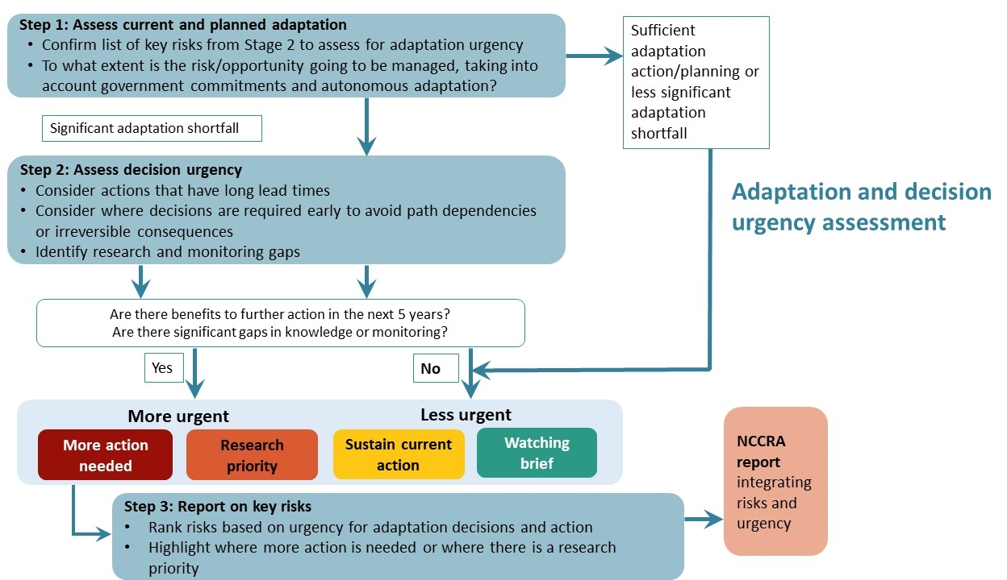

Task 1: Review current and planned adaptation
Stage 3 considered existing and planned adaptation actions and the extent to which risks and opportunities are being addressed at a high level. Types of adaptation include:
- autonomous adaptation, for example by individuals or the private sector
- deliberate policy decisions initiated and implemented by governments at all levels.
Information was gathered through stakeholder consultation, expert elicitation and a review of the Climate Change Adaptation Technical Working Group’s (CCATWG) Stocktake Report of Climate Adaptation in New Zealand (Climate Change Adaptation Technical Working Group, 2017) and the Recommendations Report (Climate Change Adaptation Technical Working Group, 2018). To identify where adaptation is planned or under way to address the prioritised national risks and identified opportunities, stakeholders were asked:
- Who has mandated responsibility to respond to/manage this risk?
- Are there adaptation actions planned or under way?
- Who is driving this response?
- Would risks benefit from short-term action (in the next five years)?
- Where are decisions needed early to avoid irreversible consequences, or being committed to a way forward that proves inflexible as impacts worsen (ie, being ‘locked in’)?
- To your knowledge, are there any significant research and monitoring gaps related to the risks?
This information was used in assessing decision urgency.

Task 2: Assess decision urgency
Stage 3 generated adaptation and urgency ratings for each of the priority risks and opportunities, using the concept of adaptation decision urgency to summarise the findings of the analysis.
Urgency is defined as “a measure of the degree to which further action is needed in the next five years to reduce a risk or realise an opportunity from climate change” (Committee on Climate Change, 2017, p 5). The NCCRA framework adopted the urgency categories from the 2017 UK Climate Change Risk Assessment (Committee on Climate Change, 2017).
Figure 5: Application of urgency categories in the NCCRA
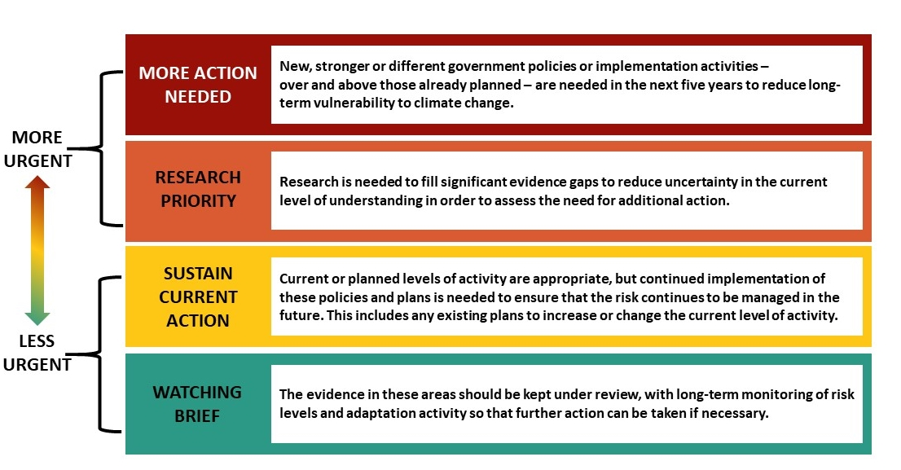
Each risk was given a rating (out of 100), according to the level of need for each of these types of action (4 ratings in total).
The four ratings (which were weighted based on the level of urgency for that type of action) were combined to provide a total rating for action urgency.
The overall urgency ratings are useful for comparing relative action urgency between risks in each domain. They are less useful for comparing relative urgency between risks in different domains.

The way these categories were applied in the NCCRA (figure 5) differed from the method outlined in the NCCRA framework. The framework had categories that are mutually exclusive so that, if this method had been applied, each risk would have fallen into a single urgency category – which is how urgency was defined in the UK assessment. This approach proved inappropriate for the New Zealand NCCRA.

Urgency profiles
Given the breadth of each risk, and that New Zealand is still in the early stages of planning for climate change, a more nuanced application of the urgency categories was adopted. Rather than each risk falling into only one category, the NCCRA developed an ‘urgency profile’ through expert elicitation with the domain leads for each risk.
The profiles rate the applicability of each category to each risk and then use a weighted sum of these rates to assess the overall urgency. The more urgent categories were weighted higher than less urgent categories (the scale on the left of figure 5 indicates the relative urgency). Each risk was assigned:
- an overview of the types of actions required, using the urgency categories
- an overall urgency rating to inform decision-making in each domain.
This involved the following tasks.
- The RA team and domain leads worked together on initial scoring, based on adaptation information outlined in task 1. They took the following approach to each risk.
- Domain leads estimated the percentage of total effort required under each of the urgency criteria. For example, a risk may have the following allocation:
Watching brief: 10 per cent
Sustain current action: 40 per cent
Research priority: 20 per cent
More action needed: 30 per cent.
- To facilitate the comparison of risks within each domain, these scores were compared using a simple weighted average of the effort allocations, with individual weights set to indicate the relative urgency of the four criteria. Weighting assumed a linear progression, with equal steps between the weights, for example, 1, 2, 3, 4, starting from ‘watching brief’ and going up to the highest weighting, ‘more action needed’. The weighted average is taken as the overall urgency score for the risk (weighted averages of NCCRA risk range from 45 to 93).
- Urgency profiles were also developed for each opportunity, using the same approach.
- The domain leads, RA team and technical reviewers met (stage 3, prioritisation meeting 1) to review and calibrate the application of urgency rating across domains. They also discussed priority risks and opportunities, and connections between governance risks and risks in other domains.
- The RA team revised the urgency ratings based on outcomes of step 3 in figure 4.
- The domain leads and RA team met (stage 3, prioritisation meeting 2) to review and calibrate scoring, and discuss priority risks and opportunities.
- They made final revisions to the urgency writings and wrote up the risks.
- The domain leads and RA team met (stage 3, prioritisation meeting 3) to agree final scoring and priority risks and opportunities.

Engagement approach
The NCCRA framework set out guidance for participation, including considerations for engagement with Māori. It identified key agencies, partners and stakeholders relevant to potential elements at risk.
In accordance with the framework, the engagement plan was based on the good practice principles set out by the International Association of Public Participation (IAP2). The community engagement spectrum of participation in the IAP2 was used as a basis for engagement design (see section 3.1.1).
The aim was to allow for a mutual exchange of information. This would foster positive relationships with and between key stakeholders, Māori/iwi and the Ministry, to support New Zealand’s ongoing work to identify and respond to climate risk.
This engagement supported the development of the NCCRA by:
- sharing information – building awareness and understanding of the project among partners and stakeholders, so they can better understand the final report and the process used to achieve it
- gathering information – providing a strong, broad and representative evidence base to inform the risk assessment, including verification and critical input, which involves providing critical and informed input into the risks, opportunities, adaptation action information and gaps for further consideration
- building positive long-term relationships – building positive and mutually advantageous relationships with and between key stakeholders, Māori/iwi and the Ministry. This included laying the groundwork for continued engagement – ensuring that at the end of the NCCRA process, there is a foundation for further engagement with partners and stakeholders to be led by the Ministry, for future adaptation work
- undertaking a transparent and repeatable process, to provide a sound basis for the NAP and future NCCRAs.
Stage 1, involving broad engagement with a wide range of partners and stakeholders, aimed to:
- identify as many potential risks throughout New Zealand as possible
- connect with stakeholders and partners across different regions and disciplines.
Stage 2 focused on input from stakeholders with direct responsibility for managing the priority risks.

Stakeholder identification
Starting with the key agencies, partners and stakeholders identified in the framework, stakeholders were mapped against domain descriptions to check for completeness. The project team then compared this list with appendix 3 (‘Stakeholders we engaged with’) of the CCATWG stocktake report, and added stakeholders where these were identified.
The identification exercise was tested at the project team inception meeting on 16 September 2019 and at a workshop with local government representatives on 30 September 2019.
There was a full review of the list at the end of stage 1, and ongoing updates on the basis of attendees at the national workshop and hui, the online survey and other identified stakeholders. This included the domain leads reviewing and identifying key stakeholders. Appendix E lists the organisations and groups contacted.
The initial identification resulted in a stakeholder directory, which included:
- researchers (eg, Crown research institutes, universities, private research companies)
- policy analysts (eg, hazard, risk and climate policy) in central and local government
- practitioners (eg, planners, engineers, economists, social, cultural) with experience in climate matters
- local government and infrastructure owners
- professional bodies with representatives well versed in climate change issues
- non-governmental organisations (NGOs) (eg, Environmental Defence Society, School Strike 4 Climate).
The directory also included Māori/iwi contacts. The approach to Māori/iwi engagement is set out in section 3.1.2.
Public engagement was not included, due to the timeframe and technical nature of the work.

Stakeholder influence
The NCCRA framework recommends a spectrum of engagement activities based on the IAP2 model (iap2.org.au), which sets out the types of engagement based on the decisions to be made and associated level of influence that stakeholders have on a project. For the risk assessment, stakeholders were informed, consulted and involved (figure 6). Stakeholders who were consulted and involved in the process included specialists with technical expertise particularly relevant to the risk assessment (as identified by domain leads), and those likely to be risk owners and policy agencies (particularly central and local government).
Figure 6: Stakeholder level of influence on the NCCRA project, based on the IAP2 model (iap2.org.au)

Approach to Māori/iwi engagement
The approach was to engage with Māori/iwi directly involved in climate change-related matters and decision-making, within the timeframes. This was carried out in a way that recognises:
- the principles of Te Tiriti o Waitangi (the Treaty of Waitangi) and Te Tiriti partnership between Māori/iwi and the Crown
- the importance of Māori decision-making in matters that affect Māori
- the value of mātauranga Māori (Māori knowledge) in decision-making and effective action.

Mātāpono (guiding principles)
The mātāpono in the NCCRA framework underpin the approach to incorporating Māori perspectives, values and priorities. These were established to ensure the notions of taiao (environment) and tangata (people) remain important focal points when considering and undertaking the risk assessment.
The mātāpono are additional to Te Tiriti o Waitangi principles (partnership, protection, participation and potential). They are set out in the framework as:
- manaakitanga (care and reciprocity)
- kaitiakitanga (intergenerational sustainability)
- whanaungatanga (connectedness and relationships)
- ōhanga (prosperity)
- rangatiratanga (leadership and autonomy)
- kia mahi ngātahi (engagement and participation)
- kia āwhina (support).
Using these values for discussion, and their relationship with climate change, was a key focus of the engagement work, including the hui (see below and sections 3.2.2, 3.3.2, 4.2 and 4.8).

Hui
Originally four regional hui were proposed. However, detailed engagement across Māori/iwi was challenging to deliver within the constraints of timeframe and resourcing.
The approach therefore was to hold one hui in stage 1, seeking representatives from across hapū and iwi as well as Māori organisations and individuals with specific knowledge about climate change. The project team undertook specific outreach beginning in October 2019 (before the stage 1 hui) to organisations including the Federation of Māori Authorities (FOMA), Iwi Chairs Forum, Office of the Māori Climate Change Commissioner, Māori Women’s Welfare League and Te Ohu Kaimoana.
This outreach included seeking advice on the design of Māori engagement.
A number of these organisations raised the project timeframes as an issue, noting that they constrained the project team’s ability to hear from a range of Māori perspectives (iwi, hapū and whānau). After the stage 1 hui, a number of local hui were held (see section 3.3.2).

Engagement methods: stage 1
The engagement activities for stage 1 were:
- a national multi-stakeholder workshop
- a stage 1 hui, inviting representation from Māori organisations and iwi throughout New Zealand
- an online survey
- focused meetings with target stakeholders and communities
- supplementary engagement at conferences and other forums.
As anticipated in the engagement plan, the approach evolved as the project progressed, responding to opportunities as they arose.

National workshop
This workshop was held on 20 November 2019 in Wellington. Its purpose was to:
- involve a broad cross-section of local government, business, NGOs, private sector, primary industries and other stakeholders working across all five domains
- allow for a timely exchange and discussion of ideas and a broad representation of perspectives
- elicit relevant information from stakeholders and begin to build the relationships and consortium for future engagement
- identify gaps in information and risks, and key individuals or stakeholders for stage 2.
For further refinement, a stakeholder mapping tool identified target participants as the ‘risk owners’ in each organisation.
Over 300 people were invited, and 128 attended (excluding the project team). Of these attendees:
- about one-third represented local government organisations. Of these, 28 were from district councils and city councils, and eight from regional councils. Four of the five unitary councils were represented (Auckland Council, Gisborne District Council, Marlborough District Council, Nelson City Council and Tasman District Council). Fifteen representatives were based in the South Island and 27 in the North Island
- about one-third represented central government, including the core state sector agencies and the major risk owners
- the remaining third represented a range of stakeholder organisations, including Crown entities and research institutes, nationwide interest groups such as DairyNZ, Tourism Association, Insurance Council and Recreation Aotearoa, infrastructure providers such as KiwiRail and Nelson Airport, and private financial entities such as KPMG, Westpac and BNZ.
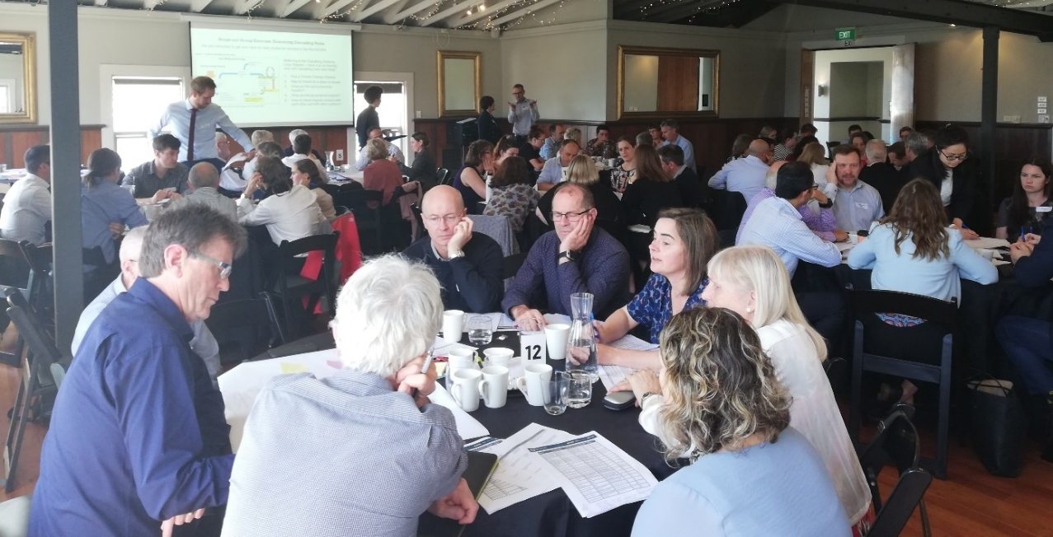
Workshop participants.
The national workshop featured a number of presentations (‘information-sharing with participants’) and activities (‘information-gathering from participants’), including confirmation of risk descriptions, and input into analysis and evaluation of risks.
Attendees were split into groups to focus on one domain in their area of expertise. Exercises were facilitated by project team members, with domain leads providing technical oversight and responding to queries.
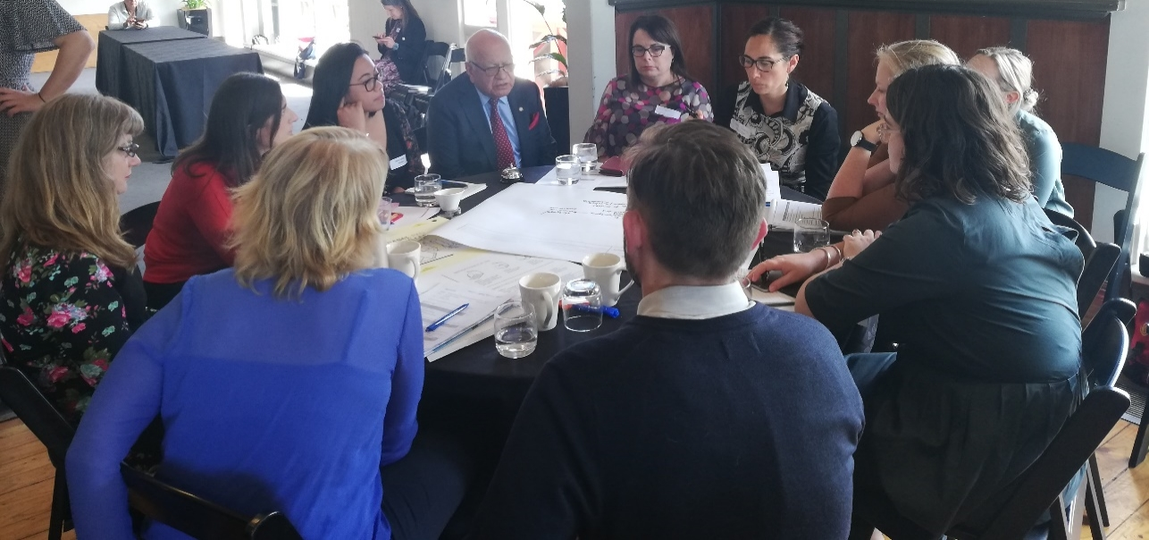
Facilitated discussion at one of the tables focusing on the human domain.
At the close of the workshop, evaluation forms were distributed. These included feedback on what went well and what could be improved, along with indications of interest for stage 2 engagement. A follow-up email was sent on Thursday 21 November to thank attendees for their time, attaching the attendees list, the slide deck of presentations used on the day and a link to a ‘future weather forecast’ video that formed part of the NIWA presentation on climate change impacts and implications for New Zealand.

Stage 1 hui
The stage 1 hui was held on 29 November 2019 in Tāmaki Makaurau (Auckland). The aim was to discuss:
- work under way at the Ministry to understand and respond to the impacts of climate change
- climate change risks to Māori and how these affect Māori now and in the future.
The Ministry sent the pānui (announcement) for the hui on 12 November 2019. It went to the Ministry’s iwi distribution list, and to organisations and individuals identified by the project team, including FOMA, Iwi Chairs Forum, Office of the Māori Climate Change Commissioner and Te Ohu Kaimoana.
The hui was held at the NIWA offices in Auckland. There were 33 responses to confirm attendance, and on the day the hui hosted 25 attendees (excluding the project team and Ministry representatives).
- About half the attendees were mandated for climate change work by their iwi or hapū organisations.
- Organisations represented included the Independent Māori Statutory Board (Auckland), the Māori Climate Change Commission, Scion and Waikato Regional Council.
- Geographic representation was largely from iwi or hapū from the central and upper North Island.
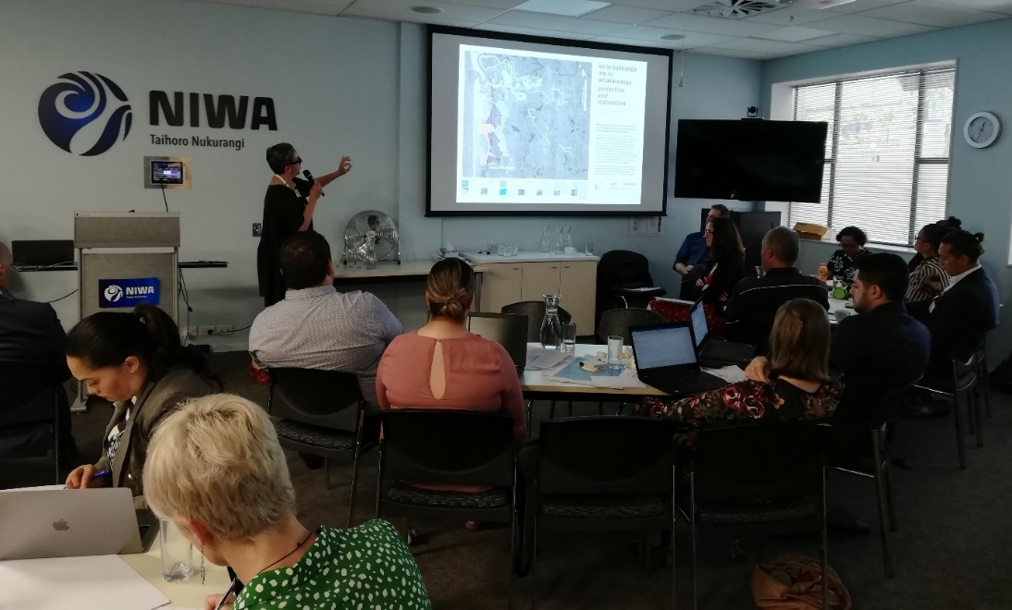
Dr Huhana Smith opening the hui discussion on Māori values and climate change.
The hui was opened by Ngāti Whātua o Ōrakei, one of the mana whenua of the Auckland rohe (area). Niketi Toataua (Pou Ārahi, NIWA) led the speech of welcome on behalf of NIWA as location host for the day.
Guidance for the hui was provided by Sir Mark Solomon, Chair of the Māori Carbon Foundation, who acted as Project Kaumātua in Sir John Clarke’s place.
A follow-up email was sent on 2 December 2019 to thank attendees for their time, attaching the attendees list, the slide deck of presentations used on the day, a link to a ‘future weather forecast’ video that formed part of the NIWA presentation on climate change impacts and implications for New Zealand, and links to Ministry documents. These included the NCCRA framework, which forms the basis of this project’s methodology.

Online survey
An online survey was sent on 26 November 2019 to target stakeholders who were unable to attend the national workshop or hui. It closed on 2 December 2019.
Respondents were asked to select their preferred domains, or opt to comment on all five domains, and then to respond to the following information requests:
- read the risk descriptions and the consequence descriptions for their selected domain and add any information they felt appropriate
- taking into account the prioritisation criteria for the NCCRA, identify the top five risks in their selected domain
- indicate whether they would like to be involved in stage 2
- indicate whether there were any other organisations or individuals the project team should engage with because of their involvement with the elements at risk
- advise whether they wished to review the interim report, which the Ministry shared from 23 December 2019 to 13 January 2020.
This survey was sent to about 300 stakeholders; several forwarded it to their contacts. The survey recorded 100 responses, 38 being detailed replies to the survey questions.

Focused meetings
The engagement plan provided for meetings with key sector and interest groups, to involve target stakeholders unable to participate in the national workshop, hui or survey, or to provide an opportunity for a more targeted discussion.
An initial workshop was held with local government representatives on 30 September 2019, in conjunction with the Ministry. A follow-up session on 7 October 2019 addressed local government’s role in and input into the NCCRA process. This built an awareness of the project and an understanding of how the framework would be applied to the risk assessment.
A teleconference was held with local government representatives who were unable to attend the workshop.
The Ministry also led a briefing with central government agencies in advance of the national workshop, with the support of the Engagement Lead for the NCCRA project, Dan Ormond.
Throughout stage 1, it became apparent that further engagement with Māori would be necessary as some iwi responded to the hui pānui with an invitation to hui with them directly. However, due to the timeframes and the limited availability of key participants, these were held in stage 2 (see section 3.3.2).

Supplementary engagement
To create awareness of the project and provide for broad engagement with the target stakeholders within the timeframes, opportunistic engagement was also undertaken at a series of forums. These presented information about the project, followed by one-on-one discussions:
- Climate Change and Business Conference, 8–9 October 2019, Auckland
- Lifelines Conference, 14–15 October 2019, Christchurch
- Aotearoa Circle event, 31 October 2019, Auckland
- Roundtable on Insurance and Climate Change hosted by the British High Commissioner, 6 November 2019, Wellington
- Local Government New Zealand Special Interest Group (Natural Hazards), 11 November 2019, Christchurch
- New Zealand Coastal Society Conference, 12–15 November 2019, Invercargill.

Engagement methods: stage 2
Based on the engagement approach set out in section 3, in stage 2 the engagement focused on a detailed risk assessment and adaptation measures.
The engagement sought stakeholder input on:
- detailed descriptions of each of the 48 prioritised risks
- the exposure and vulnerability assessment of these risks
- a high-level qualitative engagement on whether adaptation measures are planned or under way in response to the priority risks.
The engagement was also intended to support a transparent process that builds awareness and understanding of the project. This would support understanding of the final report, the process used to achieve it and how it informs the NAP.
A range of activities and options was offered to partners and target stakeholders:
- five risk workshops (one on each value domain)
- three local hui
- an online survey
- focused outreach (meetings, phone calls and correspondence)
- briefings with local and central government to review and identify adaptation activities.
The Ministry also held a series of regional hui in February 2020 where the NCCRA was discussed. A number of stakeholders also commented on the NCCRA interim report, which was shared by the Ministry from 23 December 2019 to 13 January 2020 with those stakeholders who had offered to review it.

Risk workshops
The objectives for the workshops were to:
- provide information about the NCCRA project‘s objectives, methods and findings to date
- gather input on the detailed risk assessment of the draft priority national risks (stage 2) as follows:
- exposure and vulnerability of risks
- adaptation responses planned or under way
- adaptation urgency discussion
- interdependencies between risks
- information gaps about risks
- explain next steps in the risk assessment, including the final report and how it will feed into the NAP.
Five workshops were held: three hosted in Wellington on 10–11 February 2020, and two in Auckland on 18 February 2020.
A review of the stakeholder list confirmed stakeholders with a particular interest and expertise relevant to the risks. The RSVP list was regularly reviewed, to check there was a good representation of expertise and ‘risk owners’ for each of the priority risks. About 45 people attended each of the workshops.
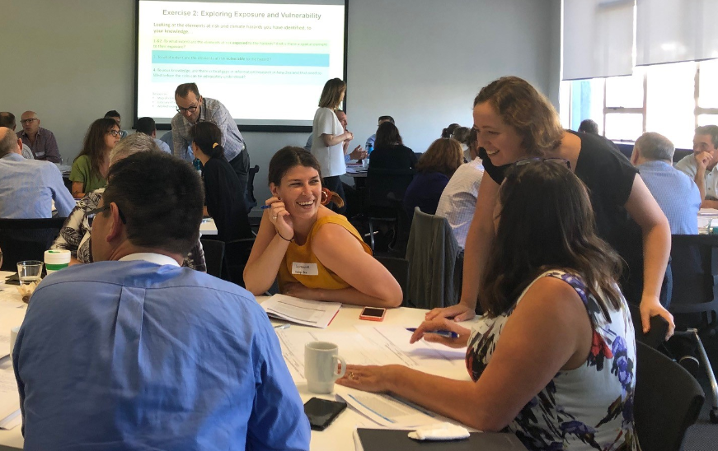
Discussions on risk exposure and vulnerability.
Preparatory material was circulated to participants at least one week before the workshops. It included:
- background on the NCCRA:
- a link to the project page on the Ministry website
- a list of key terms
- a link to the NCCRA framework, which guided the risk assessment
- the list of draft priority risks for the relevant domain
- questions seeking advice on adaptation measures planned or under way for the priority risks, and the urgency of addressing these risks. A link to the online survey, which addressed the same questions, was included as an option.
Each half-day workshop consisted of introductory presentations (‘information-sharing with participants’) followed by focused activities (‘information-gathering from participants’).
Tables were directed to focus on one to three priority risks, allowing participants to focus on risks in their area of expertise. Exercises were overseen by project team members. Domain leads each attended the workshop for their domain, to provide technical oversight as needed.
At the Auckland domain workshops, Sir John Clarke (Project Kaumātua) and Teina Boasa-Dean (in her capacity as advisor to the Ministry) held a side meeting with Deborah Te Riaki (Ngāti Rangi) to discuss how to bring a Māori perspective to the NCCRA.
A follow-up email was sent to thank attendees for their time, attaching the attendee list, the slide deck of presentations used on the day, a link to an evaluation form (Microsoft online forms) and the online survey as an option for further input (see section 3.3.3).

Local hui
Following the invitation to the stage 1 Māori engagement hui, some iwi invited the Ministry and the project team to travel to their region to hui with them about the project.
- The Ministry and the project team were invited to Te Tau Ihu Taiao Practitioners’ Forum, hosted by Te Ātiawa (Tau Ihu o te Waka a Maui) in Picton on 13 February 2020.
- Te Arawa held a hui with the Ministry at Te Arawa Lakes Trust in Rotorua on 20 February 2020, which was also attended by the project team.
- The Ministry and the project team were invited to present the project and discuss it with Waikato-Tainui, at Tainui Group Holdings in Hamilton on 25 February 2020.
The Ministry also held a series of regional hui throughout February. While the focus was on the resource management reforms, climate change adaptation was also discussed. There was an update and overview on the NCCRA, as well as discussion prompted by the following questions.
- What changes in your local climate have you seen?
- What impacts has this had in your rohe?
- What climate change impacts are you, your hapū or your iwi concerned about?
- What actions are you taking to respond to these impacts?
- What is the first thing we should do to start the conversation with you on the national adaptation plan?
The Ministry continues to liaise with Ngāti Paoa and Ngāi Tahu on the Climate Change Programme as a result of conversations arising from the stage 1 hui.

Online survey
An online survey was used to consult with target stakeholders who were not able to attend the workshops, focusing on adaptation measures. This asked participants to review the prioritised risks and advise on the following questions, in relation to each risk.
- To your knowledge, which organisation(s)/group(s) is/are formally responsible for responding to or managing the risk identified?
- Are you aware of any organisational, management or policy responses to address these risks (either planned or under way)?
- Who is leading this response?
Final questions, relating to all risks, included the following.
- In some cases, risks would benefit from short-term action (in the next six years) to avoid irreversible consequences and to increase the range of options for responding to them. To your knowledge, do any of these prioritised risks fall into this category?
- In relation to the risks identified, where are decisions required early to avoid irreversible consequences or being ‘locked in’ or committed to a certain way forward that is not flexible?
- To your knowledge, are there any significant research and monitoring gaps related to the risks identified?
- Are there any reports/papers/other literature you would strongly recommend we read as part of the detailed risk assessment, in relation to the priority risks?
The link to the survey was included in the workshop briefing and follow-up, as an optional exercise.

Focused meetings
The engagement plan allowed for meetings with key sector and interest groups, to involve target stakeholders who were unable to participate in the national workshop, or to provide an opportunity for a more targeted discussion. The stakeholder directory was regularly reviewed throughout the engagement period, to confirm that target stakeholders were reached.
The project team undertook specific outreach to target stakeholders and ‘risk owners’ who did not attend the workshops, including:
- airports (Auckland Airport, Christchurch Airport, Queenstown Airport, New Zealand Airports Association)
- the health sector (particularly Auckland District Health Board)
- experts identified by the domain leads and other stakeholders as holding knowledge about specific priority risks
- Generation Zero and School Strike 4 Climate (youth-led climate organisations)
- private sector peak bodies including the Insurance Council and Property New Zealand
- ports (Northport, Ports of Auckland, Port of Tauranga and Lyttelton Port)
- primary sector peak bodies, including:
- DairyNZ
- Federated Farmers
- Fisheries Inshore New Zealand
- Horticulture New Zealand
- Rural Support National Council
- Rural Women New Zealand
- Tourism Industry Aotearoa and Tourism New Zealand
- electricity sector representatives (Vector and Meridian).
In conjunction with the Ministry, the NCCRA project team held meetings on 3 March 2020 with local government representatives, and on 11 March 2020 with central government representatives to:
- check that the project team had sufficiently captured adaptation measures by local and central government risk-owners
- conclude discussions on the risk assessment, and acknowledge local and central government involvement
- advise next steps for project completion.

Results of engagement

National workshop: stage 1
Overall, the national workshop delivered on its purpose (section 3.2.1) and aligned with the engagement aims (section 3).
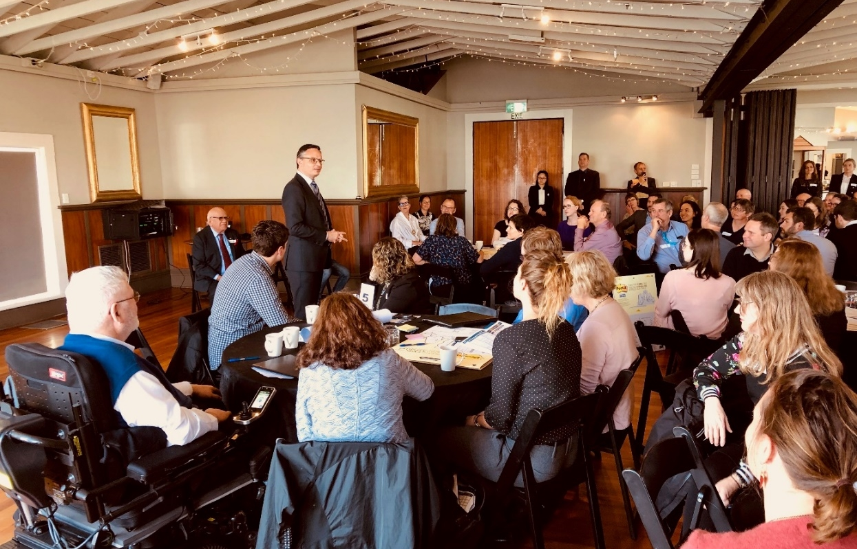
Hon James Shaw addressing workshop participants.

Feedback
The recorded discussions at the national workshop provided input into the risk assessment, bringing a broader perspective to the risks and consequences drafted by the project team. The data gathered at the national workshop directly informed and refined the risk and consequence descriptions in the NCCRA interim report.
Feedback in the evaluation forms indicated that the workshop helped awareness and understanding of the project among stakeholders:
“Excellent introduction to the work and method … a very important meeting.”
“Learned a lot about the NCCRA which is very useful.”
“Good ‘buzz’ in the room – feels good to be doing something!”
Participants also valued the networking opportunity. The workshop confirmed key stakeholders for stage 2, including participants who wanted be involved, and additional stakeholders who participants identified as holding valuable information about risks and consequences.
Feedback identified improvements to be made in the next round of engagement, including the following.
- Reconsider what material to pre-circulate. Some comments were that the introductory presentations were too long and that there was a lot of information and material to understand and respond to in one day. Others appreciated the context these presentations provided.
Getting the right balance of information that different participants wish to receive before and during the workshop was carefully noted for stage 2.
- To support easy discussion, consider the venue’s size and acoustics, and the size of the shared group worksheets.
- Give as much notice of the workshop dates as possible.
Section 4.6 sets out how feedback on stage 1 was applied to stage 2.
Some participants also asked whether there should be public engagement for this project, given the broad impacts of climate change. Public engagement was not included in the project scope due to the timeframe and technical nature of the work (as noted in section 3.1).
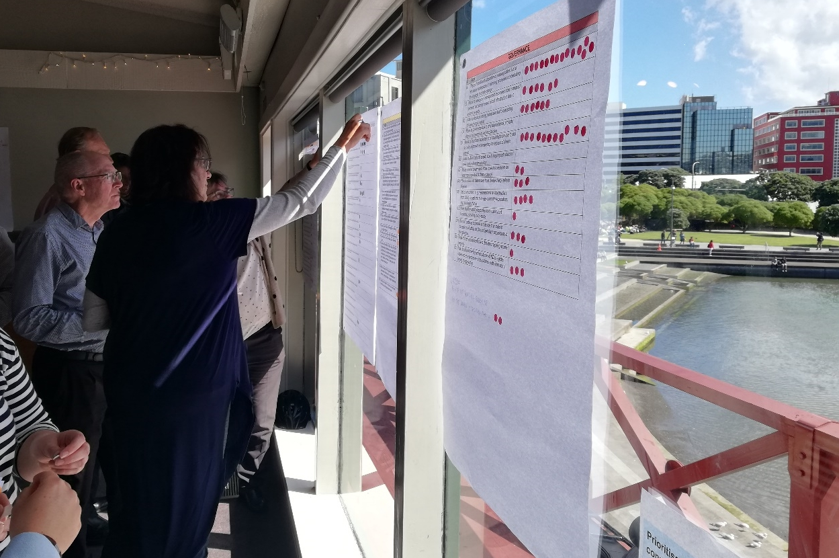
Prioritisation exercise in action.

Māori engagement hui: stage 1
The hui presented information about climate change impacts and the NCCRA, along with Ministry work under way to understand and respond to the impacts.
The hui discussions provided broad perspectives on the risk assessment approach, and explored specific risks and consequences for Māori now and in the future.
Some participants reflected that while climate change represented a significant challenge for New Zealand, Māori have lived in New Zealand for many generations and have survived and prospered by adapting to changes in the climate and the natural world.
There was also acknowledgment that many iwi and hapū are generating their own climate change plans that articulate values, issues and aspirations surrounding climate change risks and adaptation. Several participants noted that Māori will continue to work independently to adapt to a changing climate and would like to do this in partnership with the Crown.
The participants also provided strong feedback on the Government’s approach to engaging with Māori on climate change. This feedback is detailed in section 4.2.2.

Māori perspectives on the risk assessment process
Matters for consideration and concerns that were raised at the hui in relation to Māori perspectives, values and priorities included the following.
- The current NCCRA framework, developed by the Ministry to guide the NCCRA, is not positioned within a Māori framework and therefore the relationship of mātauranga Māori to the domains (human, natural environment, built environment, economy, governance) and their risks is unclear. In some instances, this restricted participants’ ability to frame risks from a Māori perspective. Mātauranga Māori forms a holistic basis for viewing the world, and the linear approach of a risk assessment methodology is not consistent with this.
- Greater work is required to clarify how different forms of mātauranga Māori might be shared, who should share it (eg, kaumātua, pakeke, rangatahi or those with mandate) and what safety mechanisms can be provided to different groups. There were differing views at the hui on this.
- Some participants noted that mātauranga Māori should form the basis of understanding te ao Māori, specifically at a local iwi or hapū level. This raised the tension between achieving a pan-Māori perspective on national risks for New Zealand, and regional and local perspectives on more local climate risks and opportunities.
- There was general consensus that investment in more discussion on Māori concepts could unlock a way forward for Māori on climate change, and that mātauranga Māori is a key component that would drive such an approach. This discussion should be led by Māori at the iwi and hapū levels, with the Crown’s participation as a partner.
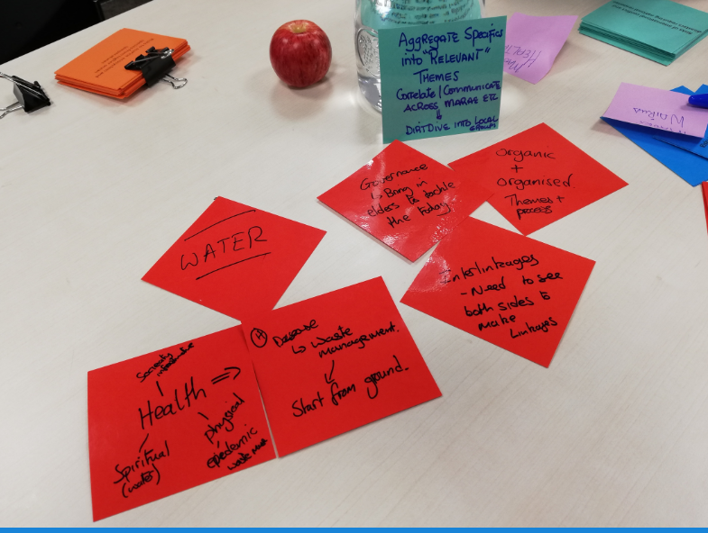
Cards used during the hui to support discussions.

Feedback on the engagement process
A number of process-related challenges were encountered despite the aim to observe best practice for Māori engagement. In particular, the short notice period for the stage 1 hui and the time of year made it difficult for many to participate. Many invitees were unable to attend, and some participants had to leave early to attend to other matters.
Others felt that before they could participate, they would need to discuss the kaupapa (topic) with their hapū and iwi, to determine the best way for them to participate.
A number of Māori organisations, including FOMA and Iwi Chairs Forum, were not represented.
Participants raised issues about the broader process. At the hui they expressed concern about the role of Māori more generally in climate change mitigation, risk identification and adaptation. This concern related to the level of partnership with the Crown and the degree to which Māori would be included in decision-making. There was also concern as to how national decision-making would relate to responding to regional risks, particularly where it affects Māori adaptation efforts already under way. Specific matters included:
- the NCCRA framework and the participants’ inability to inform its methodology for measuring risk
- formation of the Climate Change Commission, its level of Māori representation and its limitations as an ‘advisory group’ (ie, the Commission would not have the ability to directly make decisions on climate change issues)
- the national adaptation plan and the inference that the national priority is adaptation rather than mitigation
- lack of specific Māori engagement for the remainder of the project.
Hui participants commented that a preferred approach would be to establish a parallel Māori climate change risk assessment process to run alongside this NCCRA process, driven and developed by Māori. This would require adequate resourcing, mātauranga Māori research, and data to inform discussions and a policy framework. This process should be co-designed in a partnership with the Crown and its representatives in response to its Te Tiriti obligations.

Online survey: stage 1
The online survey supported the stage 1 engagement goals and process by incorporating different perspectives on the risks and consequences drafted by the project team. It was particularly useful in supporting several iterations of the risks as a result of the workshop and in improving the drafting and structure of the risks.
The survey provided an additional forum for stakeholders to indicate whether they would like to participate in stage 2, as well as to identify additional stakeholders who should be engaged in stage 2. It also identified stakeholders unable to attend the workshop, for example, health sector representatives.

Focused meetings: stage 1
Focused meetings enabled the project team to ensure that all target stakeholders had the opportunity to engage and provide input into stage 1.
On the completion of the workshop, hui and online survey, target stakeholders’ level of engagement was assessed. A number of stakeholders, particularly in the NGO sector (eg, Forest & Bird, Generation Zero and School Strike 4 Climate), did not provide a perspective in stage 1. Engaging with these groups was a priority in stage 2. For this reason, further focused meetings were held (see section 4.10).

Supplementary engagement: stage 1
The supplementary engagement events listed in section 3.2.5 successfully raised the profile of the NCCRA and informed stakeholders about the opportunities to engage with the project.

Response to participant feedback: stage 1
The records of discussions at the workshop and hui, online survey comments and evaluation forms include the following feedback, taken into account for stage 2.
- Project timeframe: Participants consistently commented that the project seemed to have a compressed timeframe that did not allow them to engage to a sufficient extent and depth. The short notice for both the hui and the workshop was problematic for some stakeholders, iwi and hapū.
- Māori engagement: Section 4.2.2 details broader feedback from the hui participants about how central government is engaging Māori in climate change planning and decision-making more generally.
- Pre-circulation of materials: Overall, stakeholders would like to have been better prepared for the workshop. The workshop agenda was pre-circulated, but a number of participants would have been willing to do additional reading to cut down on the presentations that were necessary at the workshop. The hui agenda was not circulated, in the interests of being flexible throughout the day. However, participants commented that they would prefer to have received an agenda that was subject to change, along with links to documents such as the NCCCRA framework, so that they could better prepare.
- Use of jargon: Participants in the workshop, hui and online survey gave feedback on the language used to describe the risks. They preferred plain English (rather than scientific or policy jargon).
- Venue and logistics: The acoustics, combined with the number of people in the workshop venue, made table discussions difficult for some. The poster-sized group worksheets for the workshop were easy to read but difficult to manage due to the table size. Some feedback recommended using less paper. These concerns were addressed during the hui (which used A3 paper and reusable cards) and were taken into account during the next round of workshops.
With the exception of the feedback on Māori engagement referred to in the second bullet point, which is beyond the scope of this project and was conveyed to the Ministry for response, this feedback was factored into the design of stage 2, as detailed in section 4.7.

Risk workshops: stage 2
Overall, the five risk workshops delivered on their objectives (section 3.3.1) and aligned with the engagement aim (section 3). They:
- provided focused, specific information to participants relevant to each domain
- encouraged participants with specific knowledge to sit at tables focusing on risks in their area of expertise
- enabled participants to share targeted information about each of the priority risks.
Feedback from the workshop (received via five completed evaluation forms and verbally ) indicates that it provided relevant information about the risk assessment project (objectives, methods and findings to date):
“Good succinct presentation on the background and progress of the overall project.”
“I thought the workshop was generally well run, attended and addressed all the objectives.”
“It was good to have the opportunity to raise some questions around the process and approach. Also, valuable conversations with other participants.”
“Information on the process to date was useful.”
Evaluation forms suggested improvements to the workshop including additional pre-circulated material, different approaches to exercises and table facilitation. Some commented that there was limited time to drill down into detail, although others would have preferred focusing more on the bigger picture, particularly for the human and governance domains.
A number of participants noted a lack of Māori presence at the workshops. This was acknowledged by the project team, noting that Māori/iwi representatives were invited but could not attend. We note that the feedback from a number of Māori/iwi representatives is that their kōrero does not fit into the domain framework. One participant suggested the Te Whare Tapa Whā model as a more integrated approach to the climate risk kōrero from a te ao Māori perspective. Another conversation led to a suggestion on the structure for the main report, which the project team has taken forward.
As set out in section 3.3.1, Sir John Clarke (Project Kaumātua) and Teina Boasa-Dean (in her capacity as advisor to the Ministry) held a side meeting with Deborah Te Riaki (Ngāti Rangi) at the Auckland domain workshops. This kōrero related to the content and structure of the main report. For further detail on the Māori view of the NCCRA expressed during stage 2, see section 4.8.
Some participants also sought better clarity on next steps, including the NAP:
“There is also still a huge gap in some timely direction to the regions in terms of progressing work in the climate change adaptation space – it looks like this is going to be happening from the bottom up anyway (fingers crossed!), but think it is a key area that the NAP needs to acknowledge/address, being explicit about how the NAP will inform regional adaptation (if at all?). One of the biggest risks to an effective adaptation is a lack of a consistent and co-ordinated approach across the regions – so I would expect the NAP to address that at some level.”
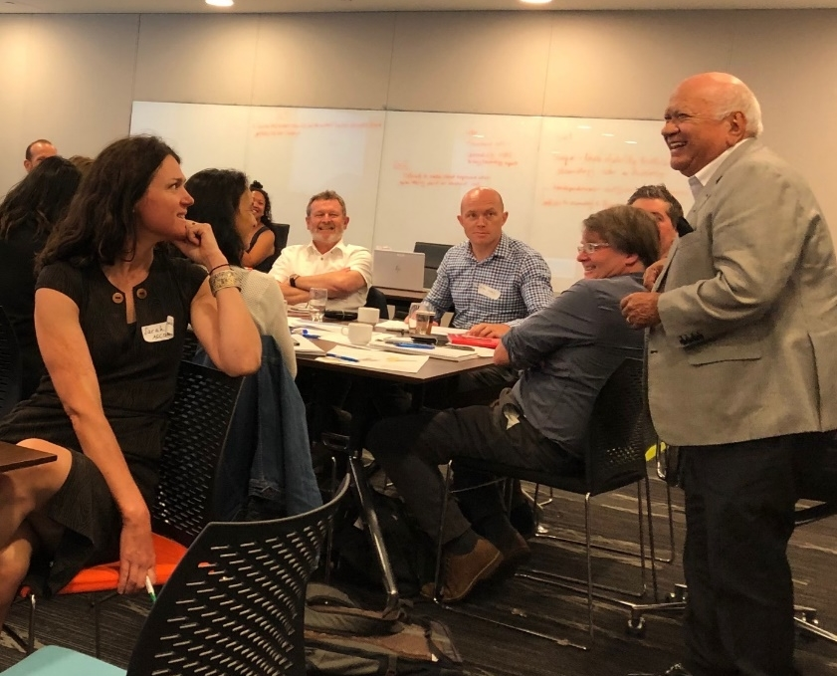
Sir John Clarke, Project Kaumātua, addressing the Auckland workshop.

Local hui: stage 2
The local hui built on the discussions started in stage 1, providing specific feedback on the NCCRA engagement process. Key messages include the following.
- Te Tiriti o Waitangi should be front and centre of climate change matters, with a genuine partnership between Māori and the Crown.
- Māori are diverse and identify in many ways, for example, as iwi, whānau, clustered whānau, and hapū. Climate risks and opportunities will be different for these different groups and communities. Some iwi, hapū and Māori businesses are well advanced in their thinking on climate change but for others, this kaupapa (topic) is new.
- Māori are a resilient people who have experienced many changes over many generations. From a circular and regenerative perspective, there may be changes, and with these comes a certain level of loss. However, changes bring new opportunities, such as Māori determining alternative adaptations in terms of how they might enhance their socio-cultural and ecological values, and envisage new economic contributions.
- A Māori assessment of climate change would include whakapapa, identity and strength.
- Many Māori perspectives do not fit comfortably into the risk assessment framework. In particular, the division into five domains has proved a barrier to articulating the Māori view of climate change.
- Māori are solution-focused and are generating their own climate change plans, which articulate values, issues and aspirations about risks and adaptation.
- Socio-economic issues make many Māori communities particularly vulnerable to climate change. This is exacerbated where Te Tiriti settlement land is in areas that may be affected by coastal change, for example, along the coast or on contaminated sites.
The project team, with the guidance of Sir John Clarke (Project Kaumātua), Dr Huhana Smith and Dr Darren Ngaru King (Lead Advisors, Māori), built on the information from stages 1 and 2 to bring the kōrero from these hui and workshops into the main report in terms of structure, framing and content.

Online survey: stage 2
The survey, which focused on adaptation measures, was sent to target stakeholders unable to attend the workshops. A total of 22 anonymous responses were received, addressing the following areas:
- human – Māori/iwi, historic or cultural heritage
- natural environment – particularly biosecurity
- economy – particularly tourism, insurance
- built environment – particularly three waters
- governance.
These responses were collated with the adaptation information collected during the workshops, along with a review of the CCATWG stocktake report, which fed directly into the project team’s adaptation and decision urgency assessment.

Focused meetings: stage 2
The project team undertook specific outreach to target stakeholders and risk owners who did not participate in the workshops, hui or survey. Table 10 summarises the outcomes.
Table 10: Focused outreach summary
Stakeholder | Contact
Central government | The Ministry held an inter-agency meeting on adaptation with central government organisations. It sought input on the central government adaptation work planned or under way.  The list of adaptation actions captured through the workshops, survey and review of the CCATWG stocktake report was circulated to over 70 central government representatives before and after the meeting. Input was received after the meeting from Ministry for Culture and Heritage, Heritage New Zealand, Ministry for Primary Industries, Ministry of Business, Innovation and Employment, and Te Puni Kōkiri.
Local government | With the Ministry, the engagement team met on 3 March 2020 with local government representatives to:  - check that the project team had sufficiently captured adaptation measures by local government risk owners  - conclude discussions on the risk assessment and acknowledge local government and central government involvement in this work  - advise next steps for project completion.  The meeting was attended by about 25 participants, online and in person.  The list of adaptation actions captured through the workshops, survey and review of the CCATWG stocktake report was pre-circulated and comment sought on gaps and additions. Additional input was received at the meeting and follow-up input was received from the Ministry (landfills and cultural heritage), Hawke’s Bay Regional Council and Otago Regional Council.
Airports | The project team convened a conference phone call on 9 March 2020 to discuss specific risks to airports. This was attended by Auckland Airport, Christchurch Airport, Queenstown Airport and New Zealand Airports Association. The invitation also included Wellington Airport. This discussion fed straight into the assessment of the built environment risks.
Health sector | A meeting was held with Auckland District Health Board (DHB) on 4 December 2020 to discuss the NCCRA process and the national workshop, which was followed up with an email detailing the stage 2 workshops. Auckland DHB later attended relevant workshops. There were email exchanges with Canterbury DHB and others in the health sector due to concern that the health sector had not been involved enough in stage 1.
Experts identified by the domain leads and other stakeholders as holding knowledge about specific priority risks | Key experts who could not attend the workshops were encouraged via email to complete the survey. This included specialists in lake ecology and heritage.
Youth-led climate organisations (Generation Zero and School Strike 4 Climate) | Generation Zero and School Strike 4 Climate were invited to all the workshops and to join the survey. The project team attempted to contact them via phone and email a number of times in stages 1 and 2. Unfortunately, there has been no response from Generation Zero to date. Initially, School Strike 4 Climate indicated it would attend the workshops, but the times did not suit school hours. No response was received to follow-up emails to arrange a more suitable time.
Private sector peak bodies | The Insurance Council was contacted via email with a link to the online survey, which it completed. There was follow-up by email and phone call.  Property New Zealand reviewed the online survey and commented via email.
Ports | The project team held a conference phone call on 9 March 2020 to discuss specific risks to ports. This was attended by Northport (Whangārei) and Ports of Auckland. The invitation also included Port of Tauranga and Lyttelton Port, but representatives were unable to attend. This discussion fed straight into the assessment of the built environment risks.
Primary sector peak bodies | The primary sector was represented at the national workshop, but representation reduced during stage 2 due to the specific nature of the risks and competing priorities at that time of year. Input from representatives was gathered in other ways, such as through the survey and phone calls, including from:  - DairyNZ  - Federated Farmers  - Fisheries Inshore New Zealand  - Horticulture New Zealand  - New Zealand Winegrowers and Bragato Research Institute  - Rural Support National Council  - Rural Women New Zealand.  Their feedback was fed into the risk assessment work.
Tourism sector | The project team followed up with Tourism Industry Aotearoa and Tourism New Zealand via email after the stage 2 workshops. Additional input was received via the online survey.
Electricity sector representatives | A meeting was held with Vector on 6 December 2019 to brief it on the NCCRA process. Vector attended the stage 2 built environment and economy workshops. The Built Environment Domain Lead, James Hughes, discussed risks to electricity generation with Meridian in March 2020, to confirm completeness of the project team’s assessment of these risks.

Summary of engagement reach
Engagement for the NCCRA sought to be a reciprocal process – a mutual exchange of information. This approach aimed to foster positive relationships with and between key stakeholders, Māori/iwi and the Ministry to support New Zealand’s ongoing work to identify and respond to climate risk.
Engagement was based on the IAP2 principles of good practice, and the guidance in the NCCRA framework for engagement on the risk assessment.
Stage 1 involved a wide range of partners and stakeholders, to identify as many potential risks throughout New Zealand as possible, and to engage across different regions and disciplines.
In stage 2, the focus narrowed, seeking input from stakeholders with direct responsibility for managing the priority risks.
Initial identification of stakeholders was based on the NCCRA framework, which identifies key agencies, partners and stakeholders relevant to potential elements at risk. The project team refined the stakeholder list throughout the engagement period, targeting those identified as risk owners in each organisation.
Stakeholders who were consulted and involved included specialists with technical expertise relevant to the risk assessment (as identified by domain leads) and those identified as likely risk owners and policy agencies (particularly central and local government).
Participants included:
- government and Crown agencies, engaged as stakeholders and information providers, with input from a broad range of agencies. As noted, these agencies will make adaptation decisions as risk owners and drivers of policy. Therefore, there were additional briefings with central government
- local government, which also provided significant input and made up about one-third of the participants. Some members attended all five risk workshops in February 2020
- representatives of a range of stakeholder organisations, including:
- research institutes such as Scion, Manaaki Whenua – Landcare Research, and Institute of Environmental Science and Research Limited
- primary sector groups such as DairyNZ, Horticulture New Zealand, Rural Women New Zealand, Federated Farmers, Fisheries Inshore New Zealand and New Zealand Winegrowers/Bragato Research Institute.
- national bodies and NGOs including Insurance Council, Water New Zealand, Engineering New Zealand, ICOMOS New Zealand, Museums Aotearoa and Environmental Defence Society
- infrastructure providers including ports and airports, Transpower New Zealand, Watercare, Wellington Water, KiwiRail, and electricity generation and transmission providers
- private entities such as major banks, professional services (eg, EY) and legal firms.
Some target stakeholders were not consulted due to the timeframe, despite repeated outreach by the project team. These included the youth groups Generation Zero and School Strike 4 Climate.
The approach to Māori/iwi engagement has been to engage with Māori/iwi directly involved in climate change matters and decision-making, within the condensed timeframes. Participants noted that they will continue to work to adapt to a changing climate but would like to do this in partnership with the Crown – that is, Te Tiriti o Waitangi should be front and centre of climate change matters, with a genuine partnership between Māori and the Crown.

Appendix A: Glossary
Key term | Definition
Adaptation | The process of adjustment to actual or expected climate change and its effects. In human systems, adaptation seeks to moderate or avoid harm, or exploit beneficial opportunities. In some natural systems, human intervention may facilitate adjustment (IPCC, 2014a).
Adaptive capacity | The ability of systems, institutions, humans and other organisms to adjust to potential damage, to take advantage of opportunities or to respond to consequences (IPCC, 2014a).
Assets | Things of value that may be exposed or vulnerable to a hazard or risk. Physical, environmental, cultural or financial/economic elements that have tangible, intrinsic or spiritual value (see ‘Taonga Māori’ in appendix B) (Ministry for the Environment, 2019).
Baseline | The baseline (or reference) is any datum against which change is measured.
Biodiversity | The variability among living organisms from terrestrial, marine and other ecosystems. Includes variability at the genetic, species and ecosystem levels (IPCC, 2014a).
Cascading effects (of climate change) | Effects that flow on from a primary hazard, to compound and affect other systems in a dynamic sequence.
Climate | The narrow definition is the average weather. More rigorously, it is the statistical description in terms of the mean and variability of relevant quantities over a period of time, ranging from months to thousands or millions of years. The classical period for averaging these variables is 30 years, as defined by the World Meteorological Organization. The relevant quantities are most often surface variables such as temperature, precipitation and wind. Climate in a wider sense is the state, including a statistical description, of the climate system (IPCC, 2014a).
Climate change | A change in the state of the climate that can be identified (eg, through statistical tests) by changes or trends in the mean and/or the variability of its properties, and that persists for an extended period, typically decades to centuries. Includes natural internal climate processes and external climate forcings such as variations in solar cycles, volcanic eruptions and persistent anthropogenic changes in the composition of the atmosphere or in land use (IPCC, 2014a).
Climate projection | The simulated response of the climate system to a scenario of future emission or concentration of greenhouse gases and aerosols, generally derived from climate models. Climate projections are distinguished from climate predictions by their dependence on the emission, concentration or radiative forcing scenario used, which is in turn based on assumptions about, for example, future socio-economic and technological developments that may or may not be realised (IPCC, 2014a).
Co-benefits | The positive effects a policy or measure for one objective might have on other objectives, irrespective of the net effect on overall social welfare. Often subject to uncertainty and depend on local circumstances and implementation practices, among other factors. Also known as ancillary benefits (Ministry for the Environment, 2019).
Community | A geographic location (community of place), a community of similar interest (community of practice) or a community of affiliation or identity (such as industry) (Ministry for the Environment, 2019).
Compound hazards and stressors | Cumulative hazards and stressors that will become more significant in the future as adaptation thresholds are reached. For example, for a low-lying coastal area, a persistent wet season (high groundwater, reduced field capacity) is followed by a coastal storm on the back of sea-level rise coincident with intense rainfall, leading to compound flooding impacts (Ministry for the Environment, 2019).
Confidence | A qualitative measure of the validity of a finding, based on the type, amount, quality and consistency of evidence (eg, data, mechanistic understanding, theory, models, expert judgement) and the degree of agreement (Ministry for the Environment, 2019).
Consequence | The outcome of an event that may result from a hazard. It can be expressed quantitatively (eg, units of damage or loss, disruption period, monetary value of impacts or environmental effect), semi-quantitatively by category (eg, high, medium or low level of impact) or qualitatively (a description of the impacts) (adapted from Ministry of Civil Defence and Emergency Management, 2019). It is also defined as the outcome of an event affecting objectives (ISO/IEC 27000:2014 and ISO 31000: 2009) (Ministry for the Environment, 2019).
Disaster | Severe alterations in the normal functioning of a community or a society due to hazardous physical events interacting with vulnerable social conditions, leading to widespread adverse human, material, economic or environmental effects that require immediate emergency response to satisfy critical human needs and that may require external support for recovery (IPCC, 2014a).
Driver | An aspect that changes a given system. Drivers can be short term but are mainly long term in their effects. Changes in both the climate system and socio-economic processes including adaptation and mitigation are drivers of hazards, exposure and vulnerability. Drivers can, thus, be climatic or non-climatic (Ministry for the Environment, 2019).
Emissions | The production and discharge of substances that are potentially radiatively active (ie, absorb and emit radiant energy) in the atmosphere (eg, greenhouse gases, aerosols) (Ministry for the Environment, 2019).
Exposure | Lack of protection, where people, livelihoods, species or ecosystems, environmental functions, services and resources, infrastructure, or economic, social or cultural assets in places and settings could be adversely affected by a change in external stresses that a system is exposed to. In the context of climate change these are normally specific climate and other biophysical variables (IPCC, 2007).  Lack of protection against loss or harm in a hazard zone, affecting the number, density or value of people, property, services or other things we value (taonga) (Ministry of Civil Defence and Emergency Management, 2019).
Extreme weather event | An event that is rare at a particular place and time of year. Rare is normally defined as “as rare as or rarer than the 10th or 90th percentile of a probability density function estimated from observations”. The characteristics of extreme weather may vary from place to place. When a pattern persists, such as a season, it may be classed as an extreme climate event, especially if it yields an average or total that is itself extreme (eg, a season of drought or heavy rainfall) (IPCC, 2014a).
Frequency | The number or rate of occurrences of hazards, usually over a particular period (Ministry for the Environment, 2019).
Greenhouse gas | Gaseous constituents of the atmosphere, both natural and anthropogenic, that absorb and emit radiation at specific wavelengths within the spectrum of thermal infrared radiation emitted by the Earth's surface, by the atmosphere itself and by clouds. This property causes the greenhouse effect. Water vapour (H₂O), carbon dioxide (CO₂), nitrous oxide (N₂O), methane (CH₄) and ozone (O₃) are the primary greenhouse gases in the Earth's atmosphere.
Hazard | The potential occurrence of a natural or human-induced physical event or trend or physical impact that may cause loss of life, injury or other health impacts, as well as damage and loss to property, infrastructure, livelihoods, service provision, ecosystems and environmental resources (IPCC, 2014a).  In this report, hazard usually refers broadly not only to climate-related physical hazard events (such as floods or heatwaves), but also to evolving trends or their gradual-onset physical impacts (IPCC, 2014a).
Heatwave | A period of abnormally and uncomfortably hot weather (IPCC, 2014a).
Impacts (consequences, outcomes) | The effects on natural and human systems of extreme weather and climate events and of climate change. Generally refer to effects on lives, livelihoods, health, ecosystems, economies, societies, cultures, services and infrastructure due to the interaction of climate changes or hazardous climate events within a specific period, and the vulnerability of an exposed society or system. Impacts are also referred to as consequences and outcomes (IPCC, 2014a).
Intergovernmental Panel on Climate Change (IPCC) | A scientific and intergovernmental body under the auspices of the United Nations.
Land use | The total of arrangements, activities and inputs undertaken in a certain land cover type (a set of human actions). The term is also used in the sense of the social and economic purposes for which land is managed (eg, grazing, timber extraction and conservation). In urban settlements it is related to land uses within cities and their hinterlands. Urban land use has implications for city management, structure and form and thus for energy demand, greenhouse gas emissions and mobility, among other aspects (IPCC, 2014a).
Land-use change | A change in the human use or management of land, which may change land cover. This may affect the surface albedo, evapotranspiration, sources and sinks of greenhouse gases, or other properties of the climate system and may thus give rise to radiative forcing and/or other impacts on climate, locally or globally (IPCC, 2014a).
Likelihood | The chance of an outcome occurring, where this might be estimated probabilistically (IPCC, 2014a).
Lock in | The situation where decisions, events or outcomes at one point in time constrain adaptation, mitigation or other actions or options at a later point in time (IPCC, 2014a).
Māori values and principles | Māori values and principles derive from Māori views of the world. Instruments through which Māori make sense of, experience and interpret the world. They form the basis for Māori ethics and principles (Ministry for the Environment, 2019).
Mitigation | A human intervention to reduce the sources or enhance the sinks of greenhouse gases (IPCC, 2014a).
Percentile | A value on a scale of 100 that indicates the percentage of the data set values that is equal to or below it. The percentile is often used to estimate the extremes of a distribution. For example, the 90th (or 10th) percentile may be used to refer to the threshold for the upper (or lower) extremes.
Representative concentration pathway (RCP) | A suite of future scenarios of additional radiative heat forcing at the Earth’s surface by 2100 (in Watts per square metre), which is the net change in the balance between incoming solar radiation and outgoing energy radiated back up in the atmosphere. Each RCP can be expressed as a greenhouse gas concentration (not emissions) trajectory adopted by the IPCC for its Fifth Assessment Report (AR5) in 2014 (IPCC, 2014a).
Residual risk | The risk that remains (and may continue to rise) in unmanaged form, after risk management measures and adaptation policies have been used to adapt to climate change and more frequent hazards, and for which emergency response and other actions must be maintained or limits to adaptation addressed. Policy interventions and adaptation plans will need to reconcile changing residual risks with changing (evolving) societal perceptions of tolerable risk.
Resilience | The capacity of social, economic and environmental systems to cope with a hazardous event, trend or disturbance by responding or reorganising in ways that maintain their essential function, identity and structure, while also maintaining the capacity for adaptation, learning and transformation (IPCC, 2014a).
Risk | The potential for consequences where something of value is at stake and where the outcome is uncertain, recognising the diversity of values. Risk is often represented as probability or likelihood of occurrence of hazardous events or trends multiplied by the impacts if these events or trends occur. It also refers to the potential, when the outcome is uncertain, for adverse consequences on lives, livelihoods, health, ecosystems and species, economic, social and cultural assets, services (including environmental services) and infrastructure. Risk results from the interaction of vulnerability, exposure and hazard. To address the evolving impacts of climate change, it can also be defined as the interplay between hazards, exposure and vulnerability (IPCC, 2014a).
Risk assessment | The qualitative and/or quantitative process of identifying, analysing and evaluating risk, with entry points for communication and engagement, monitoring and reviews (AS/NZS ISO 31000:2009, Risk Management Standard).
Shock | A sudden, disruptive event with an important and often negative impact for New Zealand.
Stress | A long-term issue with an important and often negative impact, in this case, for New Zealand.
Stressor (climate) | Persistent climatic event (eg, change in pattern of seasonal rainfall) or rate of change or trend in climate variables, such as the mean, extremes or range (eg, ongoing rise in mean ocean temperature or acidification), which occurs over a period of time (eg, years, decades or centuries), with important effects on the system exposed, increasing vulnerability to climate change (Ministry for the Environment, 2019).
System | A set of elements working together as parts of an interconnected network and/or a complex whole.
Three waters | Drinking water, wastewater and stormwater.
Uncertainty | A state of incomplete knowledge that can result from a lack of information or from disagreement about what is known or even knowable. It may have many types of sources, from imprecise data to ambiguously defined concepts or terminology, or uncertain projections of human behaviour (IPCC, 2014a).
Value domain | The NCCRA framework outlines five ‘value domains’ for assessing risks and opportunities. These represent groups of values, assets and systems that may be at risk from climate change-related hazards or could benefit from them (opportunities). They are a hybrid of The Treasury’s Living Standards Framework (The Treasury, 2018) and those used in the National Disaster Resilience Strategy (Ministry of Civil Defence and Emergency Management, 2019). They are interconnected and apply at the individual, community and national levels. They include tangible and intangible values.
Vulnerability | The propensity or predisposition to be adversely affected. Vulnerability encompasses a variety of concepts and elements including sensitivity or susceptibility to harm, and lack of capacity to cope and adapt (IPCC, 2014a).  Assessing vulnerability is broader than conventional risk assessments; it includes indirect and intangible consequences on the four wellbeings, and adaptive capacity (eg, communities, whānau, hapū and iwi may be resourceful and adaptive but may lack the resources, insurance access and mandate or capacity to adapt) (Ministry for the Environment, 2019).
Wellbeing | Wellbeing is achieved when people are able to lead fulfilling lives with purpose, balance and meaning (The Treasury 2019a). The Treasury’s Living Standards Framework notes that intergenerational wellbeing relies on growth, distribution and sustainability of four interdependent capitals: natural, social, human and financial/physical. The Crown–Māori relationship is integral to all four capitals (The Treasury, 2018). Within te ao Māori – the Māori world – the drivers of wellbeing are considered against the values that imbue te ao Māori with a holistic perspective. These values are interconnected and span multiple aspects of wellbeing. Wellbeing results from the application of these values through knowledge, beliefs and practices (The Treasury, 2019b).

Appendix B: Te reo Māori glossary
Māori key term | Definition in English
Ahurea | Culture
Āwhina | Support
Hapū | A section of a tribe, secondary tribe
Hui | Meeting, gathering
Huringa āhuarangi | Climate change
Iwi | Tribe, tribal group
Kaitiakitanga | Stewardship of natural resources; intergenerational sustainability
Kaumātua | Elder, person of status
Kaupapa | Topic, subject
Kaupapa Māori | This concept has many definitions and is used in various contexts. To ensure that nothing is left out, we offer those broader definitions here: Māori approach, topic, customary practice, institution, agenda, principles, ideology – a philosophical doctrine, incorporating the knowledge, skills, attitudes and values of Māori society (Ministry for the Environment, 2019).
Kawa | Ceremony, protocol
Kōrero | Talk, discourse, information
Kura taiao | Living treasures, and the ecosystems that they form in terrestrial, freshwater and marine environments
Mahi ngātahi | Engagement, participation
Mahinga kai | Food gathering
Mana | Authority, dignity, governance, power
Mana whenua | Power from or authority over land or territory
Manaakitanga | Care, reciprocity
Mātāpono | Principle
Mātauranga Māori | Māori knowledge systems. These are context specific to indigenous Māori people, and the term has its origins in Aotearoa New Zealand. It has many definitions that cover belief systems, epistemologies, values and knowledge, in a traditional and contemporary sense. The knowledge, comprehension or understanding of everything visible and invisible in the universe (Ministry for the Environment, 2019).
Mauri | The life force
Ōhanga | Economic, economy
Pakeke | Adult
Rangatahi | Young person
Rangatiratanga | Leadership, autonomy
Rohe | Land, territory, domain, boundary
Taiao | Environment
Tangata | People
Taonga Māori | Taonga are tangible and intangible items that are highly valued in Māori culture. They include:  - natural environment (whenua/land, ngahere/forests, awa/rivers, maunga/mountains and moana/ocean)  - human and non-human capital (whānau, hapū, iwi) and spiritual (mauri)  - social capital (mātauranga Māori)  - economic capital (financial value of assets including land holdings)  - material capital (buildings including marae, commercial investments and private homes) (Ministry for the Environment, 2019).
Te ao Māori | The Māori world and worldview
Te Tiriti o Waitangi | The Treaty of Waitangi
Tikanga | Procedures, lore, practices
Tūrangawaewae | Place where one has the right to stand
Urupā | Burial ground, cemetery
Wāhi taonga | Place where taonga are held or kept
Wāhi tapu | Sacred place
Whakapapa | Genealogy that links to one’s ancestors
Whakatipu rawa | Business, enterprise
Whanaungatanga | Connectedness and relationships
Whenua | Land, territory, nation

Appendix C: Assessment criteria

Magnitude of consequence criteria
Table 11: Magnitude of consequence criteria
 | Consequence level (national scale aggregated from the seven sub-national climate zones)
 | Insignificant  No significant change in impact nationally – can be handled through business-as-usual; or some local or regional impacts requiring no specialised management | Minor  Some minor impacts at the national scale that could be addressed through local or regional management and adaptation processes | Moderate  Significant impacts at the national scale, of interest to national agencies to address adaptation, or a major impact for 1–2 sub-national climate zones | Major  Major impacts at the national scale, of high interest to national agencies to quickly address adaptation, or an extreme impact for 1 sub-national climate zone | Extreme  Extreme impacts at the national scale (or even in a few sub-national climate zones), of heightened interest to national agencies to urgently address adaptation. May be of interest to international partners or financial or insurance institutions
Human | No discernible changes in physical health, physical safety and mental health  No change to satisfaction of life in New Zealand  Happiness and satisfaction of whānau are minimally affected | Minor impact on physical health, physical safety or mental health  Happiness and satisfaction of whānau in some communities are mildly affected  Isolated and short-term disruption to education, employment and community services  Minor impact on patterns of daily activity and behaviour | Moderate lasting impacts on physical health, physical safety or mental health  Happiness and satisfaction of hapū and iwi in some communities are moderately affected  Moderate disruption to education, employment and community services  Moderate impacts on patterns of daily activity and behaviour  Coping capacity of many communities exceeded | Physical health, physical safety and wellbeing significantly compromised in many communities  The happiness and satisfaction of hapū and iwi are affected in a major way  Prolonged disruption to education, employment and community services  Major impacts on patterns of daily activity and behaviour  Coping range of most communities exceeded | Health, safety and wellbeing significantly compromised across whole of society  The happiness and satisfaction of hapū and iwi are severely affected  Permanent disruption to education, employment and community services  Patterns of daily activity and behaviour unable to continue  Coping range of all communities exceeded
Natural environment | Very short-term impacts, or having a signal that is indistinguishable from natural background variation  Negligible impact or very short-term, event-driven reversible alteration of biologically important attributes | Temporary localised or minor regional effects on ecosystems and/or species  Temporary localised or minor regional alteration of biologically important attributes  Short-term loss/minor decline in the ecological integrity/stability of a small minority of protected natural areas  Short-term loss/minor decline in the conservation status of taonga species or sub-species | Sustained localised or shorter-term regional effects on ecosystems and/or species  Sustained localised or shorter-term regional alteration of biologically important attributes  Sustained localised or shorter-term regional change in the ecological integrity/stability of high-value protected natural areas (including marine protected areas)  Sustained localised or shorter-term regional decline in the conservation status of taonga species  Sustained localised impacts on recreation and/or aesthetics | Widespread alteration of ecosystems and/or species at regional to national scales leading to significant ecosystem instability and/or species declines  Widespread alteration of biologically important attributes across multiple sub-national climate zones  Regional/medium term reduction in the ecological integrity/stability of most protected natural areas (including marine protected areas)  Serious national declines in the conservation status of taonga species, with some at risk of complete loss  Sustained regional impacts on recreation and/or aesthetics | Significant alteration of ecosystems and/or species resulting in major ecosystem instability and serious loss of species  Significant alteration of biologically important attributes throughout New Zealand  Major and widespread instability in natural ecosystems, resulting in significant loss of community composition, structure and function  Serious declines in the conservation status of taonga species, with a significant proportion suffering complete loss  Sustained and serious national impacts on recreation and/or aesthetics
Economy | Limited financial losses  No impact on businesses, livelihoods or consumer behaviour | Financial losses equivalent to 1% of gross regional product (GRP)  Limited impacts on businesses, livelihoods and consumer behaviour  Temporary increase in unemployment within one sector  Short-term/minor increase in local and central government costs, minimal loss of assets | Financial losses equivalent to 2–4% of GRP  Ongoing losses equivalent to 0.5% of GRP  Temporary impacts on businesses, livelihoods and consumer behaviour  Temporary increase in unemployment in many sectors  Medium-term increase in local and central government costs | Financial losses equivalent to >5% of GRP or  1–2% of gross domestic product (GDP)  Ongoing losses equivalent to 1% of GRP  Sustained impacts on businesses, livelihoods and consumer behaviour  Sustained increase in unemployment in many sectors  Long-term increases in local and central government costs, some loss of assets | Financial losses equivalent to >3% of GDP  Ongoing losses equivalent to >0.5% reduction of GDP  Sustained increase in unemployment across most sectors  Long-term costs for local and central government increase, and significant loss of assets
Built environment | Minor or insignificant infrastructure disruption at local level  Negligible damage to buildings  Negligible damage to Māori cultural assets, such as marae, urupā, wāhi tapu and wāhi taonga | Isolated and short-term infrastructure service disruption; no permanent damage; some minor restoration work required  Early renewal of infrastructure by 10–20%; need for new or modified ancillary equipment or design standards  Increasing temporary or recoverable damage to buildings  Planning for future relocation required  Some damage to a small number of Māori cultural assets | Many short-term infrastructure service disruptions; damage recoverable by maintenance and minor repair  Early renewal of infrastructure by 21–50%  Moderate damage to 10–100 dwellings; some require immediate relocation  Between 5–20 commercial and public buildings require assessment; some require temporary relocation  Moderate, reparable damage to Māori cultural assets | Widespread short-to-medium term disruptions to infrastructure service; extensive infrastructure damage requiring major repair  Major loss of infrastructure service  Early renewal of infrastructure by 51–90%  Major damage to 100–1000 dwellings; significant numbers need to be immediately relocated  Costs exceed insured value  Between 20 and 100 commercial and public buildings require assessment; many need to be permanently relocated  Major, widespread damage to Māori cultural assets | Widespread, long-term service disruption; significant permanent damage to and/or complete loss of infrastructure and its service  Loss of infrastructure support and translocation of service to other sites; early renewal of infrastructure by more than 90%  More than 1000 dwellings require assessments for immediate relocation  More than 100 commercial buildings and more than 100 government and non-commercial buildings require assessment for permanent relocation options  Costs significantly exceed insured value  Damage to more than 75% of Māori cultural assets
Governance | No impact or some low-level inconsequential impacts  Small increase in local demand for central government support | Some minor impacts at the local level, leading to tensions between levels of government  Disruption to some local governance and decision-making functions (eg, temporary limited access to local services)  Some negative impacts on perceived reputation  Minimal effects on Te Tiriti o Waitangi rights | Moderate localised impacts on decision-making functions, service delivery and community resilience  Rising community unrest and litigation  Moderate impacts on perceived reputation requiring specialised management to restore  Some Te Tiriti o Waitangi rights temporarily eroded or damaged | Major multifunctional impacts on decision-making and service delivery at local and national levels  Policy and legislation cannot cope with the impacts, eg, funding, planning practice, emergency services  Inequitable outcomes lead to loss of trust and reputation, and greater community unrest and litigation  Major erosion of Te Tiriti o Waitangi rights | Extreme multifunctional, cascading and compounding impacts lead to inability at all levels of government to govern and provide services in an equitable and just manner  Extreme community disruption (eg, loss of place and community cohesion)  Significant damage to perceived reputation of and trust in institutions  Te Tiriti o Waitangi rights overridden
Supplementary guidance on the consequence descriptors
Human
The areas of human wellbeing to be assessed include:
1. safety and health (consider how the safety, physical and mental health of individual and communities are affected as a result of the increased frequency, intensity and magnitude of extreme events and slow-onset change. Such impacts could arise from physical threats, individual response to economic and social change as well as chronic health impacts eg, respiratory disease, waterborne disease and new types of disease)
2. happiness (how the happiness and satisfaction of individuals, families and communities are affected by ongoing change including changes within communities and to sense of belonging (place) as a result of physical, economic and social change)
3. access to services (consider how individual and community access to critical services and the ability to earn an income change, due to worsening impacts from episodic events and relocation of essential services)
4. activity patterns (how the ability to undertake normal daily habitats and activities [eg, shopping or travelling to work] is affected, and whether these changes can be tolerated by those who live there).
Natural environment
The areas of the natural environment to be assessed include:
1. ecosystems (how ecosystems will continue to provide services as impacts worsen)
2. species (how individual species may be affected)
3. biodiversity (including the variability within species, between species and of ecosystems)
4. taonga species.
Economy
The areas of the economy to be assessed include:
1. businesses (how they perform as impacts worsen in frequency, intensity and magnitude, considering episodic and ongoing changes)
2. local and central government assets (how these are affected by impacts and their potential costs)
3. financial institutions (how liabilities change and emerge from worsening impacts)
4. consumption patterns (including tourism).
Consider the duration and permanence of the effect: temporary changes are likely to be more minor than sustained or permanent effects.
Consider the criticality of the business or sector.
Built environment
The areas of the built environment to be assessed include:
1. residential dwellings
2. commercial and government buildings
3. infrastructure (including transport, energy, communications, water)
4. built Māori cultural assets (such as marae, urupā, wāhi tapu and wāhi taonga).
Governance
The areas of governance to be assessed include:
1. policies, rules and laws (how they perform as impacts worsen in frequency, intensity and magnitude, considering episodic and ongoing changes)
2. informal norms and practices (how individuals and communities change as the impacts worsen)
3. legal responsibilities and litigation (how liabilities play out under community pressures that emerge from worsening impacts)
4. trust in institutions (how relationships between national and local governments and between governments, communities and sectors play out)
5. Te Tiriti o Waitangi (how partnership and Te Tiriti rights are affected as impacts worsen).

Confidence
The confidence rating used in this assessment follows the Guidance Note for Lead Authors of the IPCC Fifth Assessment Report on Consistent Treatment of Uncertainties (Mastrandrea et al, 2010). In line with this guidance, this assessment uses two metrics for communicating the degree of certainty in key findings:
- confidence in the validity of a finding, based on the type, amount, quality and consistency of evidence (eg, mechanistic understanding, theory, data, models, expert judgement) and the degree of agreement. Confidence is expressed qualitatively (table 12)
- quantified measures of uncertainty in a finding (where appropriate) expressed probabilistically (based on statistical analysis of observations or model results, or expert judgement).
Table 12: Confidence scale
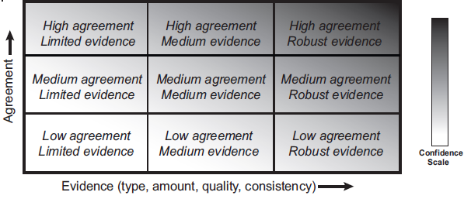

Urgency criteria
Table 13: Urgency criteria from the 2017 UK Climate Change Risk Assessment (Committee on Climate Change, 2017)
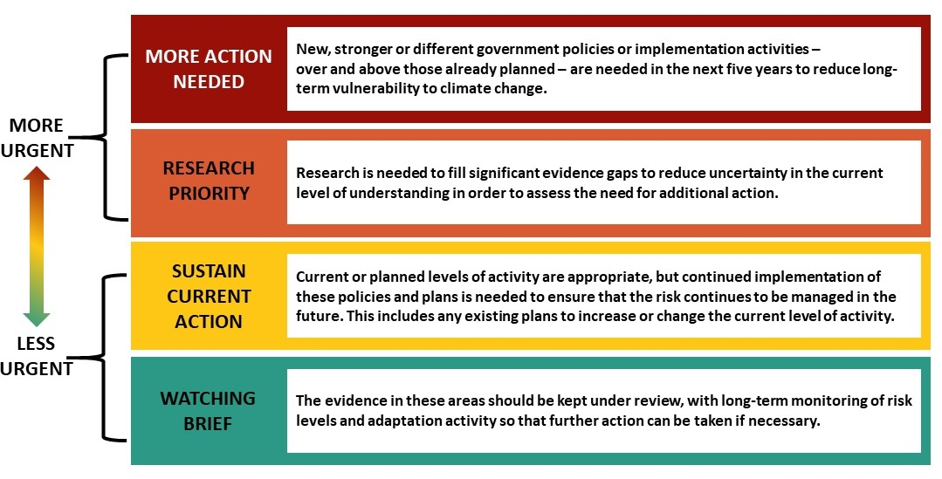
Vulnerability and exposure criteria
Table 14: Vulnerability and exposure criteria
Level | Exposure definition | Vulnerability definition
Extreme | The majority (>75%) of the sub-category or element at risk is exposed to the hazard. | Extremely likely to be adversely affected, because the ‘sub-category or element at risk’ is highly sensitive to a given hazard and has a low capacity to adapt.
High | A high proportion (50–70%) of the sub-category or element at risk is exposed to the hazard. | Highly likely to be adversely affected, because the ‘sub-category or element at risk’ is highly sensitive to a given hazard and has a low capacity to adapt.
Moderate | Up to half (25–50%) of the sub-category or element at risk is exposed to the hazard. | Moderately likely to be adversely affected, because the ‘sub-category or element at risk’ is moderately sensitive to a given hazard and has a low or moderate capacity to adapt.
Low | A small proportion (5–25%) of the sub-category or element at risk is exposed to the hazard. | Low likelihood of being adversely affected, because the ‘sub-category or element at risk’ has low sensitivity to a given hazard and a high capacity to adapt.

Supplementary guidance for exposure and vulnerability descriptions

Natural environment
The areas of the natural environment that could be adversely affected include:
- ecosystems (including their composition, functions and processes, and the services that they provide)
- species (how individual species may be affected)
- taonga species.
Vulnerability to climate change is derived from the interplay of sensitivity and adaptive capacity. Sensitivity and adaptive capacity in relation to the natural environment include the considerations that table 15 identifies.
Table 15: Sensitivity and adaptive capacity in the natural environment domain
Sensitivity | Adaptive capacity
- Environmental tolerance and geographic range: Species and ecosystems that have a wide environmental tolerance – generally reflected in a wide geographic range – will likely be less sensitive to the impacts of climate change. By contrast, species and ecosystems that have narrow environmental ranges and/or are restricted to unusual combinations of environment are likely to be less tolerant (Thuiller et al, 2005).  - Species/ecosystems with specific climate requirements: Ecosystems and species that have highly specific climate requirements (eg, persistent winter snow cover, winter chilling for flower initiation or hibernation, frost for exclusion of competing tree species) will likely be more sensitive. | - Genetic adaptation/evolutionary mechanisms: Species that have historically been subjected to changes in the natural environment will have a capacity to adapt to future changes. Genetic adaptation at individual, population and species levels, including natural selection and gene flow, allows for greater population fitness and adaptive capacity (Lidner et al, 2010).  - Reproductive rates: Reproductive rates are an important factor in the ability of species or ecosystems to adapt after a disturbance or climate hazards (Williams et al, 2008). Higher reproductive rates will allow for a greater ability to recover and adapt.
- Dispersal ability: Species with poor dispersal ability and/or occupying environments with significant barriers to dispersal (eg, lowland forest fragments) are likely to be more sensitive than those with good dispersal ability and/or those that occupy environments with fewer barriers to dispersal (eg, many marine environments) (Williams et al, 2008).  - Abundance: Species that are naturally rare may be more sensitive due to their limited population size. Species that are limited both in their distribution and abundance will likely be the most sensitive (Johnson, 1998).  - Geographic isolation: Geographic isolation of species and ecosystems will render them more sensitive and susceptible. This is particularly relevant to endemic species that are restricted to a defined geographic location.  - Genetic diversity: Species with less genetic diversity (eg, threatened species that have passed through population bottlenecks) will likely be more sensitive because of their reduced capacity for adaptation (Reed and Frankham, 2003).  - Ocean acidification: Species dependent on calcium carbonate for the maintenance of exoskeletons will be particularly susceptible to the effects of ocean acidification. | - Behavioural plasticity: The ability of species and ecosystems to change behaviours based on environmental conditions will contribute greatly to adaptive capacity. Such behaviours involve shifts in distribution or seasonal activity, acclimation and changes in habitats (Williams et al, 2008). Behavioural changes favoured by natural selection through survival and reproduction may become fixed in populations over time.

Human
The areas of human wellbeing that could be adversely affected include the following.
- Safety and health – Consider how the safety, physical and mental health of individuals and communities are affected by the increased frequency, intensity and magnitude of extreme events and slow-onset change. Such impacts could arise from physical threats, individual, community and policy responses to economic and social change, and chronic health impacts (eg, respiratory disease, waterborne disease and new types of disease).
- Happiness – Consider how the happiness and satisfaction of individuals, families and communities are affected by ongoing change, including changes within communities and sense of belonging (place) as a result of physical, economic and social change.
- Access to services – Consider how individual and community access to critical services and the ability to earn an income change due to worsening impacts from episodic events, slow-onset changes and relocation of essential services.
- Access to resources – Consider the ability to obtain and secure resources (eg, clean water, finance, insurance, and safe and dry homes).
- Activity patterns – Consider how the ability to undertake normal daily habits and activities (eg, shopping or travelling to work, engaging in community or cultural activities) is affected and whether these changes can be tolerated by those who live there.
- Ability of Māori, iwi and hapū to carry out cultural practices, express kaitiakitanga and pass on mātauranga.
Vulnerability is derived from the interplay of sensitivity and adaptive capacity. Sensitivity and adaptive capacity in relation to human wellbeing include the considerations that table 16 identifies.
Table 16: Sensitivity and adaptive capacity in the human domain
Sensitivity | Adaptive capacity
- Debt levels: Those who are overcapitalised may be more sensitive.  - Socio-economic status: In general, people living in poverty are more exposed and sensitive than the wealthy to hazard impacts (Fothergill and Peek, 2004).  - Race and ethnicity: Ethnic communities are often geographically and economically isolated from jobs, services and institutions. Discrimination also plays a major role in increasing the vulnerability of racial and ethnic minorities (Bolin, 2006; Fothergill et al, 1999). Where minorities are immigrants from non-English-speaking countries, language barriers can greatly increase vulnerability to a disaster and recovery (Trujillo-Pagan, 2007).  - Gender: Following disasters, displaced women and children are often at greater risk of sexual violence. Unequal participation in labour markets and decision-making compounds inequalities (Enarson, 2007). Relocation due to slow-onset change may present similar challenges.  - Age: Disruptions created by a disaster can have significant psychological and physical impacts on children. The elderly are likely to experience health problems and a slower recovery, and tend to be more reluctant to evacuate their homes in a disaster or move from their community due to slow-onset change.  - Disability and physical health: People living with mental or physical disabilities are less able to respond effectively to disasters and additional stress, and require additional help in preparing for and recovering from disasters, and adapting to slow-onset change (McGuire et al, 2007).  - The number of impacts an individual, community or hapū is exposed to, either simultaneously or in a short period, affects their sensitivity. For example, a family may own property that is simultaneously affected by flooding and pests, or coastal inundation then drought in quick succession.  - Strength of identity is linked to the ability to undertake cultural practices and assert kaitiakitanga or live in a particular place, or do a particular job (eg, self-identity in farmers). | - Social capital (the interpersonal relationships, shared identities, understandings, values and norms, and trust, cooperation and reciprocity present in a social group) can have both a positive and a detrimental impact on adaptive capacity (Adger, 2003).  - Management capacity (ability to engage in risk management, planning and adaptive management) (Smit and Wandel, 2006).  - Access to financial, technological and information resources.  - The institutional environment within which adaptation occurs.  - Political influence.  - Kinship networks.  - Socio-economic status influences the ability of individuals and communities to absorb the losses from hazards or the disruption of relocation (Masozera et al, 2007).  - Age: Both the young and the elderly may be unable to respond to disasters without outside support. Children who lack adequate family support are at a major disadvantage. Generally, the elderly are more likely to lack the necessary physical and economic resources to respond effectively.  - Personal resilience and characteristics affect the process of adapting well in the face of adversity, trauma, tragedy, threats or significant sources of stress.  - Mobility and flexible self-identity: Attachment to a place may be closely linked to a sense of belonging to a community. Individuals with a strong attachment to their community are often unwilling to migrate to maintain their income levels, because they are reluctant to leave behind their social and emotional support groups and adapt to a new community. Individuals with a high level of place attachment can be distressed at the prospect of moving from their home communities (Adger et al, 2013).

Economy
The areas of the economy that could be adversely affected include:
- businesses (including the primary sector), including how they perform as impacts worsen in frequency, intensity and magnitude, considering episodic and ongoing changes
- local and central government finances and assets, including how these are affected by impacts and potential costs of climate change, and how the economy performs as a whole as key sectors (eg, dairy and tourism) begin to be adversely affected
- financial institutions, including how liabilities change and emerge from worsening impacts.
Vulnerability is derived from the interplay of sensitivity and adaptive capacity. Sensitivity and adaptive capacity in relation to the economy include the considerations that table 17 identifies.
Table 17: Sensitivity and adaptive capacity in the economy domain
Sensitivity | Adaptive capacity
- Dependence on ecological systems: If elements or subcategories are dependent on ecological systems, they are likely to be highly sensitive to changes in such systems.  - Leverage and risk-taking: Borrowed capital increases sensitivity to unexpected economic perturbations.  - Interconnectedness and common exposures: Interconnectedness with other exposed and vulnerable elements, through supply chains for example, influences sensitivity. Multiple, concurrent or successive hazards will increase sensitivity.  - System characteristics: In the primary sector particularly, different systems have differing sensitivities – for example, intensive livestock production may be more sensitive to heat stress than extensive systems. Certain crops are more sensitive to water stress. | - Wealth: National wealth and the state of the economy determine the ability to finance public sector adaptation. Similarly, in the private sector, financial performance, cash flow and solvency will affect the ability to cope with shocks and stressors.  - Innovation: Elements with innovative potential are likely to be better positioned to adapt to change.  - Supply chain control: The ability to exert influence over supply and distribution networks can bolster resilience to shocks.  - Sound macroeconomic management: Macroeconomic stability (ie, sustainable fiscal position, low price inflation and low unemployment) contributes to economic resilience.  - Liquidity: The ability to liquidate assets can support adaptive capacity.  - Knowledge and skills: Knowing the risks and adaptation options, and having the skills to implement them, are essential for adaptive capacity.  - Absence of barriers: Behavioural, financial, structural and governance barriers may constrain adaptation. These may include physical barriers, such as the location of a business (or farm).  - Access to insurance: The availability of insurance is an important component of the ability to adapt.

Built environment
The areas of the built environment that could be adversely affected include:
- residential dwellings
- commercial and government buildings
- infrastructure (including transport, energy, communications, and the three waters)
- built Māori cultural assets (such as marae, urupā, wāhi tapu and wāhi taonga).
Vulnerability is derived from the interplay of sensitivity and adaptive capacity. Sensitivity and adaptive capacity in relation to the built environment include the considerations that table 18 identifies.
Table 18: Sensitivity and adaptive capacity in the built environment domain
Sensitivity | Adaptive capacity
Physical characteristics of assets and infrastructure more generally have a controlling factor on sensitivity. The key characteristics are the following.  - Design (materials): Types of construction materials are fundamental for considering asset sensitivity.  - Age: This is often used as a proxy for condition; however, age is a key criterion in its own right. It should be considered along with design life to account for changing physical characteristics with time.  - Condition: This is intrinsically linked to sensitivity. It provides accountability for the current physical state of an asset. | Factors affecting adaptive capacity are:  - the design life and resilience of the asset to impacts (particularly if it is not a permanent asset or structure)  - planning controls and design standards for new infrastructure and facilities that take into account extreme weather, rising seas and groundwater  - the degree to which the asset can be reconfigured or redesigned to accommodate changes in climate, extreme weather events, and rising seas and groundwater  - existing policies and procedures for workplace health and safety, for example, operations in storm, wind, wave, heat and low-visibility conditions  - technological changes, including the ability to work longer and function during periods of more challenging conditions.

Governance
The areas of governance adversely affected by climate change impacts include:
- policies, rules and laws, including how they perform as impacts worsen in frequency, intensity and magnitude, considering episodic and ongoing changes
- informal norms and practices, including how individuals and communities change and respond as the impacts worsen
- legal responsibilities and litigation, including how liabilities play out under community pressures that emerge from worsening impacts
- trust in institutions, including how relationships between national and local governments and between governments, communities and sectors play out
- Te Tiriti o Waitangi, including how partnership and Te Tiriti rights are affected as impacts worsen.
The adaptive capacity of the governance system has been assessed across the five areas above. The interdependencies between the capacity to address the four other domain risks and the governance domain risks are fundamental. The following dependencies are highlighted.
- New policies, rule and laws are needed that can anticipate the domain risks, to enable adaptation to ongoing climate change-related hazards, episodic events that become more frequent, and climate surprises.
- The capacity to change policies, rules and laws to address the greater scale, frequency and speed of climate change and its impacts is constrained by the speed of policy and rule change, which in turn relies on cross-party agreement.
- The governance risks highlight how effective adaptation to the other domain risks depends on statutory changes, adequate capability development and funding mechanisms, the provision of nationally consistent and accessible information, and the uptake of tools to anticipate and respond to the risks.
- Adapting to new and unexpected changes that increase the residual risk in climate change impacts also depends on the response capacity of adaptation planning and emergency management at all levels of government in a way that reduces risk, rather than increases it.
- The capacity to build trust in government as climate change impacts worsen will depend on collaborative governance between all levels of government, between Te Tiriti partners, and with communities nationally and locally.
- The burden from the impacts will not fall equitably. Shared understanding and responses will need to be codified between levels of government and between Te Tiriti partners, communities and individuals.
- Addressing the capacity of local government will be critical to effective adaptation that addresses all climate change risks. This will necessitate resources and ongoing capacity and capability building.

Appendix D: References
Adger W. 2003. Social aspects of adaptive capacity. Climate change, adaptive capacity and development 29–49. Retrieved from 10.1142/9781860945816_0003 (24 June 2020).
Adger WN, Barnett J, Brown K, Marshall N, O’Brien K. 2013. Cultural dimensions of climate change impacts and adaptation. Nature Climate Change 3(2): 112–117. Retrieved from https://doi.org/10.1038/nclimate1666 (24 June 2020).
Bolin R. 2006. Race, class, and disaster vulnerability. In: E L Quarantelli, R Dynes (eds). Handbook of Disaster Research. New York: Springer. pp 113–129.
Climate Change Adaptation Technical Working Group. 2017. Adapting to climate change in New Zealand: Stocktake report from the Climate Change Adaptation Technical Working Group. Wellington: Ministry for the Environment.
Climate Change Adaptation Technical Working Group. 2018. Adapting to climate change in New Zealand: Recommendations from the Climate Change Adaptation Technical Working Group. Wellington: Ministry for the Environment.
Committee on Climate Change. 2017. UK Climate Change Risk Assessment 2017: Synthesis report: Priorities for the next five years. London: Committee on Climate Change. Retrieved from www.theccc.org.uk/wp-content/uploads/2016/07/UK-CCRA-2017-Synthesis-Report-Committee-on-Climate-Change.pdf (19 July 2019).
Enarson E. 2007. Identifying and addressing social vulnerabilities. In: W L Waugh, K Tierney (eds). Emergency management: Principles and practices for local government (2nd ed). Washington DC: ICMA Press. pp 257–278.
Fothergill A, Peek L. 2004. Poverty and disasters in the United States: A review of recent sociological findings. Natural Hazards 23(2): 89–110.
Fothergill A, Maestras E, Darlington J. 1999. Race, ethnicity, and disasters in the United States: A review of the literature. Disasters 23(2): 156–173.
IPCC. 2014a. Annex II: Glossary [Mach K J, Planton S, von Stechow C (eds)]. In: Core Writing Team, R K Pachauri, L A Meyer (eds). Climate Change 2014: Synthesis report. Contribution of Working Groups I, II and III to the Fifth Assessment Report of the Intergovernmental Panel on Climate Change. Geneva: Intergovernmental Panel on Climate Change. pp 117–130.
IPCC. 2014b. Annex I: Glossary [Allwood J M, Bosetti V, Dubash N K, Gómez-Echeverri L, von Stechow C (eds)]. In: Edenhofer O, Pichs-Madruga R, Sokona Y, Farahani E, Kadner S, Seyboth K, Adler A, Baum I, Brunner S, Eickemeier P, Kriemann B, Savolainen J, Schlömer S, von Stechow C, Zwickel T and Minx J C (eds.) Climate Change 2014: Mitigation of Climate Change. Contribution of Working Group III to the Fifth Assessment Report of the Intergovernmental Panel on Climate Change. Cambridge University Press, Cambridge, United Kingdom and New York, NY, USA.
Johnson C. 1998. Species extinction and the relationship between distribution and abundance. Nature 394: 272–274.
Lawrence J, Blackett P, Cradock-Henry N, Nistor B J. 2018. Climate Change: The Cascade Effect. Cascading impacts and implications for Aotearoa New Zealand. Wellington: Deep South National Science Challenge.
Lidner M, Maroschek M, Netherer S, Kremer A, Barbati A, Carcia-Gozalo J, …. Marchetti M. 2010. Climate change impacts, adaptive capacity, and vulnerability of European forest ecosystems. Forest Ecology and Management 259: 689–709.
Masozera M, Bailey M, Kerchner C. 2007. Distribution of impacts of natural disasters across income groups: A case study of New Orleans. Ecological Economics 63: 299–306.
Mastrandrea M D, Field C B, Stocker T F, Edenhofer O, Ebi K L, Frame D J … Zwiers F W. 2010. Guidance Note for lead authors of the IPCC Fifth Assessment Report on consistent treatment of uncertainties. Intergovernmental Panel on Climate Change (IPCC). Retrieved from http://www.ipcc.ch.
McGuire L, Ford E, Okoro C. 2007. Natural disasters and older US adults with disabilities: Implications for evacuation. Disasters 31(1): 49–56.
Ministry for the Environment. 2019. Arotakenga Huringa Āhuarangi: A Framework for the National Climate Change Risk Assessment for Aotearoa New Zealand. Wellington: Ministry for the Environment.
Ministry of Civil Defence and Emergency Management. 2019. National Disaster Resilience Strategy: Rautaki ā-Motu Manawaroa Aituā. Wellington: Ministry of Civil Defence and Emergency Management. Retrieved from www.civildefence.govt.nz/assets/Uploads/publications/National-Disaster-Resilience-Strategy/National-Disaster-Resilience-Strategy-10-April-2019.pdf (19 July 2019).
NIWA. 2019. Climate change scenarios for New Zealand. Available at https://niwa.co.nz/our-science/climate/information-and-resources/clivar/scenarios
Reed D H, Frankham R. 2003. Correlation between fitness and genetic diversity. Conservation Biology 17(1): 203–237.
Smit B, Wandel J. 2006. Adaptation, adaptive capacity and vulnerability. Global Environmental Change 16(3): 282–292. Retrieved from https://doi.org/10.1016/j.gloenvcha.2006.03.008.
Task Force on Climate-related Financial Disclosures (TCFD). 2017. Recommendations of the Task Force on Climate-related Financial Disclosures – Final Report. Available at https://www.fsb-tcfd.org/wp-content/uploads/2017/06/FINAL-2017-TCFD-Report-11052018.pdf
The Treasury. 2018. Our Living Standards Framework. Wellington: The Treasury. Retrieved from https://treasury.govt.nz/information-and-services/nz-economy/living-standards/our-living-standards-framework (19 July 2019).
The Treasury. 2019a. The Wellbeing Budget 2019. https://treasury.govt.nz/sites/default/files/2019-05/b19-wellbeing-budget.pdf
The Treasury. 2019b. An indigenous approach to the Living Standards Framework. https://treasury.govt.nz/sites/default/files/2019-01/dp19-01.pdf
Thuiller W, Lavorel S, Araújo M B. 2005. Niche properties and geographical extent as predictors of species sensitivity to climate change. Global Ecology and Biogeography 14: 347–357.
Trujillo-Pagan N. 2007. Katrina's Latinos: Vulnerability and disasters in relief and recovery. In: KA Bates, RS Swan (eds) Through the Eye of Katrina: Social Justice in the United States. Durham: Carolina Academic Press. pp 147–168.
Williams S E, Shoo L P, Isaac J L, Hoffmann A A, Langham G. 2008. Towards an Integrated framework for assessing the vulnerability of species to climate change. PLoS Biology 6(12): 2621–2626.

Appendix E: Organisations and groups contacted

Organisations and groups contacted
Organisation
Central government
Department of Conservation  Department of Internal Affairs  Department of the Prime Minister and Cabinet  Earthquake Commission  Heritage New Zealand  Land Information New Zealand  Ministry for Culture and Heritage  Ministry for Primary Industries  Ministry for the Environment  Ministry for Women  Ministry of Business, Innovation and Employment  Ministry of Defence  Ministry of Education | Ministry of Foreign Affairs and Trade  Ministry of Health  Ministry of Housing and Urban Development  Ministry of Justice  Ministry of Transport  National Emergency Management Agency  New Zealand Defence Force  New Zealand Transport Agency  New Zealand Treasury  Reserve Bank of New Zealand  Statistics New Zealand  Te Puni Kōkiri
Crown entities and research institutes
New Zealand Archaeological Association  AgResearch Limited  Electricity Authority  Energy Efficiency and Conservation Authority  Financial Markets Authority  Fire and Emergency New Zealand  Fisheries Inshore New Zealand  GNS Science  Health Research Council of New Zealand  Institute of Environmental Science and Research Limited  Kainga Ora – Homes and Communities  Local Government New Zealand  Manaaki Whenua – Landcare Research New Zealand Limited  New Zealand Lifelines Council  New Zealand Society of Local Government Management  NIWA  Office of the Auditor-General  Parliamentary Commissioner for the Environment  Productivity Commission of New Zealand | Scion (New Zealand Forest Research Institute Limited)  Sport New Zealand  State Services Commission  The New Zealand Institute for Plant and Food Research Limited  Toitū Envirocare  Tourism New Zealand  Transpower New Zealand Ltd  Auckland District Health Board  Canterbury District Health Board  Nelson Marlborough Health  Cawthron Institute  Engineering New Zealand  Environmental Defence Society  Fish & Game New Zealand  Forest & Bird NZ  Generation Zero  ICOMOS New Zealand/Te Mana o Nga Pouwhenua o Te Ao  Museums Aotearoa  School Strike 4 Climate  Water New Zealand
Infrastructure, industry and business
ANZ  AON New Zealand  ASB  Auckland Airport  BNZ  BRANZ  Business NZ  CentrePort  Chapman Tripp  Christchurch Airport  Economic Development New Zealand  Electricity Networks Association  Employers and Manufacturers Association  EY  GHC Consulting Ltd  IAG  Infrastructure New Zealand  Institute of Directors  Jacana Consulting  Kiwibank  KiwiRail  KPMG  LWCM  Lyttelton Port  Major Electricity Users Group  Meridian Energy  Nelson Airport  New Zealand Airports Association | New Zealand Bankers Association  New Zealand Insurance Council  Northport  NZ Institute of Economic Research Inc  Pattle Delamore Partners (PDP)  Pepanz  Port of Tauranga  Ports of Auckland  Property Council New Zealand  Queenstown Airport  Rabobank  Recreation Aotearoa  Sanford  Simpson Grierson  Straterra  Sustainable Business Council  Sustainable Business Network  The Aotearoa Circle  Tourism Industry Aotearoa  Traverse Environmental  TSB  Vector  Waste Management Institute of New Zealand  Watercare Services Limited  Wellington Water  Westpac  Wollemi Consulting limited
Other organisations
Iwi organisations  Federation of Māori Authorities  Independent Māori Statutory Board  Individuals (Māori expertise)  Iwi Chairs Forum  JS Consulting  Kaitiaki o Ngāti Paoa Iwi Trust  Kurae Moana (fisheries and aquaculture)  Luff Consultants  Manukau Urban Māori Authority  Māori Carbon Foundation / Collective  Māori Women’s Welfare League  Maungaharuru-Tangitū Trust  National Hauora Coalition  National Māori Climate Network  New Zealand Māori Council  Ngā Maunga Whakahii o Kaipara Development Trust  Ngā Maunga Whakahii o Kaipara Whenua Hoko Holdings Ltd  Ngā Puhi Iwi (WAI2523)  Ngaa Rauru Kiitahi  Ngaati Makirangi  Ngāi Tahu  Ngāti Paoa Iwi Trust  Ngāti Rangi  Ngāti Te Ata  Ngāti Whātua Ōrakei  Office of the Māori Climate Commission  Ora Taio  Taiao Practitioners’ Forum (Te Tau Ihu)  Te Arawa  Te Ātiawa Manawhenua Ki Te Tau Ihu Trust  Te Ohu Kaimoana  Te Rūnanga o Ngāti Kuia Trust  Te Rūnanga o Ngāti Manawa  Te Rūnanga o Ngāti Rārua  Te Rūnanga-Ā-Iwi-O-Ngāpuhi  Te Taumata (Māori International Trade)  Te Waiariki, Ngati Korora, Ngati Takapari, Ngati Hine, Ngati Kawiti  Te Whānau o Waipareira Trust  Toitangata  Tūwharetoa Māori Trust Board  Waikato-Tainui  Te Kapu Ō Waitaha  Wright Partners  Local government  Ashburton District Council  Auckland Council  Bay of Plenty District Council  Buller District Council  Carterton District Council  Central Hawke’s Bay District Council  Central Otago District Council  Chatham Islands Council  Christchurch City Council  Clutha District Council  Dunedin City Council  Environment Canterbury  Environment Southland  Far North District Council  Gisborne District Council  Gore District Council  Greater Wellington Regional Council  Grey District Council  Hastings District Council  Hauraki District Council  Hawke’s Bay Regional Council  Horizons Regional Council  Horowhenua District Council  Hurunui District Council  Hutt City Council  Invercargill City Council  Kaikōura District Council  Kaipara District Council  Kāpiti Coast District Council  Kawerau District Council  Mackenzie District Council | Manawatu District Council  Marlborough District Council  Masterton District Council  Matamata-Piako District Council  Napier City Council  Nelson City Council  New Plymouth District Council  Northland Regional Council  Ōpōtiki District Council  Otago Regional Council  Otorohanga District Council  Palmerston North City Council  Porirua City Council  Queenstown-Lakes District Council  Rangitikei District Council  Rotorua Lakes Council  Ruapehu District Council  Selwyn District Council  South Taranaki District Council  South Waikato District Council  South Wairarapa District Council  Southland District Council  Stratford District Council  Taranaki Regional Council  Tararua District Council  Tasman District Council  Taupō District Council  Tauranga City Council  Thames-Coromandel District Council  Timaru District Council  Upper Hutt City Council  Waikato District Council  Waikato Regional Council  Waimakariri District Council  Waimate District Council  Waipā District Council  Wairoa District Council  Waitaki District Council  Waitomo District Council  Wellington City Council  West Coast Regional Council  Western Bay of Plenty District Council  Westland District Council  Whakatāne District Council  Whanganui District Council  Whangarei District Council  Primary sector  Apples and Pears  Aquaculture New Zealand  Beef + Lamb NZ  DairyNZ  Federated Farmers  Fertiliser Association  Fisheries Inshore New Zealand  Fonterra  Foundation for Arable Research  Horticulture New Zealand  Irrigation New Zealand  Meat Industry Association  New Zealand Winegrowers and Bragato Research Institute  New Zealand Forest Owners Association  New Zealand Young Farmers  Rural Support National Council  Rural Women New Zealand  Zespri  Universities  AUT  Massey University  Otago University  University of Auckland  University of Canterbury  University of Otago  University of Waikato  Victoria University of Wellington
Notes:
- This table does not reflect the full extent of Māori/iwi organisations that received the pānui (announcement) for the stage 1 hui or other communication from the Ministry on the NCCRA, as this database is held by the Ministry.
- This table reflects organisations and individuals that the project team had direct contact with throughout the project (including where invitations or pānui were declined).
- A number of organisations sent multiple representatives to workshops. This particularly applies to government and research organisations.

Appendix F: NCCRA project team
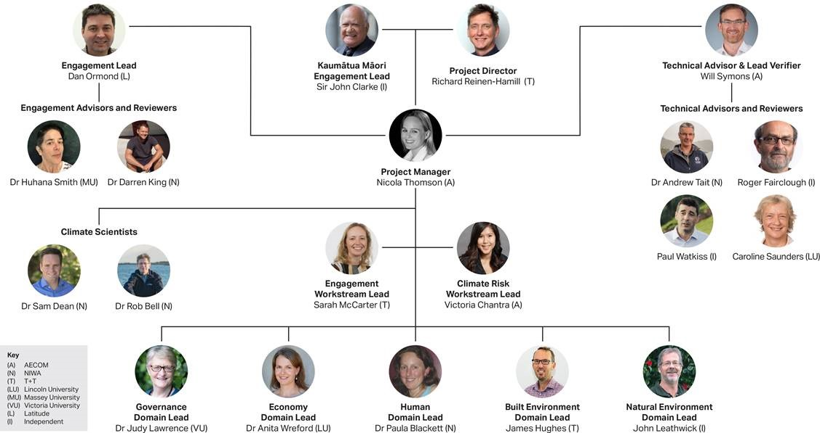

The application of urgency ratings in the NCCRA draws on the UK Climate Change Risk Assessment 2017 but differs in how it developed the urgency profiles. A full description of this method is in section 2.4.2.
Radiative forcing is the change in the net, downward minus upward, radiative flux (expressed in Watts per square metre; W m⁻²) at the tropopause or top of atmosphere due to a change in an external driver of climate change, such as a change in the concentration of carbon dioxide (CO₂) or the output of the sun (IPCC, 2014b).
Adaptation that does not constitute a conscious response to climatic stimuli but is triggered by ecological changes in natural systems and by market or welfare changes in human systems. Also referred to as spontaneous adaptation (Ministry for the Environment, 2019).
See, for example, https://www.health.govt.nz/our-work/populations/Māori-health/Māori-health-models/Māori-health-models-te-whare-tapa-wha.

