# Aotearoa New Zealand climate change projections guidance

Interpreting the latest IPCC WG1 report findings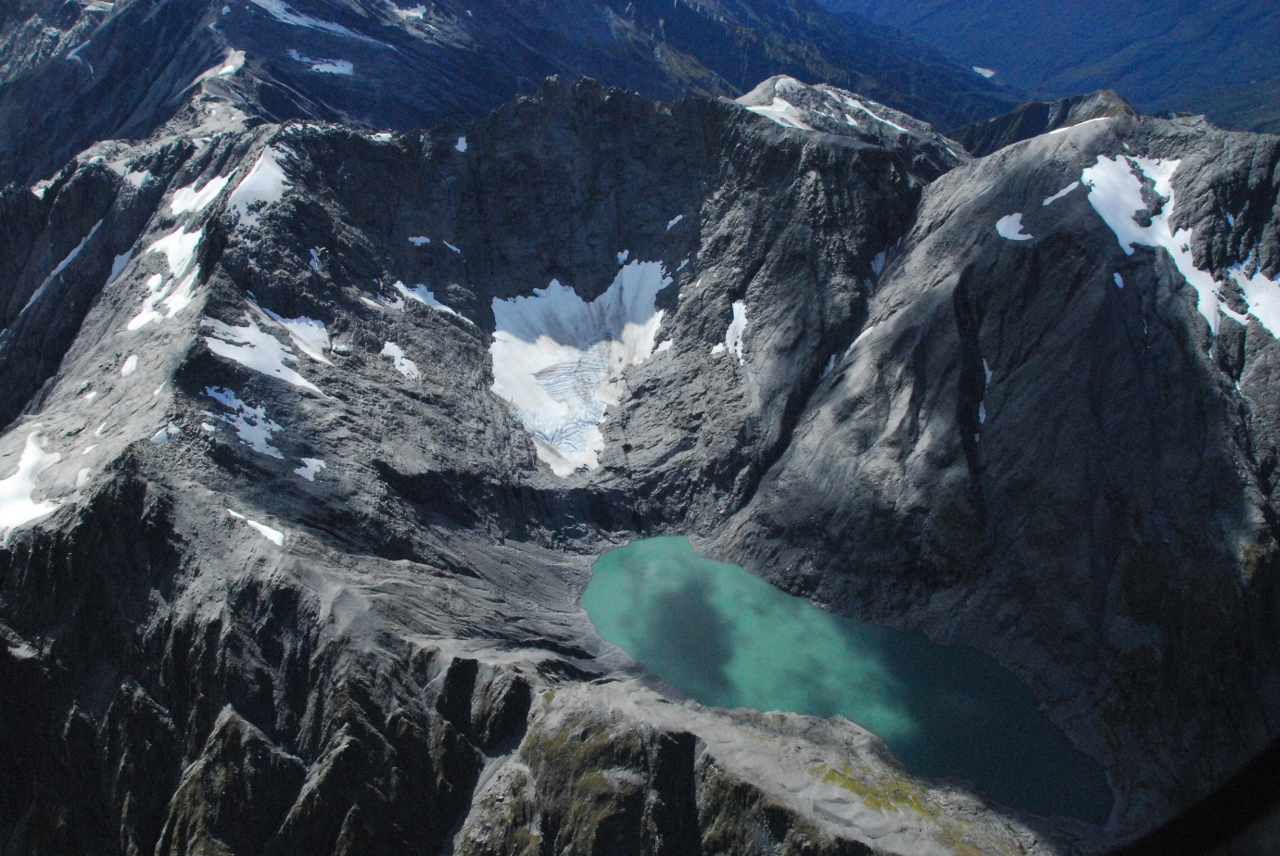

**Disclaimer**

© All rights reserved. The copyright and all other intellectual property rights in this report remain vested solely in the organisations listed in the author affiliation list.

The organisations listed in the author affiliation list make no representations or warranties regarding the accuracy of the information in this report, the use to which this report may be put or the results to be obtained from the use of this report. Accordingly the organisations listed in the author affiliation list accept no liability for any loss or damage (whether direct or indirect) incurred by any person through the use of or reliance on this report, and the user shall bear and shall indemnify and hold the organisations listed in the author affiliation list harmless from and against all losses, claims, demands, liabilities, suits or actions (including reasonable legal fees) in connection with access and use of this report to whomever or how so ever caused.

When quoting, citing or distributing this report or its individual sections, please provide the full reference: *Bodeker, G., Cullen, N., Katurji, M., McDonald, A., Morgenstern, O., Noone, D., Renwick, J., Revell, L. and Tait, A. (2022). Aotearoa New Zealand climate change projections guidance: Interpreting the latest IPCC WG1 report findings. Prepared for the Ministry for the Environment, Report number CR 501, 51p.*

**Acknowledgements**

Prepared for the Ministry for the Environment by a consortium consisting of (listed alphabetically): Bodeker Scientific Ltd (Dr Greg Bodeker), National Institute for Water and Atmospheric Research (NIWA; Dr Andrew Tait and Dr Olaf Morgenstern), University of Auckland (Dr David Noone), University of Canterbury (Dr Laura Revell, Dr Adrian McDonald and Dr Marwan Katurji), University of Otago (Dr Nicolas Cullen) and Victoria University of Wellington (Dr James Renwick).

*Funding was provided by the New Zealand Ministry for the Environment (contract number 24765).*

*Cover image: Ivory Glacier, Southern Alps, taken during the annual end of summer snowline survey in March 2022 by Gregor Macara, NIWA.*

Published in April 2022 and updated in February 2023

This document is available on the Ministry for the Environment website: [environment.govt.nz](http://www.environment.govt.nz).

# Executive summary

This report distils and interprets information relevant to Aotearoa New Zealand from the Working Group 1 (WG1) contribution to the Intergovernmental Panel on Climate Change (IPCC) Sixth Assessment Report (AR6) titled ‘The Physical Science Basis’, published in August 2021.

The key findings are:

* The mean global warming from 1850-1900 up to 2011-2020 is 1.09°C.
* We are getting closer to crossing the Paris Agreement thresholds of 1.5 and 2°C.
* Future effects of the El Niño Southern Oscillation (ENSO) cycle upon New Zealand climate are not expected to change significantly this century. The future of trends in the Southern Annular Mode (SAM) and the location of the mid-latitude jet stream depend on greenhouse gas mitigation action and how quickly the ozone hole recovers.
* Evidence of observed changes in extreme weather events and their attribution to human influence has strengthened since the IPCC’s Fifth Assessment Report (AR5).
* The evidence for warming in New Zealand continues to build. New Zealand experienced its warmest year on record in 2021, surpassing the previous record set in 2016. Seven of the past nine years have been among New Zealand’s warmest on record.
* Unlike AR5 which used Representative Concentration Pathways (RCPs), the AR6 relied on Shared Socioeconomic Pathways (SSPs) to produce projections of future climate change. In contrast to the RCPs, the SSPs developed for AR6 were designed such that the emission scenarios originate from a wide array of socioeconomic drivers.
* An increase of mean air temperature of +1.0°C (0.60 to 1.32°C, 10-90 percentile range) relative to 1995-2014 is projected by mid-century for the New Zealand region (over land and sea), and an increase of +1.6°C (1.03 to 2.26°C) by end century under SSP2-4.5. For SSP5-8.5, the projected increase in mean air temperature is +1.3°C (0.91 to 1.66°C) and +3.1°C (2.20 to 4.05°C 10-90 percentile range) relative to 1995-2014 by mid and end century, respectively.
* Annual rainfall patterns are expected to change, with increases projected in the west and south of New Zealand. Projected winter and spring rainfall follow the annual increase in the west and south, but with less rainfall in the east and north. More summer rainfall is expected in the east of both islands, with less in the west and central North Island.
* River flooding, drought severity and fire weather are projected to increase in most areas of the country.
* Glacier volume between 1978 and 2020 decreased from 53.3 km3 to 34.6 km3 (a loss of 35%). Relative to 2015, glaciers in New Zealand are projected to lose 36 ± 44%, 53 ± 33%, and 77 ± 27% of their mass by the end of the century under the AR5 emission scenarios RCP2.6, RCP4.5, and RCP8.5, respectively.
* Marine heatwaves are expected to increase over the 21st century. If emissions are high in the future, median marine heatwave intensities could increase between 80 and 100% by the end of the century and conditions that we refer to as marine heatwaves today could become permanent year-round by the end of the century.
* The availability of updated global model data from the Coupled Model Intercomparison Project Phase 6 (CMIP6) ensemble provides a significant opportunity for producing updated regional climate change projections for New Zealand. This work is underway, with output data to be published in 2024 and assessments to follow shortly thereafter. Presentation of information should include projected climate changes in future time periods and changes relative to global warming levels.
* Until the CMIP6-based regional downscaling is completed, regional climate model projections reported in Ministry for the Environment (2018): *Climate Change Projections for New Zealand* can continue to be used with reasonable confidence as new knowledge from AR6 will most likely not fundamentally change the existing projections.

# Contents

Executive summary 3

Introduction and purpose 6

Section 1: New information from the IPCC AR6 WG1 report 8

1.1 Changes to statements of confidence since AR5 9

1.2 The development and use of SSP scenarios and a comparison to RCPs 11

1.3 Updates to projected global mean warming and equilibrium climate sensitivity 13

1.4 The presentation of climate projections in AR6 associated with global warming levels 16

1.5 Advances in global climate model performance since CMIP5 18

1.6 A comparison of projected large-scale climate patterns 20

1.7 Improvements in understanding and attributing extremes 23

Section 2: Trends and projections of New Zealand climate from AR6 WG1 and other recent studies 25

2.1 Mean air temperature 26

2.2 Hot extremes 28

2.3 Cold extremes 28

2.4 Precipitation 29

2.5 Flooding and landslides 30

2.6 Aridity and drought 31

2.7 Glaciers and seasonal snow 31

2.8 Wind 33

2.9 Tropical cyclones 33

2.10 Fire 33

2.11 Sea surface temperature (SST) 33

2.12 Groundwater 34

Section 3: Does this new information change what we know? 36

3.1 Can the existing New Zealand climate change projections still be used? 37

3.2 Advancing attribution science in New Zealand between AR5 and AR6 38

3.3 What might change when the new downscaling is completed? 39

3.4 Annual/seasonal variability, extremes and associated uncertainty 40

Glossary of abbreviations and terms 42

References 44

# Introduction and purpose

In August 2021 the Intergovernmental Panel on Climate Change (IPCC) published its Working Group 1 (WG1) contribution to the 6th Assessment Report (AR6) (IPCC, 2021). This WG1 report, titled ‘The Physical Science Basis’, addresses:

“the most up-to-date physical understanding of the climate system and climate change, bringing together the latest advances in climate science, and combining multiple lines of evidence from paleoclimate, observations, process understanding, and global and regional climate simulations.”

The WG1 report utilized output from a suite of updated Global Climate Models and Earth System Models (collectively referred to from here on as global climate models). These models are collated and managed by the World Climate Research Programme (WCRP) in the Coupled Model Intercomparison Project Phase 6 (CMIP6). While the WG1 report is predominantly a global assessment, it does include some global-regional (e.g. Africa, Europe, Australasia) scale summary information. There is also an associated online interactive atlas[1] where it is possible to access and download CMIP6 data, maps and graphs averaged over the New Zealand/Tasman Sea region. However, the WG1 report and the atlas provide limited information on projected climate change for Aotearoa New Zealand at the scale useful for local assessments (i.e. to a spatial resolution of a few kilometres).

In New Zealand, the National Institute of Water and Atmospheric Research Ltd (NIWA) undertakes a Regional Climate Modelling (RCM) science programme. The purpose of the RCM programme is to downscale coarse-resolution global climate model output to a resolution useful for local-scale analyses (usually ~5km). Downscaling is performed using a physically realistic regional climate model of moderate spatial resolution (previously this has been 30km, but the updated model now runs at 12km) and then further statistically downscale the dynamic model output[2].

New Zealand local-scale climate projections are produced two to three years after each IPCC WG1 report is published, due to the time-consuming nature of this work. For example, the previous IPCC WG1 report for the 5th Assessment Report (AR5) was published in late 2013. RCM-based outputs for New Zealand were produced by NIWA in 2015 and associated maps and descriptions were published in the Ministry for the Environment report ‘Climate Change Projections for New Zealand’ in 2016 with an updated report in 2018 (MfE, 2018). A similar timeframe is expected for the downscaled CMIP6 projections, with output data to be published in 2024 and assessments to follow shortly thereafter.

This interim document:

* distils New Zealand-relevant information from the IPCC AR6 WG1 report
* identifies similarities or differences from information provided in previous IPCC reports (e.g. AR5) and
* explores if and how the information in the AR6 WG1 report may affect the utility of existing New Zealand-specific AR5-based climate change projections utilising regional downscaling methods (e.g. as presented in MfE, 2018).

It must be noted that all information and conclusions presented in this document are based on interpretation of CMIP6 global model data and related publications only. A comprehensive assessment of the impact of the latest global climate models for New Zealand can only be made once the regional climate modelling work has been completed.

We also note that this document is published alongside updated sea-level rise information being prepared separately.

# Section 1: New information from the IPCC AR6 WG1 report

### Key findings

1. The use and application of confidence language in the IPCC Sixth Assessment Report (AR6) is consistent overall with the usage in the IPCC Fifth Assessment Report (AR5). In the period from AR5 to AR6, many processes have become better understood and modelled, and all observational time series have been lengthened by 7-8 years, giving more certainty and significance to many observed trends.
2. Unlike AR5 which used Representative Concentration Pathways (RCPs), the AR6 relied on Shared Socioeconomic Pathways (SSPs) to produce projections of future climate change. In contrast to the RCPs, the SSPs developed for AR6 were designed such that the emission scenarios originate from a wide array of socioeconomic drivers. While some of the SSP-based scenarios and RCPs reach the same radiative forcing by 2100 (e.g., SSP2-4.5 and RCP4.5), the greenhouse gas concentration pathways taken to reach that radiative forcing are not necessarily the same.
3. AR6 presents slight increases in the best-estimates for global warming, but the uncertainty ranges overlap comfortably with those from AR5. There is a change in the uncertainty ranges from *likely* in AR5 to *very likely* in AR6 as the SSP-based projections are subject to substantially smaller uncertainties than the RCP-based ones.
4. These results are consistent with the unchanged recommended Equilibrium Climate Sensitivity (ECS) – the warming realised in climate model experiments after instantaneously doubling the carbon dioxide (CO2) concentration from its preindustrial value.
5. In terms of the already-realised warming since 1850-1900, AR5 reported a 0.78 °C increase in temperature up to 2003-2012, which has been revised by 0.31 °C to a 1.09 °C increase in temperature up to 2011-2020. The reasons for the 0.31°C increase include methodological changes, the assessed global-mean surface temperature of the preindustrial period (1850-1900) decreasing, and significant ongoing warming since 2003-2012 of around 0.19°C up until 2011-2020.
6. Because of the larger assessed warming we are now closer to crossing the Paris Agreement global warming thresholds of 1.5 and 2°C.
7. A global warming level does not by itself define the state of global change. The pathway to a warming level must be considered, including the time period involved (especially for slower components of the climate system such as ice mass and sea level), and the trade-offs between warming effects from greenhouse gases and cooling effects of aerosols and land-use change.
8. The Paris Agreement is framed using global warming levels, providing the underpinning for international negotiation around mitigation action.
9. The advances in performance of the global climate models assessed in AR6 are substantial. However, some weaknesses remain that will likely be important for future climate projections of New Zealand. Among these are ongoing difficulties simulating Antarctic sea ice, persistent warm biases of Southern Ocean sea-surface temperature and a large majority of CMIP6 models not featuring interactive ozone chemistry.
10. The difference in behaviour between global models that include and exclude atmospheric chemistry implies that care must be used in selecting models for New Zealand downscaling.
11. Future effects of the El Niño Southern Oscillation (ENSO) cycle (and associated longer term Pacific Decadal Variability; PDV) upon New Zealand climate are not expected to change significantly this century, as concluded in the AR5. The future of trends in the Southern Annular Mode (SAM) and the associated location of the mid-latitude jet stream depends on how rapid mitigation action is this century and how quickly the ozone hole recovers. This adds uncertainty to New Zealand climate projections, as rapid mitigation (to meet the goals of the Paris Agreement) would likely be associated with a negative trend in the SAM in summer, and increased winds and storminess. Conversely, a failure to mitigate would be associated with lighter winds and drier/warmer conditions over New Zealand in all seasons.
12. Evidence of observed changes in extreme weather events and their attribution to human influence (including greenhouse gas and aerosol emissions, and land-use changes) has strengthened since AR5, in particular for extreme precipitation, droughts, tropical cyclones and compound extremes (including dry/hot events and fire weather).

## 1.1 Changes to statements of confidence since AR5

The use and application of confidence language in the AR6 is consistent overall with the usage in the AR5. In the period from the AR5 to the AR6, many processes have become better understood and modelled, and all observational time series have been lengthened by 7-8 years, giving more certainty and significance to many observed trends. As a result, confidence statements have often been strengthened in the AR6 compared to the AR5.

For example, the AR6 has the statements:

“It is unequivocal that human influence has warmed the atmosphere, ocean and land”

and

“Human influence has warmed the climate at a rate that is unprecedented in at least the last 2000 years”

compared with the AR5 statements:

“Human influence on the climate system is clear”

and

“It is *extremely likely* that human influence has been the dominant cause of the observed warming since the mid-20th century”.

In particular, evidence has strengthened considerably around extreme events and the attribution of such events to human-induced climate change.

The AR6 SPM states:

“Human-induced climate change is already affecting many weather and climate extremes in every region across the globe.”

while the corresponding AR5 statement is:

“Human influence has been detected in … changes in some climate extremes.”

|  |
| --- |
| **What do IPCC levels of confidence and likelihood mean?**  In the IPCC reports, confidence is expressed qualitatively and tells us how certain we are that scientific findings are valid. The level of confidence is determined by the type, amount, quality and consistency of evidence.    The certainty of scientific findings is then described using likelihoods. Findings are assessed probabilistically using observations, modelling results or expert judgement.    These definitions of confidence and certainty are used throughout this report, with all statements italicised in the text. |

Looking in detail, not all aspects of the changing climate are more definitely understood, especially at the regional level. The future of the ENSO cycle remains uncertain, as do its effects upon the Aotearoa New Zealand region. However, ENSO and its teleconnections are expected to continue as a dominant feature of climate variability.

The SAM will continue to dominate climate variability in the Southern Hemisphere on scales from weeks to seasons, but its future behaviour is also uncertain (see Section 1.6). The future of the SAM and its effects upon New Zealand weather and climate depends on how climate change mitigation actions play out this century.

## 1.2 The development and use of SSP scenarios and a comparison to RCPs

To produce projections of future climate change, global climate models require future scenarios of greenhouse gas and aerosol concentrations. Scenarios are not predictions; rather they provide information on what could happen were certain developments to occur (Moss *et al*., 2010). Unlike the IPCC AR5 which used Representative Concentration Pathways (RCPs), the AR6 relied on Shared Socioeconomic Pathways (SSPs).

The RCPs characterise a range of potential greenhouse gas and aerosol concentration pathways (Moss *et al*., 2010, van Vuuren *et al*., 2011). Four RCPs were examined in IPCC AR5, namely RCP2.6, RCP4.5, RCP6.0 and RCP8.5. Each RCP is named for the end-of-21st-century radiative forcing reached; e.g. RCP2.6 assumes a radiative forcing of 2.6 W m2 in 2100. The RCPs do not account for socioeconomic developments; rather they focus only on changes in atmospheric composition.

In contrast to the RCPs, the SSPs developed for the IPCC AR6 were designed such that the emission scenarios originate from a wide array of socioeconomic drivers. These include population growth, technological development and economic development. The resulting emissions scenarios represent narratives for energy use, air pollution control, land use and greenhouse gas emissions. The SSP narratives are ‘sustainability’ (SSP1), ‘middle of the road’ (SSP2), ‘regional rivalry’ (SSP3), ‘inequality’ (SSP4) and ‘fossil-fuel intensive development’ (SSP5). Further details are given by O’Neill *et al*. (2017) and Riahi *et al*. (2017).

For the Working Group 1 (WG1) contribution to the IPCC AR6, the SSPs were combined with the RCPs to produce the following five scenarios which span a range of plausible societal and climatic futures:

* SSP1-1.9
* SSP1-2.6
* SSP2-4.5
* SSP3-7.0
* SSP5-8.5

In SSP1-1.9, the ‘1’ refers to the socioeconomic narrative (SSP1), and the ‘1.9’ represents the end-of-21st-century radiative forcing. Global climate models were run with these scenarios to project future climate change (O’Neill *et al*., 2016), and the resulting model output can be used to assess potential climate impacts and risks.

While some of the SSP-based scenarios and RCPs reach the same radiative forcing by 2100 (e.g. SSP2-4.5 and RCP4.5, the greenhouse gas concentration pathways taken to reach that radiative forcing are not necessarily the same. For example, the SSPs feature a larger maximum concentration of carbon dioxide (CO2), with the CO2 concentration in SSP5-8.5 approximately 200 ppm larger in 2100 compared to RCP8.5 (Figure 1). Aerosol emissions also differ between the two sets of scenarios: the RCPs featured uniformly low aerosol pathways across all scenarios, while the SSPs include a range of aerosol pathways, most notably SSP3-7.0, which represents large aerosol emissions. SSP3-7.0 and SSP5-8.5 can be considered as ‘no-climate policy’ scenarios, noting however that greenhouse gas and aerosol emissions in alignment with SSP5-8.5 are considered unlikely due to developments in the energy sector (Hausfather and Peters, 2020).

The SSPs also include a very low climate change mitigation scenario (SSP1-1.9), which features reduced energy use, a rapid shift away from traditional fossil fuel use, and CO2 removal. SSP1-1.9 can be used with SSP1-2.6 to explore the different outcomes of 1.5 °C and 2 °C of global warming, respectively, in alignment with the goals of the Paris Agreement (Rogelj *et al*., 2018).

Figure 1: Global-, annual-mean greenhouse gas concentrations in the Shared Socioeconomic Pathways (SSPs, solid lines) and Representative Concentration Pathways (RCPs, dashed lines). Data sourced from Meinshausen *et al*. (2011) and Meinshausen *et al*. (2020).

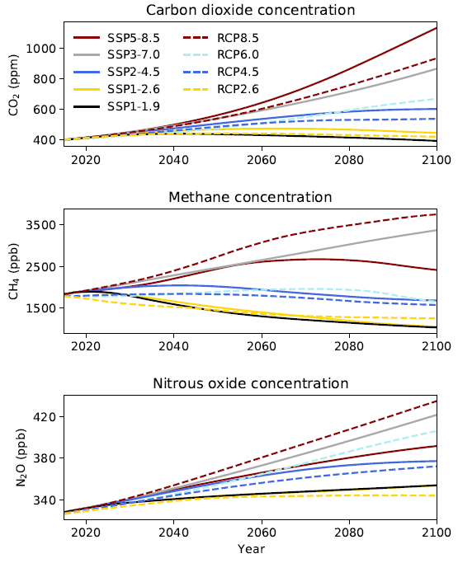

## 1.3 Updates to projected global mean warming and equilibrium climate sensitivity

The IPCC AR6 WG1 report presents projected changes in the global climate corresponding to several Shared Socioeconomic Pathways (SSPs). Noting that AR6 SSPs and AR5 RCPs are not strictly comparable (see section 1.2), the global mean warming projections compare as follows:

Table 1: Projected global mean warming in 2081-2100, relative to 1850-1900, in AR5 and AR6. The AR5 values are originally relative to the mean temperature of 1986-2005. Following AR5, 0.6°C has been added to represent warming between 1850-1900 and 1986-2005. ‘SPM’ refers to the WG1 Summary for Policymakers reports for AR5 and AR6.

| End-of-century nominal radiative forcing (Wm-2) | Warming in 2081-2100 (°C) under RCP scenarios (likely range; AR5 table SPM.2) | Warming in 2081-2100 (°C) under SSP scenarios (very likely range; AR6 SPM table B.1.2) |
| --- | --- | --- |
| **1.9** |  | 1.4 (1.0-1.8) |
| **2.6** | 1.6 (0.9-2.3) | 1.8 (1.3-2.4) |
| **4.5** | 2.4 (1.7-3.2) | 2.7 (2.1-3.5) |
| **7.0** |  | 3.6 (2.8-4.6) |
| **8.5** | 4.3 (3.2-5.4) | 4.4 (3.3-5.7) |

Table 1 shows that AR6 presents very slight increases in the best-estimate global warming, but the uncertainty ranges overlap comfortably with those from AR5. Noting the change in the uncertainty ranges from *likely* in AR5 to *very likely* in AR6, the SSP-based projections are subject to substantially smaller uncertainties than the RCP-based ones.

These results are consistent with the unchanged recommended equilibrium climate sensitivity (ECS) – the warming realised in climate model experiments after instantaneously doubling the CO2 concentration from its preindustrial value. The AR6 assesses the ECS to be 3°C, which is in the middle of the AR5 likely range (1.5-4.5°C); however, AR6 finds a narrower uncertainty range than AR5 (Figure 2).

|  |
| --- |
| **What is the Equilibrium Climate Sensitivity (ECS)?**  The ECS is defined as the warming ensuing from a hypothetical doubling of CO2 above its preindustrial concentration of around 270 parts per million (i.e. 270 molecules of CO2 in every million molecules of air). In climate model experiments, this doubling triggers a multi-century warming of several degrees; the slow response is due to the time it takes for the warming to reach the deep ocean. This concept was first introduced by Swedish physicist Svante Arrhenius in 1896 and has played a central role in climate science ever since, including in all six IPCC climate reports which have appeared thus far. |

Figure 2: Climate sensitivity and future warming. Left: Equilibrium climate sensitivities for the current CMIP6 and the previous CMIP5 generations of climate models, and the best estimate and *very likely* range as assessed in IPCC AR6. Right: Same, but for the end-of-century (2081-2100) warming under the RCP8.5 and SSP5-8.5 scenarios, respectively. (reproduced from IPCC AR6, FAQ 7.3, figure 1).

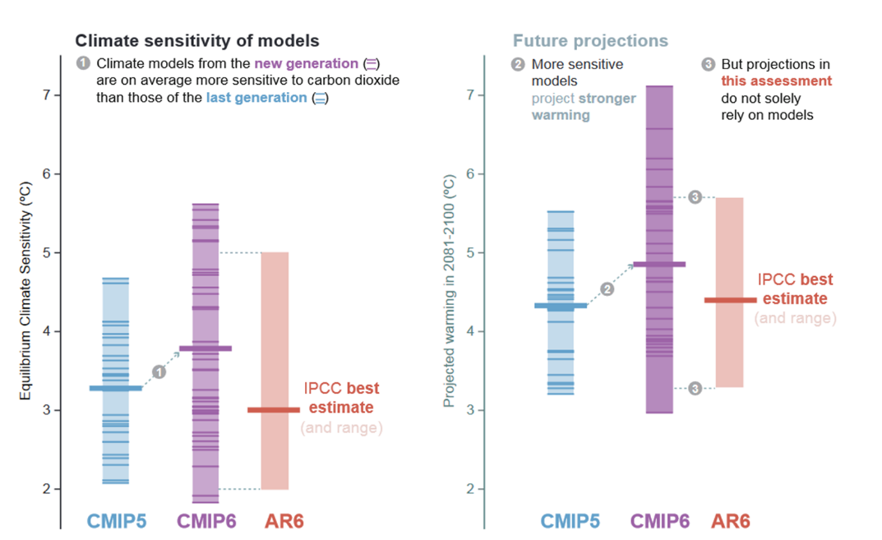

Climate models with a large ECS usually produce a larger end-of-century warming than others with a medium or small ECS. The AR6 discusses at length the presence of several models in the CMIP6 ensemble with ECSs larger than 4.5°C. Amongst other lines of evidence, large-ECS models tend to:

(a) overestimate the global-mean surface temperature derived from geological evidence for periods of the Earth’s geological past with much higher CO2 levels than at present, such as the Early Eocene Climate Optimum

(b) underestimate the temperature during low-CO2 epochs, such as the Last Glacial Maximum, and

(c) often produce faster warming for the post-1975 period than observed.

Using such information about the ECS, in calculating assessed end-of-century warming, AR6 effectively downweighs large-ECS models in the CMIP6 ensemble. This ensures the assessed 21st century warmings are only slightly larger than, and indistinguishable within the uncertainties from, the AR5 values.

In terms of the already-realised warming since 1850-1900, AR5 reported a 0.78°C increase in temperature up to 2003-2012. This has been revised upwards by 0.31°C to a 1.09°C increase in temperature up to 2011-2020 (Chapter 2 of AR6). The reasons for this increase of 0.31°C include methodological changes, the assessed global-mean surface temperature of the preindustrial period (1850-1900) decreasing, and significant ongoing warming since 2003-2012 of around 0.19°C up until 2011-2020. The slightly lower mean temperature for the historical reference period is due to new datasets (including more digitised historical ship log data) informing the assessment.

As a consequence of the larger assessed warming, we are now closer to crossing the Paris Agreement thresholds of 1.5 and 2°C, implying reduced remaining carbon budgets consistent with those global warming targets (Cross-Chapter Box 2.3 of Chapter 2, AR6). Of the scenarios considered in AR6, only the high-mitigation scenario SSP1-1.9 will *more likely than not* result in end-of-century warming of less than 1.5°C. This scenario involves substantial net CO2 sequestration in the second half of this century, causing a cooling trend.

## 1.4 The presentation of climate projections in AR6 associated with global warming levels

A global warming level, for example 1.5°C above average pre-industrial temperatures, does not by itself define the state of global change. The pathway to that warming level, the time period involved (especially for slow components of the climate system such as ice mass and sea level), and the trade-offs between warming effects from greenhouse gases and cooling effects of aerosols and land-use change must be considered. However, and thanks to advances in quantifying or overcoming the above issues, global warming levels provide a robust and useful integration mechanism. They facilitate knowledge from different domains to be integrated and communicated.

Global warming levels are the way that the Paris Agreement is framed, and so provide the underpinning for international negotiation around mitigation action. Hence, the 1.5°C and 2°C warming levels are relevant to thinking around the Paris Agreement and individual country’s Nationally Determined Contributions (NDCs). Many regional climate effects have also been found to be close to linearly related to the level of global warming. Moreover, the “Reasons for Concern” discussed in several IPCC Assessment Reports are related to specific global warming levels and thresholds (for example, see the Working Group 2 contribution to AR6, Australasia Chapter 11[3], Figure 11.6). Lastly, use of global warming levels facilitates the comparison of current and past results from climate model projections which may be based on different sets of greenhouse gas and aerosol emissions scenarios. An example of a warming-level representation of global change in temperature is shown in Figure 3.

Figure 3: Projected spatial patterns of change in annual average near-surface temperature (°C) at different levels of global warming. Displayed are (a–d) spatial patterns of change in annual average near-surface temperature at 1.5°C, 2°C, 3°C, and 4°C of global warming relative to the period 1850–1900 and (e–g) spatial patterns of differences in temperature change at 2°C, 3°C, and 4°C of global warming compared to 1.5°C of global warming. The number of models used is indicated in the top right of the maps. No overlay indicates regions where the change is robust and likely emerges from internal variability, that is, where at least 66% of the models show a change greater than the internal-variability threshold (see Section 4.2.6) and at least 80% of the models agree on the sign of change. Top-left to bottom-right hatching indicates regions with no change or no robust significant change, where fewer than 66% of the models show change greater than the internal-variability threshold. Cross-hatching indicates areas of conflicting signals where at least 66% of the models show change greater than the internal-variability threshold but fewer than 80% of all models agree on the sign of change. Values were assessed from a 20-year period at a given warming level, based on model simulations under the Tier-1 SSPs of CMIP6. From IPCC AR6 WG1 Report, Figure 4.31.

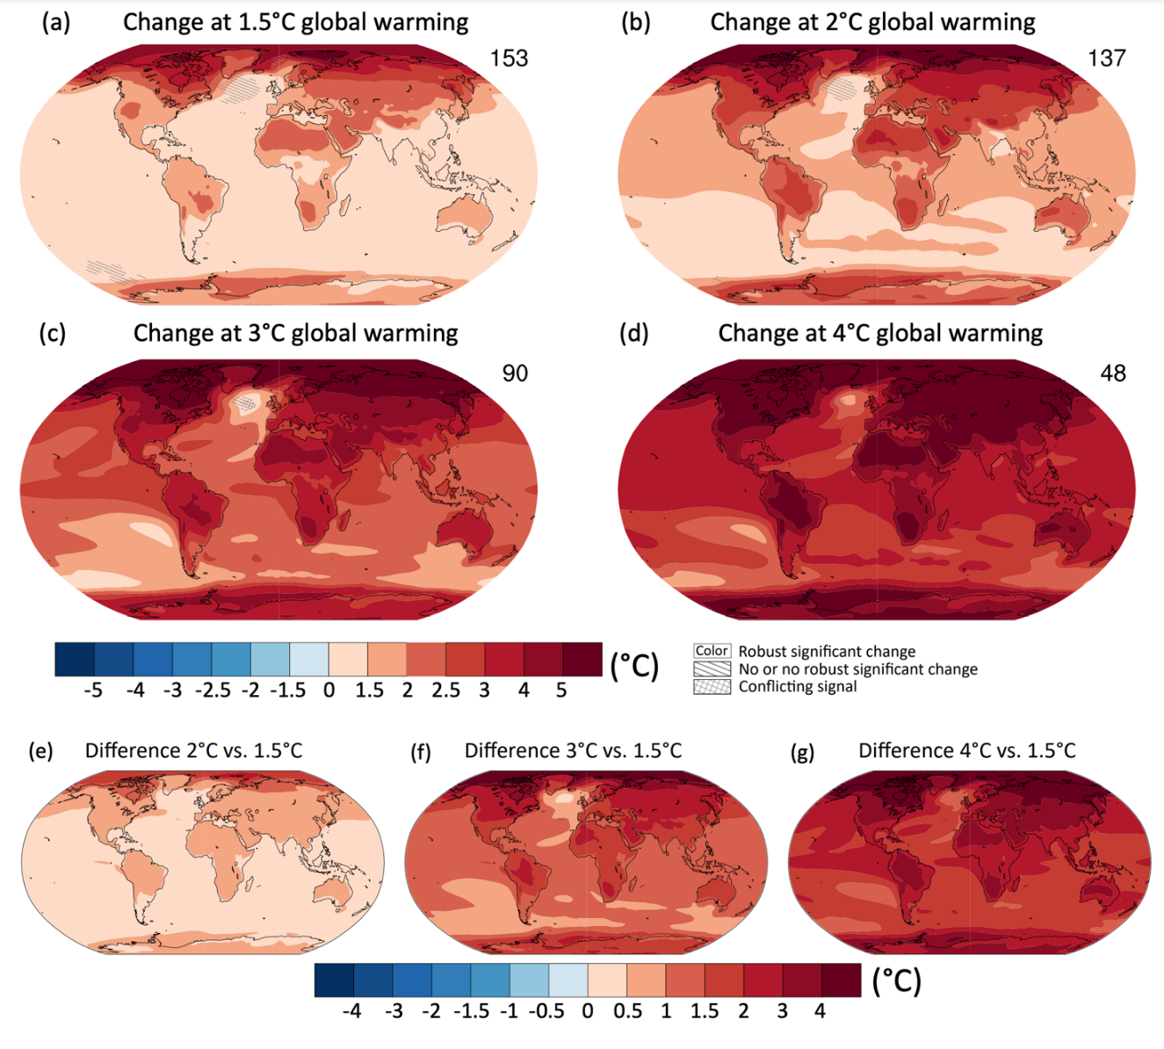

How particular global warming levels compare to time slices from SSP-based scenarios, and what the time frames are for specific warming levels, depends on the scenario under consideration and the implied rate of emission of greenhouse gases, i.e. on the strength of the human forcing on the climate system. For warming levels of 2°C or more above pre-industrial levels, CMIP6 models suggest that the lowest emissions scenarios (SSP1-1.9 and SSP1-2.6) may not reach such a warming level at all. As the level of emissions increases through the scenarios, the time frames decrease accordingly, and the level of certainty for a given warming level increases.

For example, using CMIP6 model results summarised in the AR6, over the near term (2021–2040), a 1.5°C increase in the 20-year average of surface temperatures (relative to the average over the period 1850–1900) is:

* *very likely* to occur in scenario SSP5-8.5
* *likely* to occur in scenarios SSP2-4.5 and SSP3-7.0, and
* *more likely than not* to occur in scenarios SSP1-1.9 and SSP1-2.6.

In all scenarios assessed (except SSP5-8.5), the central estimate of crossing the 1.5°C threshold lies in the early 2030s, about 10 years earlier than the midpoint of the likely range (2030–2052) assessed in the IPCC Special Report on 1.5°C. For 2°C warming, this occurs on average during the 2040s under SSP2-4.5, the late 2030s under SSP3-7.0, and the early 2030s under SSP5-8.5. The 3°C level of global warming is estimated to be reached after 2100 under SSP2-4.5, in the 2060s under SSP3-7.0, and during the 2050s under SSP5-8.5.

## 1.5 Advances in global climate model performance since CMIP5

Global climate models are assessed on how well they simulate climate characteristics such as pressure, temperature, rainfall and wind, relative to global observations. There has been an increase in model performance across almost all CMIP6 models from previous model generations. This goes for models with any ECS, noting that ECS itself is not a metric used for model performance evaluation. For the metrics of mean climate used in Figures 3.42 and 3.43 of AR6, CMIP6 models (i.e. the latest generation) clearly outperform the earlier CMIP3 and CMIP5 generations. The skill is dependent on the variable in question, with precipitation remaining relatively difficult to simulate correctly.

The improved global models include several previously used in regional climate modelling for New Zealand (MfE, 2018) versus their CMIP6 counterparts. Examples include the Hadley Centre model (HadGEM2-ES versus HadGEM3-GC31-LL), the Community Earth System Model (CESM1-CAM5 versus CESM2), the Geophysical Fluid Dynamics Laboratory models (GFDL-CM3 versus GFDL-CM4) and the Norwegian Earth System Model (NorESM1-M versus NorESM2-MM). However, some poor performers remain in the CMIP6 ensemble. Hence, for assessing New Zealand or any other regional climate, conducting a suitable pre-selection of models remains important, including accounting for the large-ECS models discussed in Section 1.3.

AR6 highlights several linked biases (Kajtar *et al*., 2021) and problems with models used in that report that affect projections of New Zealand climate. Some of these specific issues are briefly discussed below:

* Antarctic sea ice: CMIP5 models generally projected decreasing Antarctic sea ice extent, whereas sea ice extent, in the decades before 2012, actually increased. This discrepancy remains in the CMIP6 models. Several studies cited in AR6 associate this increase with anomalous atmospheric circulation. Since 2016, there has been a series of years with low sea ice extent. CMIP6 models generally simulate neither the earlier increase nor the subsequent drop in sea ice extent. Therefore, even though simulated mean sea ice concentration fields have become more realistic between CMIP5 and CMIP6, AR6 expresses *low confidence* in the simulation of Antarctic sea ice across the CMIP6 ensemble.
* Zonal-mean sea-surface temperature biases have increased slightly in the Southern Hemisphere extra-tropics, compared to CMIP5 (Figure 3.24a of AR6 WG1). This may be indicative of continuing deficits in climate physics affecting this region.
* AR5 had identified a major issue with clouds over the Southern Ocean, whereby too much shortwave (visible) radiation was hitting the ocean surface, contributing about 70% to the warm sea surface temperature (SST) bias (Hyder *et al*., 2018). This pervasive CMIP5 model problem is not explicitly discussed in AR6. Other literature suggests though that, at least in some models, this is now a less prevalent problem because several modelling centres have made changes to their models, essentially increasing simulated cloud brightness. However, these changes are now the leading reason for the improbably large ECSs in several models (Bodas-Salcedo *et al*., 2019; Zelinka *et al*., 2020; Section 1.3), meaning that Southern Ocean clouds remain an active target for international and New Zealand research.
* The mean Southern Hemisphere westerly jet, including recent tropospheric trends, is well reproduced in CMIP6 models (AR6 WG1, Figure 3.19). This had not been evaluated in AR5. However, earlier literature (Ceppi *et al*., 2012) established an anticorrelation between the shortwave cloud forcing in Southern mid-latitudes (effectively the change in albedo due to clouds) and the mean latitude of the westerly jet. On average, in CMIP5 models the jet is placed 1.9° too far towards the equator. This bias is reduced to about 0.4° (Bracegirdle *et al*., 2020; Goyal *et al*. 2021) – this is a critical advance with respect to New Zealand climate projections. However, while the inter-model spread has been reduced from CMIP5 it remains substantial (Bracegirdle *et al*., 2020), so a suitable selection of models for downscaling remains critical.
* The SAM is the leading pattern of climate variability in the Southern Hemisphere extra-tropics (see Section 1.6). In its positive phase, it is characterised by positive pressure anomalies in mid-latitudes and low pressure over the Antarctic continent. AR6 finds that anthropogenic influences, in the forms of increasing greenhouse gases and ozone depletion, have driven a strengthening of the SAM (a shift towards its positive state) during austral summer. Morgenstern (2021) finds that in models that include interactive ozone chemistry, the strengthening in summer is almost exclusively driven by ozone depletion, implying that 21st century ozone recovery may shift SAM towards a more negative state than would be the case in no-chemistry models. Revell *et al*. (2022) find that there is a discrepancy between models with and without interactive ozone chemistry. Models without chemistry use ozone fields derived from the RCP scenario simulations of CMIP5, whereas chemistry models use SSP forcing. Particularly for the no-mitigation scenarios RCP8.5/SSP5-8.5, the substantially larger positive trends in Antarctic total-column ozone during the 21st century in the chemistry models translate into a much smaller strengthening of westerly winds over the Southern Ocean in those models than in the no-chemistry models characterized by relatively weak ozone recovery.

In summary, model progress as assessed in AR6 is substantial and affects practically all aspects of global climate model performance. However, some weaknesses remain that are of importance with respect to New Zealand climate projections. Amongst these are continuing difficulties simulating Antarctic sea ice, persistent warm biases of Southern Ocean sea-surface temperature (perhaps indicative of missing or deficient ocean physics), and a large majority of CMIP6 models not featuring interactive ozone chemistry (with the few that do in some cases simulating unrealistic historical ozone trends; Morgenstern *et al*., 2020, 2021). Furthermore, the findings by Revell *et al*. (2022) on the difference in behaviour between chemistry and no-chemistry models implies that care must be used in selecting models for New Zealand downscaling. This feature is most prominent for the scenario SSP5-8.5.

## 1.6 A comparison of projected large-scale climate patterns

The two key large-scale patterns of climate variability that affect New Zealand on the seasonal-to-interannual time scale are the ENSO and the SAM. On longer time scales, PDV modulates the behaviour of the ENSO cycle and hence influences New Zealand climate over time scales of decades. Regional SSTs and the location of the mid-latitude jet stream also affect New Zealand weather and climate. We discuss each of these patterns in turn.

### El Niño-Southern Oscillation (ENSO)

ENSO is based in the tropical Pacific and represents an interplay between SSTs across the basin and the trade winds that overly them. The nature and mechanism for the ENSO cycle, El Niño and La Niña events, have been well understood for several decades. However, changes in the future behaviour of ENSO have been hard to discern from global climate model projections. Many conflicting futures have been presented for the ENSO cycle, from weakening to strengthening and from a more El Niño-dominated to a more La Niña-dominated future. This is thought to be because subtle changes in SST distributions, in ocean circulation and in atmospheric circulation, can affect ENSO events in different ways. On top of that, there is considerable internal variability in the ENSO cycle, on many timescales out to several decades, making it hard to discern human-induced trends through the rest of the 21st century.

The AR6 found that climate model performance in simulating ENSO has not changed significantly from CMIP5 (used in the AR5) to CMIP6 (used in the AR6), although some characteristics are now better represented. Teleconnections associated with ENSO, the large-scale atmospheric wave patterns that influence New Zealand climate and mid-latitude climate generally, are well-represented in many CMIP6 models, in terms of their influence on surface temperatures and precipitation in several Southern Hemisphere regions (and across many regions of the Northern Hemisphere).

The nature of SST variability associated with ENSO is found in the AR6 to exhibit no systematic change through the 21st century, suggesting that ENSO may continue to behave in the future much as it has in the past. This result is consistent between the AR5 and AR6. However, the tropical precipitation variability associated with ENSO is projected to systematically increase.

In terms of teleconnections to mid-latitudes, it is likely that the pattern of ENSO teleconnection over the North Pacific and North America will shift eastward. However, there is no systematic signal in changes in Southern Hemisphere teleconnections associated with ENSO. Hence, it is reasonable to assume that the typical average effects of ENSO upon New Zealand seen in recent decades will continue into the future.

### Southern Annular Mode (SAM)

The SAM is the leading mode of variability in the Southern Hemisphere mid-latitudes. It represents the north-south meandering over the Southern Ocean of the westerly jet stream and its associated storm track, with associated changes in surface air pressure. The “positive” SAM is a state where the westerly jet and the storm track contracts towards the Antarctic coast, while the “negative” SAM is a state where the westerly jet and the storm track expand towards the Equator. In New Zealand, the positive SAM is generally associated with higher surface pressures, and warmer and drier conditions in many regions. Conversely, the negative SAM is associated with lower pressures over New Zealand, cooler and wetter conditions in many regions and more unsettled weather.

The SAM varies strongly on time scale from weeks to seasons. It has exhibited a trend over the past 40 or more years towards its positive phase. That is, there has been a tendency for the SAM to be in its positive state more frequently in recent decades, compared to the mid-late 20th century. The SAM trend reflects the average poleward movement of the westerly jet over the past 40 or more years. The trend is related to an increasing north-south temperature gradient, brought about by the way that increased greenhouse gas concentrations are warming the atmosphere, but also and more importantly to the loss of ozone in the stratosphere over Antarctica in spring (the “ozone hole”) acting to cool the high-latitude atmosphere. The overall drivers of the trend, and the relative importance of greenhouse gas increase and ozone loss, are better understood in the AR6 than they were in the AR5.

The main uncertainty over the future of the SAM and its recent trend is how future greenhouse gas emissions will trade off against recovery of the ozone hole. As ozone recovers in the stratosphere, there will be a tendency towards more occurrences of the negative SAM, in summer at least. If greenhouse gas emissions continue through this century, that will encourage more occurrences of the positive SAM at all times of year. Which of these influences wins out depends on their magnitudes, i.e. how much greenhouse gas is emitted (how rapid mitigation action is) and how quickly the ozone hole recovers. The AR6 concluded there is *high confidence* that in high emission scenarios (SSP3-7.0 3 and SSP5-8.5) the SAM becomes more positive in all seasons, while in the lowest scenario (SSP1-1.9) there is a robust decrease in austral summer. How this is represented in climate models depends on their representation of stratospheric ozone and its chemistry, as discussed in Section 1.5. Generally, CMIP6 models do a better job of simulating SAM characteristics than do their CMIP5 counterparts.

Should higher emissions scenarios better capture actual emissions through this century, we would expect to see a SAM influence on New Zealand of more frequent warmer and drier conditions in many regions (but wetter conditions in the eastern North Island, and the northeast South Island in summer). Should low emissions scenarios play out, we would expect a SAM effect on New Zealand in summertime of more frequent unsettled periods with more precipitation in many regions (but drier in the eastern North Island and northeast South Island) and cooler conditions. CMIP6 model output averaged for the high-emissions SSP5-8.5 scenario is shown in Figure 4, illustrating a decrease in storm occurrence in the middle latitudes, and an increase closer to the Antarctic coast. Uncertainties around future trends in SAM activity add uncertainty to future projections of precipitation and temperature change over NZ.

Figure 4: Changes in extratropical storm track density over the Southern Hemisphere. Displayed is the projected spatial pattern of multi-model mean change of extratropical storm track density in winter (SH JJA) in 2080–2100 for SSP5-8.5 relative to 1979–2014 based on 13 CMIP6 models. Hatching indicates regions where fewer than 80% of the models agree on the sign of the change and no overlay where at least 80% of the models agree on the sign of change. Units are number density per 5-degree spherical cap per month. From IPCC AR6 WG1 Report, Figure 4.27.

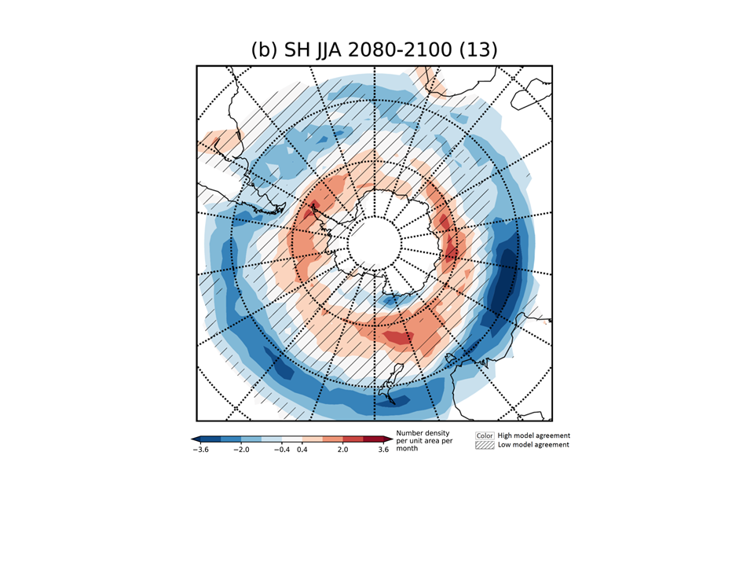

### Pacific Decadal Variability (PDV)

PDV encompasses the Pacific Decadal Oscillation (PDO) and the closely related Interdecadal Pacific Oscillation (IPO). It is manifested as changes in SSTs across the Pacific Basin on time scales of around two to three decades. Importantly, PDV has a modulating influence on the ENSO cycle in the tropical Pacific. In its positive phase, average SSTs increase over the eastern tropical Pacific, favouring El Niño events. Conversely, in its negative phase, average SSTs decrease over the eastern tropical Pacific, favouring La Niña events. Hence, the positive phase of the PDV pattern is associated over New Zealand with somewhat lower temperatures on average, stronger westerly and south-westerly winds, and increased precipitation in western regions, typical of El Niño conditions. The negative phase of PDV is associated on average with somewhat weaker westerly winds, higher temperatures over New Zealand and drier conditions in the west.

PDV appears most strongly driven by internal variability, with little sign of external forcing, from human activities or otherwise. The CMIP6 models reported on in AR6 generally do a better job of simulating PDV than do CMIP5 models in AR5. However, because there has to date been little published on model performance on PDV, conclusions are very uncertain. Based on CMIP5 results, the AR6 concluded there is *medium confidence* that a weaker and higher frequency PDV is expected under global warming. Assessments based on CMIP6 model output have yet to be published.

### Regional SSTs and the location of the jet stream

Regional SSTs have increased in the northern Tasman Sea/New Zealand region over the past century, more rapidly near the Australian coast and more slowly south of the country. Marine heatwaves have increased in frequency in the Tasman/New Zealand region as SSTs have risen. Such events can have significant effects on marine life and are associated with high terrestrial temperatures and associated impacts. The two recent events that occurred in 2017/18 and 2018/19 (Salinger *et al*. 2019; 2020) were associated with major species disruptions in marine ecosystems, significant impacts upon agriculture in New Zealand, and enhanced glacier ice melt. The AR6 concludes it is *very likely* there will be further increases in frequency, duration, spatial extent and intensity of marine heatwaves under future global warming in the 21st century. Globally, the frequency of marine heatwaves is expected to increase by between four (SSP1-2.6) and eight (SSP5-8.5) times. A similar increase is expected in the New Zealand region.

The mid-latitude jet stream and its associated storm track on average is centred over the Southern Ocean south of New Zealand. The jet stream varies in latitude on weekly to monthly time scales and can lie over southern New Zealand during the negative phase of the SAM. Over recent decades, this has happened less frequently, associated with the positive trend in the SAM (see SAM subsection). Future trends in jet location depend on the trade-off between mitigation of greenhouse gas emissions and the recovery of stratospheric ozone over Antarctica. As discussed in the SAM subsection, low emissions scenarios would be associated with the mid-latitude jet and associated storminess lying over New Zealand more frequently in summer. Conversely, high emissions through this century are likely to be associated with the jet lying south of New Zealand more frequently, with lighter winds over this country and a decrease in storminess in all seasons.

Other models of variability, such as the Indian Ocean Dipole (IOD) and Zonal Wave 3 (ZW3), affect New Zealand climate episodically. Little research has yet been done on how they affect New Zealand climate or on how they are expected to change in future.

## 1.7 Improvements in understanding and attributing extremes

Globally, evidence of observed changes in extreme weather events and their attribution to human influence (including greenhouse gas and aerosol emissions, and land-use changes) has strengthened since AR5, in particular for extreme precipitation, droughts, tropical cyclones and compound extremes (including dry/hot events and fire weather). That said, the level of complexity of the climate system processes underlying extreme events differs from one type of extreme to another, affecting our capability to detect, attribute and project changes in extreme weather events. Since AR5, the attribution of extreme weather events, and the investigation of changes in the frequency and/or magnitude of individual and local-scale and regional-scale extreme weather events due to various drivers, has provided evidence that greenhouse gases and other external forcings have affected individual extreme weather events.

‘Outcome of event’ attribution depends critically on:

1. the definition of the event (Leach *et al*., 2020)
2. the framing/conditioning (see below) of the event (Christidis *et al*., 2018; Jézéquel *et al*., 2018; Otto *et al*., 2016; Stone *et al*., 2022), and
3. on uncertainties in observations and modelling.

Observational uncertainties result from estimating the magnitude of an event as well as its likelihood (Angélil *et al*., 2017). This is especially challenging for New Zealand where long-term homogeneous records for assessing return periods of very rare events are sparse. Results of attribution studies can also be sensitive to the choice of climate variables (Sippel and Otto, 2014; Wehner *et al*., 2016) and can depend on the defined spatial (Uhe *et al*., 2016; Cattiaux and Ribes, 2018; Kirchmeier‐Young *et al*., 2019) and temporal (Harrington, 2017; Leach *et al*., 2020) extent of the event. Events of different scales involve different processes (Zhang *et al*., 2020) and large-scale averages generally result in higher attributable changes in magnitude or likelihood due to the smoothing out of the noise.

In general, confidence in attribution statements for large-scale heat and lengthy extreme precipitation events have higher confidence than shorter and more localised events, such as extreme storms. Because of New Zealand’s location in the Southern Hemisphere mid-latitudes, with associated highly variable weather, the higher levels of ‘weather noise’ make attribution studies difficult.

Extreme weather events that are typically the target of attribution studies are not representative of all extreme weather events and, as a result, conclusions drawn from these studies may not be globally applicable. That said, the large number of event attribution studies that have been conducted since AR5 provide evidence that changes in the properties of these local and individual events are consistent with expected consequences of human influence on the climate and can be attributed to external drivers.

# Section 2: Trends and projections of New Zealand climate from AR6 WG1 and other recent studies

### Key findings

1. The evidence for warming in Aotearoa New Zealand continues to build. New Zealand experienced its warmest year on record in 2021, surpassing the previous record set in 2016. Seven of the past nine years have been among New Zealand’s warmest on record. The winter in 2021 was also the warmest winter on record in New Zealand, surpassing the record set in winter 2020.
2. The warming in New Zealand is consistent with the global surface temperature observations, with an increase of 1.1°C measured from 1909-2016. In the period 1980-2014 a rate of increase of 0.1 to 0.3°C per decade has been observed.
3. An increase of mean air temperature of +1.0°C (0.60 to 1.32°C) relative to 1995-2014 is projected by mid-century for the New Zealand region (over land and sea), and an increase of +1.6°C (1.03 to 2.26°C) by end century under SSP2-4.5. For SSP5-8.5, the projected increase in mean air temperature is +1.3°C (0.91 to 1.66°C) and +3.1°C (2.20 to 4.05°C 10-90 percentile range) relative to 1995-2014 by mid and end century, respectively. For SSP1-2.6, the projected increase in mean air temperature is +0.75°C (0.39 to 1.06°C) and +0.8°C (0.47 to 1.46°C) relative to 1995-2014 by mid and end century, respectively (Ranasinghe *et al*., 2021; see also Interactive Atlas).
4. The New Zealand region has experienced an increasing intensity and frequency of hot extremes and decreasing intensity and frequency of cold extremes (*likely*).
5. More frequent and intense hot extremes and less frequent and intense cold extremes are *likely* for New Zealand in the future, compared with the pre-industrial period.
6. Historical increases in annual rainfall have been observed between 1960-2019 in the south and west of the South Island and east of the North Island. The northeast of the South Island and western and the northern parts of the North Island show decreasing precipitation trends during 1960-2019. For the most part, the trends in New Zealand have been classified as statistically not significant.
7. Projected annual rainfall patterns show increases in the west and south of New Zealand. Projected winter and spring rainfall follow the annual increase in the west and south, but with less rainfall in the east and north. More summer rainfall in the east of both islands, with less rainfall in the west and central North Island (*medium confidence*).
8. There is *medium confidence* that river flooding will increase in New Zealand.
9. Reported trends in meteorological, agricultural, and hydrological drought for New Zealand are inconsistent. However, drought severity is projected to increase in most areas of the country, except for Taranaki-Manawatu, West Coast and Southland.
10. Glacier volume between 1978 and 2020 decreased from 53.3 km3 to 34.6 km3 (a loss of 35%). Relative to 2015, glaciers in New Zealand are projected to lose 36 ± 44%, 53 ± 33%, and 77 ± 27% of their mass by the end of the century under the AR5 emission scenarios RCP2.6, RCP4.5, and RCP8.5, respectively.
11. Regional air temperature variability is the governing control on glacier mass balance in New Zealand. However, intrusions of warm, moist air are important in controlling seasonal variability in glacier mass balance. Snow cover and depth have decreased and are projected to decrease further in New Zealand.
12. Mean wind patterns in New Zealand are projected to become more north-easterly in summer, and westerlies to become more intense in winter (*low confidence*), in agreement with the strengthening of the southern hemisphere storm tracks.
13. Fire weather indices are projected to increase in many parts of New Zealand (*medium confidence*), in particular with respect to extreme fire. Days with very high and extreme fire weather increased in 12 out of 28 monitored sites, and decreased in eight, in the period 1997 to 2019.
14. The mean sea surface temperature (SST) of the ocean around Australia and east of New Zealand has warmed at a rate of about 0.22°C per decade between 1992 and 2016. Marine heatwaves are expected to increase over the 21st century. If emissions are high in the future, median marine heatwave intensities could increase between 80 and 100% by the end of the century and conditions that we refer to as marine heatwaves today could become permanent year-round by the end of the century.
15. Model projections of the available surface water for groundwater in specific regions in New Zealand suggest a decrease by the end of the century, with reductions approaching 50% for high emission scenarios. The spatial complexity of New Zealand demands further subregional modelling to assess changes in groundwater.

## 2.1 Mean air temperature

The evidence for warming in New Zealand continues to build. New Zealand experienced its warmest year on record in 2021, surpassing the previous record set in 2016. Seven of the past nine years have been among New Zealand’s warmest on record. The winter in 2021 was also the warmest winter on record in New Zealand, surpassing the record set in winter 2020.

The IPCC Sixth Assessment Report (AR6) Working Group 1 (WG1) report states that mean air temperature in New Zealand and Australasia as a whole (over land and sea) is projected to increase during the 21st century for the SSP1-2.6, 2-4.5, and 3-8.5 scenarios (*virtually certain*). In New Zealand, an increase of 1.1°C has been measured from 1909-2016 (Section Atlas.6.2; Ministry for the Environment, 2020). Since 1909, a rate of increase of 0.09 ± 0.03°C per decade has been observed (Table 25-1, AR6). Table 2 summarises projected changes in the New Zealand regional annual mean air temperature (over land and sea) derived from CMIP6 model projections under the SSP1-2.6, SSP2-4.5 and SSP5-8.5 scenarios. While the two “sustainability” and “middle of the road” (SSP1 and SSP2) scenarios project an approximate temperature stabilisation in the second half of the century, the “fossil fuel intensive” development (SSP5) provides an accelerated rate of warming in the New Zealand sector.

Table 2: Projected New Zealand region annual mean air temperature change (over land and sea) relative to 1995-2014 average (also see Interactive Atlas). Values in parentheses indicate the 10-90 percentile range spanned by the ensemble of CMIP6 models.

| NZ region | Mid century | End of century |
| --- | --- | --- |
| **SSP1-2.6** | +0.75°C  (0.39 to 1.06°C) | +0.8°C  (0.47 to 1.46°C) |
| **SSP2-4.5** | +1.0°C  (0.60 to 1.32°C) | +1.6°C  (1.03 to 2.26°C) |
| **SSP5-8.5** | +1.3°C  (0.91 to 1.66°C) | +3.1°C  (2.20 to 4.05°C) |

New Zealand regional air temperature is projected to increase slightly less than the global mean, reflecting the large oceanic influence on New Zealand climate. Summer is projected to warm more than winter and spring (Figure 5). Patterns of warming over the region are linked to regional large-scale atmospheric circulation, ocean temperatures and regional biogeography. There are different spatial patterns of projected changes for annual maximum compared to minimum temperatures. Many of the details of the spatial patterns of change require high-resolution downscaling to provide assessment at regional scales. The AR6 results therefore provide only the broad regional context. Despite these limitations, it is clear that most heat hazards in Australasia will increase and that cold hazards will decrease over the 21st century.

Figure 5: Seasonal temperature projection for the New Zealand region (derived from the IPCC WG1 Atlas).

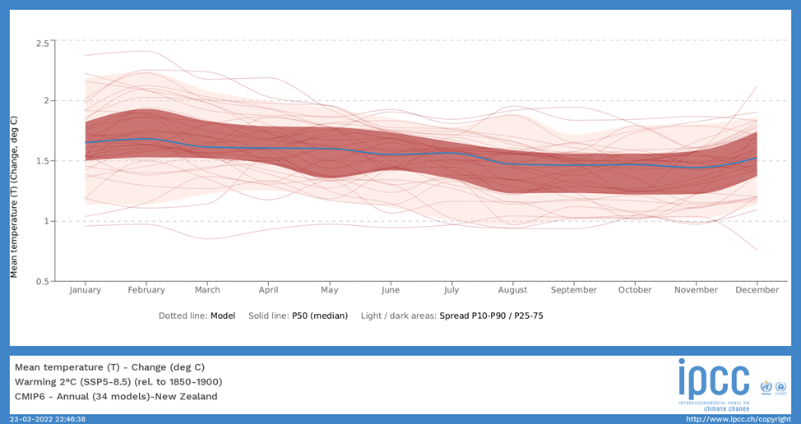

## 2.2 Hot extremes

The New Zealand region has experienced an increasing frequency and severity of hot extremes since the 1950s (*likely*). Land-atmosphere feedbacks strongly modulate regional-scale and local-scale changes in temperature extremes (Seneviratne *et al*., 2013). This effect is particularly notable in mid-latitude regions such as New Zealand where the drying of the soil exacerbates high temperatures through increases in sensible heat flux (Whan *et al*., 2015). The number of annual heatwave days increased at 18 of 30 sites during the period 1972–2019 (MfE and Stats NZ, 2020).

CMIP6 models project an increase in the intensity and frequency of the annual hottest daily maximum temperature (TXx) for New Zealand (AR6 WG1 Table 11.10). This projection has *high confidence* in a world 1.5°C warmer (global mean) compared to the recent past (1995-2014) and is considered *likely* compared to a pre-industrial world. In a world with global mean surface temperature 2°C above pre-industrial levels, the CMIP6 models project larger increases in the intensity and frequency of extreme TXx events – this is considered *likely* compared with the recent past and *very likely* compared with pre-industrial conditions. In a 4°C warmer world, the CMIP6 models project even larger increases in the intensity and frequency of extreme TXx events with likelihoods of *extremely likely* compared with the recent past and *virtually certain* compared with pre-industrial conditions.

Studies since the IPCC Fifth Assessment Report (AR5) continue to attribute the observed increase in the frequency or intensity of hot extremes to human influence, dominated by anthropogenic greenhouse gas emissions, on global and continental scales, and for many regions (Peterson *et al*., 2012, 2013, Herring *et al*., 2014, 2015, 2016, 2018, 2019, 2020). As much as 75% of the moderate daily hot extremes (above the 99.9th percentile) over land are due to anthropogenic warming (Fischer and Knutti, 2015). It was reported in MfE (2018) that while some portion of the New Zealand warming trend is probably due to natural variability (Salinger and Mullan, 1999; Mullan *et al*., 2010), a significant contribution to the warming can be attributed to greenhouse gas increases (Dean and Stott, 2009). AR6 suggested that while it is *likely* that there are positive trends in extreme heat over New Zealand, the level of confidence that we can have that the observed change is attributable to human influence is *low*.

## 2.3 Cold extremes

New Zealand has experienced less frequent and intense cold extremes since the 1950s (*likely*). The number of frost days has decreased at 12 of 30 monitoring sites around New Zealand over the period 1972–2019 (MfE and Stats NZ, 2020. Projections for New Zealand indicate that the number of frost days will decrease by 20–40% (RCP2.6) to 20–40% (RCP8.5) by 2040, relative to 1986–2005. By 2090, the decrease ranges from 30–50% (RCP2.6) to 70–90% (RCP8.5) (MfE, 2018). Studies that focused on the attributable signal in observed cold extreme events show human influence in the reducing probability of those events.

CMIP6 models project a decrease in the intensity and frequency of the annual coldest daily minimum temperature (TNn) for New Zealand (AR6 WG1 Table 11.10). This projection has *high confidence* in a world 1.5°C warmer (global mean) compared to the recent past (1995-2014) and is considered *likely* compared to a pre-industrial world. In a world with global mean surface temperature 2°C above preindustrial levels, the CMIP6 models project larger decreases in the intensity and frequency of extreme TNn events – this is considered *likely* compared with the recent past and *very likely* compared with pre-industrial conditions. In a 4°C warmer world, the CMIP6 models project even larger decreases in the intensity and frequency of extreme TNn events – considered *extremely likely* compared with the recent past and *virtually certain* compared with pre-industrial conditions.

## 2.4 Precipitation

In New Zealand, historical increases in annual rainfall have been observed between 1960-2019 in the south and west of the South Island and east of the North Island. The northeast of the South Island and western and the northern parts of the North Island show decreasing precipitation trends during 1960–2019 (MfE and Stats NZ, 2020). Note however, for the most part, the trends in New Zealand have been classified as statistically not significant (Figure Atlas.23).

Annual mean precipitation is projected to increase in the south and west of New Zealand (*medium confidence*) (Section Atlas.6.4). Projected patterns in annual precipitation exhibit increases in the west and south of New Zealand (Section 29 Atlas.6.4). Liu *et al*. (2018a) project that the South Island will have high precipitation totals under both 1.5°C and 2°C warming. Projected winter and spring rainfall follows the annual increase in the west and south, but with less rainfall in the east and north. More summer rainfall in the east of both islands, with less rainfall in the west and central North Island (*medium confidence*).

While there is broad agreement in projections for temperature, it is worth noting that there is more limited model agreement for projected rainfall changes in Australasia as a whole. Nonetheless, the AR6 findings are broadly consistent with projections reported in AR5 that showed model projections for the second half of the century suggesting summer-time precipitation totals between 90 and 110% of the historical value (between 1985 and 2005). Winter-time precipitation is similarly projected to be within 10% of historical values. Within this range, areas of the northern North Island are projected to have reduced precipitation totals while locations in the southern South Island are projected to have higher totals by the second half of the century.

Since AR5, the role atmospheric rivers play in controlling extreme precipitation in New Zealand has been more carefully documented (Figure 6; Prince *et al*., 2021). Atmospheric rivers or “rivers in the sky” are highly concentrated corridors of water vapour transport in the lower atmosphere. Ma *et al*. (2020) have reported on a poleward shift in atmospheric rivers in the Southern Hemisphere, which is consistent with changes in the Southern Hemisphere mid-latitude jet (Section 1.6). While it has been indicated that the poleward shift of atmospheric rivers in the Sothern Hemisphere will have implications on the amount of moisture and heat transported to Antarctica, there is less certainty how this will impact the New Zealand region. The advances in CMIP6 models have enabled large-scale changes in atmospheric circulation to be better resolved, which will improve the regional scale estimates of precipitation in the New Zealand region. This will provide the basis for further scrutiny of the mechanisms governing extreme precipitation, and more broadly support the recent advances in attribution of extreme weather events (e.g. Tradowsky *et al*. 2022).

Figure 6. An example of a landfalling atmospheric river (AR) in New Zealand detected using an atmospheric river detection algorithm (25 March 2019). The AR outline is shown with the green line and landfall location is identified with a grey cross. Vectors only plotted with magnitudes above 200 kg m-1 s-1, vectors associated with the AR in bold. The height of the 850 hPa pressure level is shown with contours at 25 m intervals. Time stamp in UTC (Source: Prince *et al*., 2021).

In AR6, there was *low* confidence in trends in the frequency of heavy rain days with mostly decreases simulated over New Zealand (Caloiero, 2015; Harrington and Renwick, 2014). An event attribution study by Rosier *et al*. (2016) found an influence of anthropogenic activities on the intensity and likelihood of extreme rainfall in 2014 over Northland.

## 2.5 Flooding and landslides

There is *medium confidence* that river flooding will increase in New Zealand. Projections for New Zealand indicate that the 1-in-50 year and 1-in-100 year flood peaks for rivers in many parts of the country may increase by 5 to 10% by 2050 and more by 2100 (with large variation between models and emissions scenarios), with a corresponding decrease in return periods for specific flood levels (Gray *et al*., 2005; Carey-Smith *et al*., 2010; McMillan *et al*., 2010, 2012; Ballinger *et al*., 2011).

The potential for land and rockslides increases with total precipitation rates, precipitation intensity, and several other factors. The occurrence of landslides is therefore projected to increase in areas where increases in precipitation are projected (*low confidence*).

## 2.6 Aridity and drought

Since 1972/73, soils at seven of 30 monitored sites in New Zealand became drier, while the 2012–13 drought was one of the most extreme in the previous 41 years (MfE and Stats NZ, 2020). Prudhomme *et al*. (2014) assess changes in the Drought Index, defined as areal runoff less than the 10th percentile over the reference period 1976–2005, and project Drought Index increases in New Zealand by 10–20% by 2070-2099 under RCP8.5. Liu *et al*. (2018) project that the North Island of New Zealand will be drier under both 1.5°C and 2°C warming. In the north and east of New Zealand, aridity is projected to increase with *medium confidence*, while a decrease is projected with *medium confidence* in the south and west of NZ (Section Atlas.6.4).

AR6 concluded that trends in meteorological, agricultural and hydrological droughts to date over New Zealand, are inconsistent (Caloiero 2015, Spinoni *et al*., 2015; Knutson and Zeng, 2018). Increased drying has been reported in some parts of the country (Beguería *et al*., 2014; Spinoni *et al*., 2019) and decreased drying in other parts (Dai and Zhao, 2017). The lack of data and paucity of studies has resulted in *low confidence* in historical drought trends. This has also created *low confidence* in the attribution of historical droughts to human contributions (Harrington *et al*., 2014, 2016; Knutson and Zeng, 2018). That said, the 2013 New Zealand meteorological drought was attributed to human influence by Harrington *et al*. (2014, 2016) based on fully coupled CMIP5 models. However, Angélil *et al*. (2017) found no corresponding change in the dry end of simulated precipitation from a stand-alone atmospheric model.

MfE (2018) states that more dry days (i.e., days with precipitation below 1 mm/day) are projected throughout the North Island, and in inland parts of the South Island, with up to 10 more dry days per year by 2090 under the AR5 scenario RCP8.5. Increased dry days are most marked in the north and east of the North Island, in winter and spring. The number of days of potential evapotranspiration deficit (in millimetres accumulation over the July to June ‘water year’), exceeding 300 millimetres in a calendar year is also projected to increase. The projected change in potential evapotranspiration deficit is considerable, with a consistent increase in potential evapotranspiration deficit of more than 50 millimetres over much of the North Island, with strongest changes over northern and eastern regions, and north-eastern and central South Island east of the main divide, indicating long-term drying of these regions.

Drought severity is projected to increase in most areas of the country, except for Taranaki-Manawatu, West Coast and Southland. Drought intensity, as measured by potential evapotranspiration deficit, is projected to increase in magnitude with increased greenhouse gas emissions (i.e., from RCP2.6 to RCP8.5) and time period. The strongest increases are projected to be over the northern and eastern North Island and in the lee of the main divide over the South Island, and later in the century under the strongest forcing. AR6 provides no further information on potential changes in dry day or drought conditions in New Zealand.

Projections of changes in drought severity or intensity over New Zealand reported in AR6 are also confounded by lack of studies and lack of signal. Under global mean surface temperature increases of 2°C and 4°C, increases in drought risk over the North Island are reported (Spinoni *et al*., 2020) but with *low confidence*.

## Glaciers and seasonal snow

The reported glacier volume reduction for New Zealand in Chapter 12 of AR6 (Ranasinghe *et al*., 2021) only refers to small and medium glaciers, which is the focus of a study by Salinger *et al*. (2019b). The most recent glacier ice volume estimates for New Zealand come from Macara and Willsman (2021), who estimate that glacier volume between 1978 and 2020 decreased from 53.3 km3 to 34.6 km3 (a loss of 35%). Using state-of-the-art remote sensing data from satellites, Hugonnet *et al*. (2021) reported on a record thinning rate of 1.52 ± 0.50 m per year in 2015–2019 for glaciers in the Southern Alps, which is a nearly seven-fold increase compared to 2000–2004. Relative to 2015, glaciers in New Zealand are projected to lose 36 ± 44%, 53 ± 33%, and 77 ± 27% of their mass by the end of the century under AR5 emission scenarios RCP2.6, RCP4.5, and RCP8.5, respectively (Figure 7), with the loss rates decreasing over time under RCP2.6 and increasing under RCP8.5 (Marzeion *et al*., 2020).

Figure 7. Glacier mass relative to 2015 as a function of time and RCP scenario. Solid lines indicate ensemble median and shading indicates ±1 standard deviation (shown only for RCP2.6 and RCP8.5 for clarity). (Source: Modified Figure 6 from Marzeion *et al*., 2020).

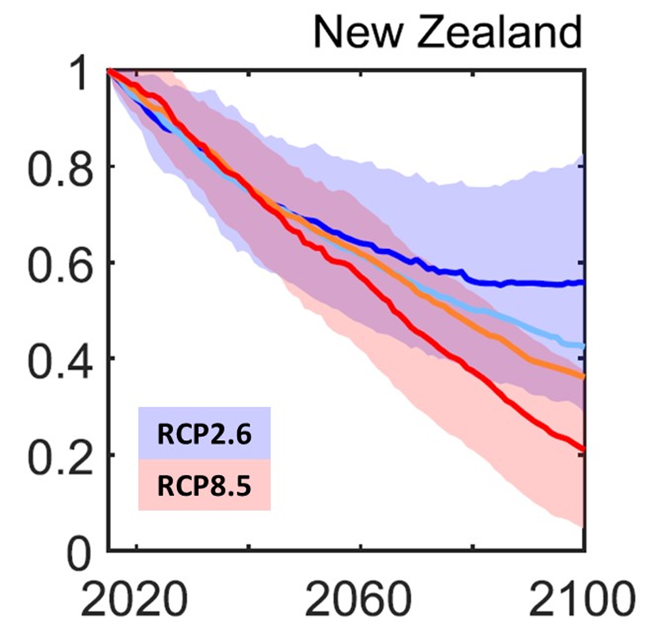

Douville *et al*. (2021) in AR6 state that warm, moist airflows and associated precipitation dominate glacier mass balance in New Zealand. There is stronger evidence that regional air temperature variability controls glacier mass balance (Mackintosh *et al*., 2017). However, there is new evidence that intrusions of warm, moist air associated with atmospheric rivers are important in controlling seasonal variability in glacier mass balance (Cullen *et al*., 2019; Little *et al*., 2019). Heating from warm air and increased longwave radiation from atmospheric moisture and low clouds are responsible for driving extreme melt events (Gillett and Cullen, 2011; Conway and Cullen, 2016).

It is stated in AR6 that snow cover and depth have decreased and are projected to decrease further in New Zealand (Gutiérrez *et al*., 2021). The basis of this statement comes from the estimate of snow days reported in MfE (2018), which is calculated by counting precipitation days where mean air temperature is below the freezing point. It is of no surprise this approach leads to the conclusion that warming leads to less snowfall, but largely fails to assess the complex physical processes governing the fate of seasonal snow or to resolve its contribution to streamflow. There is no operational snow modelling in New Zealand and efforts to simulate changes in seasonal snow in the future remain sparse (Conway *et al*., 2021). The monitoring of seasonal snow using remote sensing in New Zealand has improved vastly since AR5 (Redpath *et al*., 2019).

## 2.8 Wind

Mean wind patterns are projected to become more north-easterly in summer, and westerlies to become more intense in winter (albeit with *low confidence*), in agreement with the strengthening of the southern hemisphere storm tracks. There is similarly generally *low confidence* in observed changes in extreme winds and extratropical storms in the region. Nonetheless, an increase in extreme wind speed in New Zealand is projected over the South Island and the southern part of the North Island by mid- and end of century for all RCPs, which is related to projection of the intensification of regional cyclonic storms (MfE, 2018).

## 2.9 Tropical cyclones

AR6 reported with *high confidence* that the average and maximum rain rates associated with tropical cyclones, extratropical cyclones, and atmospheric rivers across the globe, and severe convective storms in some regions, increase in a warming world. Available event attribution studies of observed strong tropical cyclones provide *medium confidence* for a human contribution to extreme tropical cyclone rainfall. Peak tropical cyclone rain rates increase with local warming at least at the rate of mean water vapour increase over oceans (about 7% per 1°C of warming). In some cases they exceed this rate due to increased low-level moisture convergence caused by increases in tropical cyclone wind intensity (*medium confidence*).

## 2.10 Fire

Fire weather indicators are projected to increase in many parts of New Zealand (*medium confidence*), in particular with respect to extreme fire. Days with very high and extreme fire weather increased in 12 out of 28 monitored sites, and decreased in eight, in the period 1997 to 2019 (MfE and Stats NZ, 2020). Attribution studies indicate that there is *medium confidence* of an anthropogenically-driven past increase in fire weather conditions, essentially due to increase in frequency of extreme heat waves (Hope *et al*., 2019; Lewis *et al*., 2020; van Oldenborgh *et al*., 2021). Watt *et al*. (2019) projected that the number of days with very high to extreme fire risk will increase by 71 per cent by 2040, and by a further 12 per cent by 2090, for the A1B scenario (note, this older scenario falls somewhere between RCP6.0 and RCP8.5 in terms of future carbon dioxide [CO2] concentrations), with fire risk increase all along the east coast. The most marked relative changes by 2090 were projected for Wellington and Dunedin where very high to extreme fire risk is projected to increase by 89% and 207% respectively, compared to the baseline period 1970-1999.

## 2.11 Sea surface temperature (SST)

Projections show an increasing trend in marine heat waves (MHWs), with *high confidence*. The mean SST of the ocean around Australia and east of New Zealand has warmed at a rate of about 0.22°C per decade between 1992 and 2016 (Wijffels *et al*., 2018), which is higher than the global average SST increase of 0.16°C per decade (Oliver *et al*., 2018). Changes over the 20th century, derived from MHW proxies, show an increase in frequency between 0.3 and 1.5 MHWs per decade, except along the south east coast of New Zealand (see AR6 WG1 Box 9.1); an increase in duration per event; and an increase in the total number of MHW days per decade. The change is stronger in the Tasman Sea than elsewhere (Oliver *et al*., 2018). More frequent, extensive, intense and longer-lasting MHWs are projected around Australia and New Zealand for global warming levels of 1.5°C, 2°C and 3.5°C relative to the modelled reference value for 1861-1880 (Frölicher *et al*., 2018). Projections for SSP1-2.6 and SSP5-8.5 both show an increase in MHWs around Australasia by 2081–2100, relative to 1985–2014.

Given the sensitivity of the weather and climate in New Zealand to SSTs, there has been focus on the changes in occurrence and frequency of MHWs (Salinger *et al*., 2019, 2020). Recent earth system modelling by Behrens *et al*. (2022) of the present-day conditions and projected changes in MHWs in the New Zealand region using three AR6 SSPs indicate that MHW intensity will increase more strongly in subtropical waters compared to subantarctic waters. The largest changes in annual MHW days are projected south of Australia and in the Tasman Sea along the Subtropical Front frontal region. If emissions are high in the future (e.g. SSP3-7.0), median MHW intensities will increase between 80 and 100% by the end of the century, and conditions that we refer to as MHWs today could become permanent year-round by the end of the century.

Understanding the dynamical causes and sub-surface structure of the ocean during MHWs is also critical in the prediction of these anomalously warm and high impact events. Efforts to disentangle the oceanic drivers from atmospheric forcing have shown that anomalous advection-driven MHWs are deepest (three times deeper), longest (four times longer) and more prevalent in autumn and winter in the Tasman Sea region. This contrasts with atmospherically forced MHWs, which have shallower depth ranges and exhibit a strong seasonal cycle mostly occurring in summer (Elzahaby *et al*., 2021). These findings will need to be more explicitly accounted for in future regional atmospheric modelling experiments that assess the role SSTs play in controlling airmass variability in the New Zealand region.

## 2.12 Groundwater

Impacts of climate change on key water cycle processes (including precipitation and evaporation) are documented in AR6 and described in the sub-sections above and in Douville *et al*. (2021). However projections of changes to groundwater, such as rainfall recharge and water table elevation, are not provided in AR6 (Mourot *et al*., 2022). Climate change can impact groundwater through:

* the availability in rainfall
* the ability of the ground to hold groundwater through its potential for saturation and hydrogeological properties (Cao *et al*., 2016; Moreau *et al*., 2019), and
* groundwater movement to the surface (Das *et al*., 2021; Zhu *et al*., 2020).

The human demand and pressures on groundwater adds complexity to understanding the driving forces controlling future changes in groundwater availability (Lehner *et al*., 2020).

In recent efforts to model groundwater projections for two contrasting New Zealand regional settings (Hawkes Bay and Otago), regional climate projections for AR5 RCP4.5 and RCP8.5, national datasets for river catchments, and regional hydrogeological properties were used to drive a groundwater recharge and water table (Westerhoff *et al*., 2018a,b). On average, regional projections of available surface water for the groundwater models suggest a decrease by end of century with reductions of up to 50% for RCP8.5. However, the projections of the statistical extremes indicate more variability between Hawkes Bay and Otago. Hawkes Bay is impacted by a statistically significant decrease while Otago shows more variability. These results also show the importance of orography on regional variability of precipitation, where mountain ranges to the west of the catchments revealed increases in available surface water for groundwater recharge.

The modelled rainwater recharge and water table projections generally follow rainfall projections. Areas projected to become drier are also projected to have less rainwater recharge and lower water table levels, with the opposite for the areas that are projected to get wetter. However, the subregional analysis indicates that orography and the spatial variability of the hydrogeology and river catchment dynamics can control the spatial variability of rainwater recharge and water table levels. This research stresses the fact that more subregional modelling for ground water is needed in New Zealand.

# Section 3: Does this new information change what we know?

### Key findings

1. The projected range of the temperature increases over New Zealand has been narrowed. The availability of the CMIP6 model ensemble provides a significant opportunity for producing updated regional climate change projections for New Zealand.
2. Attribution statements for large-scale heat and lengthy extreme precipitation events have higher confidence than shorter and more localised events, such as extreme storms. New Zealand’s mid-latitude location in the Southern Hemisphere leads to variability in atmospheric circulation, with higher levels of ‘weather noise’ making attribution studies difficult.
3. Until the regional downscaling is completed, regional climate model projections reported in MfE (2018) can continue to be used with reasonable confidence as new knowledge from AR6 will most likely not fundamentally change the existing projections.
4. To produce regional scale climate projections for New Zealand in the future, the selection of global model output from CMIP6 for downscaling should consider the AR6 very likely range of Equilibrium Climate Sensitivity (ECS) of 2°C to 5°C and Transient Climate Response (TCR) of 1.2°C to 2.4°C.

In this section we draw some insights from Sections 1 and 2 of this report and consider how this updated information may affect existing climate change projection guidance for New Zealand. We also use past changes between previous IPCC assessments and how that impacted the New Zealand regional climate projections to make some general points. Comparison of the climate change effects and impacts assessment report (MfE, 2008) and the more recent climate change projections for New Zealand report (MfE, 2018) shows that there was a clear reduction in the uncertainties associated with downscaled projections, this change can probably be attributed to three factors:

1. Improvements in the global climate projections available in the CMIP3 and CMIP5 ensembles;
2. Changes in the global emissions pathway frameworks used in the IPCC 4th and 5th Assessment reports; and
3. Enhanced downscaling methodologies and improved bias-correction which led to improved regional climate projections.

For example, the projected range of temperature increase over New Zealand by 2040 for the older report (MfE, 2008) and the newer report (MfE, 2018) is shown in Table 3.

Table 3: The projected range of temperature increase over New Zealand by 2040 and 2090 from the climate change effects and impacts assessment report (MfE, 2008) and the more recent climate change projections for New Zealand report (MfE, 2018).

| New Zealand Climate Change Guidance Report | Mid century (2040) | End of century (2090) |
| --- | --- | --- |
| **MfE (2008)** | 0.2 to 2.0°C | 0.7 to 5.1°C |
| **MfE (2018)** | 0.2 to 1.7°C | 0.7 to 4.6°C |

It is notable that this reduction in the temperature uncertainty occurred despite an increase in the range of atmospheric carbon dioxide (CO2) concentrations considered in the later IPCC report (see Figure 2 in MfE, 2018). This uncertainty reduction in these headline temperature projections therefore suggests that regional downscaling based on the global climate projections in the AR6 may further reduce temperature uncertainties.

This is supported by the latest generation of complex climate models used in AR6 (see AR6 WG1 Chapter 1) having an improved representation of physical processes and a wider range of Earth system models now representing biogeochemical cycles. The availability of the broader CMIP6 model ensemble therefore provides a significant opportunity for producing updated regional climate change projections for New Zealand, as well as providing opportunities for developing new insights about previous work and allowing enhanced understanding.

## 3.1 Can the existing New Zealand climate change projections still be used?

New Zealand-focused regional modelling and quantitative analyses based on CMIP6 models are yet to be performed. However, work detailed in Grose *et al*. (2020) identified that over Australia temperature and rainfall from the CMIP6 model ensemble broadly agree with those from CMIP5, except for a group of CMIP6 models with higher climate sensitivity. However, Grose *et al*. (2020) also highlighted that some increases in some extremes are observed in CMIP6 after 2050. Thus, overall future regional projections using CMIP6 global projections over New Zealand, excluding extremes, are expected to be similar to previous versions, but perhaps with areas of improved confidence and clarity. The projections detailed in MfE (2018) can therefore likely be used with reasonable confidence that the improved knowledge represented in the AR6 report do not fundamentally change key findings.

It is worth noting that AR6 introduced analysis at particular global warming levels, specifically 1.5°C, 2°C and 4°C warming levels. The 1.5°C and 2°C warming levels were selected because of their relevance to the Paris Agreement. While current regional climate model projections for New Zealand remain relevant, they are presented in such a way that it is not easy to allow stakeholders to consider likely impacts at particular global warming threshold temperatures such as at 1.5°C. The AR6-based regional climate model projections, when produced, will be presented both in terms of future time periods and related to global warming levels.

## 3.2 Advancing attribution science in New Zealand between AR5 and AR6

Very little in MfE (2018) was written about attributing observed changes in extremes to specific drivers. The only clear attribution statement was that while part of the New Zealand warming trend is probably due to natural variability, a significant contribution to the warming can be attributed to greenhouse gas increases (Dean and Stott, 2009). This paper was also one of the few papers cited in the IPCC (2012) report titled Managing the Risks of Extreme Events and Disasters to Advance Climate Change Adaptation related to attribution science conducted in New Zealand.

However, since the IPCC Fifth Assessment Report (AR5), the attribution of extreme weather events has emerged as a growing field of climate research with an increasing body of literature (e.g., the series of supplements to the American Meteorological Society’s annual State of the Climate report (Peterson *et al*., 2012, 2013, Herring *et al*., 2014, 2015, 2016, 2018), including several approaches to extreme weather events described in Easterling *et al*. (2016), Otto (2017) and Stott *et al*. (2016).

Domestically, several initiatives have advanced attribution science in the New Zealand research community, including:

* The Extreme Weather Event Realtime Attribution Machine (EWERAM) project (Tradowsky *et al*., 2022): This project developed a suite of tools useful for conducting attribution of extreme weather events to anthropogenic drivers and applied these tools to analysing several specific events.
* The Deep South National Science Challenge-funded Future Extreme Weather in Aotearoa New Zealand (FEWhANZ) project: Work within this project has developed non-stationary models of extreme value distributions which allow for the detailed detection and attribution of regional trends in temperature and precipitation extremes.
* The New Zealand Detection and Attribution Group (NDAG): This group has facilitated and coordinated detection and attribution research between New Zealand and Australia, with strong connections to the international research community.
* The World Weather Attribution (WWA) project: Although this project commenced in 2014, activity in the past few years has accelerated considerably. Several members of the New Zealand climate research community are now actively involved in WWA.

Advances in attribution science in New Zealand have permitted studies such as Frame *et al*. (2020) which presented an initial attempt to quantify costs related to extreme weather due to human interference in the climate system, focusing on economic costs arising from droughts and floods in New Zealand during the decade 2007–2017. The fraction of attributable risk was calculated for 12 extreme rainfall events which, when multiplied by the total cost of each event, led to a conclusion of a $140.48 million cost attributable to climate change. The equivalent for two summer droughts in the same period led to total attributable drought losses of $800 million.

A key component in any event attribution analysis is the level of conditioning on the state of the climate system. In the least conditional approach, the combined effect of the overall warming and changes in large-scale atmospheric circulation are considered using fully coupled global climate models. Other more conditional approaches involve prescribing certain aspects of the climate system such as:

* The pattern of the surface ocean change at the time of the event (e.g., Hoerling *et al*., 2013, 2014). This often uses Atmospheric Model Intercomparison Project (AMIP)-style global climate models where the choice of SST and ice patterns influence the attribution results (Sparrow *et al*., 2018).
* The large-scale circulation of the atmosphere and using weather forecasting models or methods (e.g., Pall *et al*., 2017; Patricola and Wehner, 2018; Wehner *et al*., 2018).

A significant paper was published by Stone *et al*. (2022) as an outcome of the EWERAM and FEWhANZ projects. This paper investigated differences in event attribution conclusions across a wide range of experiment designs, spanning free-running simulations of atmosphere-ocean climate models to weather forecasts constrained to reproduce the nature of the event quite closely. For several recent extreme weather events in New Zealand, no systematic differences were found in conclusions across the various experiment configurations. This suggests that attribution statements may be transferable across methods.

## 3.3 What might change when the new downscaling is completed?

Chapter 10 of the IPCC Sixth Assessment Report (AR6) Working Group 1 (WG1) report identifies that statistical and dynamical downscaling and bias adjustment remain useful approaches for improving the representation of regional climate from dynamical climate models. That chapter also warns that bias adjustment cannot overcome all consequences of unresolved or strongly misrepresented physical processes, such as large-scale circulation biases or local feedbacks. One of the previously mentioned New Zealand relevant systematic biases in previous generations of climate models is the bias towards the equator in the latitude of the Southern Hemisphere midlatitude westerly jet, a particularly strong control of winds and precipitation (see Section 1.6). CMIP6 models show an overall reduction in this equatorward bias of the annual mean westerly jet from 1.9° in CMIP5 to 0.4° in CMIP6 (Bracegirdle *et al*., 2020). This improvement suggests that the current projections in MfE (2018) may be impacted by residual issues associated with bias adjustment and that updated projections for New Zealand using CMIP6 would not be as impacted by these residual errors.

Unfortunately, we can only identify that the bias correction applied will have likely left some residual biases based on AR6 analysis uncorrected, rather than the sign or magnitude of these biases. We can however make some estimates based on the improvement in the westerly jet bias between CMIP3 (4° latitudinal bias) and CMIP5 (1.9° latitudinal bias) projections (Bracegirdle *et al*., 2020). Comparison of the broad pattern of change in winds in MfE (2008) and MfE (2018) shows good agreement. The jet shift between CMIP5 and CMIP6 is therefore likely to have a small impact on winds, but given the large inter-model spread in CMIP6, careful use of CMIP6 data will be required. Given that dynamical drivers such as vertical wind velocities are also important for precipitation (Pfahl *et al*., 2017), and the critical nature of westerly winds on West Coast rainfall, we might expect that regional climate projections of precipitation could be impacted by a change between CMIP5 and CMIP6 forcings in that region.

Again, we can examine past changes between the MfE (2008) and MfE (2018) reports to gain some estimate and find that precipitation projections are not likely to be critically impacted in terms of the direction of change. However, it is clear that improvements in the uncertainty around rainfall projections occurred between MfE (2008) and MfE (2018). Thus projections based on AR6 will also likely provide considerable improvements in the future. We might therefore expect that uncertainties around precipitation represented in MfE (2018) may be conservative based on the greater consistency between AR6 model projections of precipitation and the more nuanced ensemble uncertainty methodology used in AR6. The multi-model mean for CMIP6 models for precipitation is improved relative to CMIP5, but with a wider variation in performance. The best CMIP6 models significantly outperform the best from the previous generation, which also hints that the MfE (2018) precipitation may now have larger uncertainties than might be derived if using CMIP6 global projections. But critically, the current MfE (2018) are still useful estimates.

As previously identified in this document, substantial advances since AR5 have been made in quantifying equilibrium climate sensitivity (ECS) based on understanding feedback processes, the instrumental record, paleoclimates and emergent constraints. For example, Chapter 7 of AR6 identifies that major advances in the understanding of cloud processes have increased the level of confidence and decreased the uncertainty range in the cloud feedback by about 50% relative to AR5. This has contributed to the AR6 report specifying that the best estimate of ECS is 3°C based on multiple lines of evidence and that the very likely range is 2°C to 5°C. However, comparison between CMIP5 and CMIP6 models on this point also identifies that on average, CMIP6 models have higher mean ECS than the CMIP5 generation of models. These higher ECS values for some CMIP6 models probably provide insights into high-risk, low-likelihood futures.

AR5 used a simple approach to quantify the uncertainty in CMIP5 projections. The multi-model ensemble was constructed by picking one realisation per model per scenario, with the 5–95% ensemble range then used to characterise the uncertainty. AR6 has used a more nuanced approach to quantify uncertainty. This also includes single model large ensembles and weighted information based on assessed best estimates of the ECS and the Transient Climate Response (TCR). The latter is derived from process understanding, warming in the instrumental record, paleoclimates, and emergent constraints. Examination of the models selected in the MfE (2018) report suggests that the two best performing models selected for regional downscaling in that work (see Table 1) are connected to high ECS models in their current model generation (Meehl *et al*., 2020). Though the average ECS represented by the six models selected in the MfE (2018) report is around 3.4°C, which is only slightly larger than the best estimate from AR6. Application of the AR6 uncertainty estimation approach, which uses ECS and TCR information to develop refined uncertainty estimates, would therefore likely mean that uncertainties in MfE (2018) represent slight overestimates given the relatively broad range of ECS values used in the models that were downscaled from CMIP5 (see Table 1).

The selection of global model output from CMIP6 for dynamical and statistical downscaling to regional projections in the future should therefore consider the AR6 very likely range of ECS of 2°C to 5°C and TCR of 1.2°C to 2.4°C.

## 3.4 Annual/seasonal variability, extremes and associated uncertainty

Work detailed in Grose *et al*. (2020) for Australia identified that minimum temperature extremes seem to be warmer and maximum temperature extremes seem to be cooler in CMIP6 compared to CMIP5. But, in general the results for CMIP5 and CMIP6 are similar for temperature and precipitation extremes. However, there is some indication that CMIP6 has reduced some of the warm bias and dry bias in precipitation.

By factoring in the overall reduction in the equatorward bias of the annual mean westerly jet from 1.9° in CMIP5 to 0.4° in CMIP6 (Bracegirdle *et al*., 2020) and looking at how similar changes have impacted regional projections in the past, we can make some qualitative assessments. In particular, comparison of the broad pattern of change in extreme wind patterns in MfE (2008) and MfE (2018) shows good agreement in general, with some slightly larger wind extremes on the West Coast of the South Island in MfE (2018). The jet shift between CMIP5 and CMIP6 is therefore likely to have a small impact on extreme winds.

AR6 suggests that CMIP6 models perform reasonably well in capturing large-scale features of precipitation extremes and that, on a regional scale, changes in extreme precipitation are strongly modulated by dynamic changes (Pfahl *et al*., 2017). AR6 also finds that comparison between observational climatologies in the historical period and model simulations for the CMIP6 and CMIP5 models with similar horizontal resolutions also have similar model evaluation scores.

However, the CMIP6 models project inconsistent changes in the very extreme precipitation events in the region (Li *et al*., 2020) and, with regard to projections of intensification of heavy precipitation. This has *low confidence* in a world 1.5°C warmer compared to the recent past and *low confidence* compared to a preindustrial world. In a world with global mean surface temperature 2°C above pre-industrial levels, the CMIP6 models again project inconsistent changes in intensification of heavy precipitation in the region (Li *et al*., 2020), with *low confidence* compared with the recent past and *medium confidence* compared with pre-industrial conditions.

In a 4°C warmer world, the CMIP6 models project increases in intensification of heavy precipitation with *high confidence* compared to both the recent past and pre-industrial conditions. Median increases of more than 15% are projected for 1-in-50-year wettest day of the year events and 1-in-50-year 5-day annual maximum precipitation events compared to a world 1°C above pre-industrial (Li *et al*., 2020). Given the relatively *low confidence* in anything other than the 4°C scenario we cannot speculate on the regional climate projections around extreme precipitation using this information. Though, we can identify that potential residual biases related to the larger westerly jet bias in CMIP6 models will likely have some impact on the uncertainty values derived in MfE (2018), but that extreme precipitation estimates in MfE (2018) remain the best estimates available.

# Glossary of abbreviations and terms

|  |  |
| --- | --- |
| Anthropogenic | Human-induced; man-made. |
| AR5 | IPCC Fifth Assessment Report 2013/14. |
| AR6 | IPCC Sixth Assessment Report 2021/22. |
| CMIP5 | Coupled Model Inter-comparison Project, Phase 5. This project involved a number of experiments with coupled atmosphere-ocean global climate models, most of which were reported on in the IPCC Fifth Assessment Report, Working Group I. See <https://www.wcrp-climate.org/wgcm-cmip/wgcm-cmip5> for more information. |
| CMIP6 | Coupled Model Inter-comparison Project, Phase 6. This project involved a number of experiments with coupled atmosphere-ocean global climate models, most of which were reported on in the IPCC Sixth Assessment Report, Working Group I. See <https://www.wcrp-climate.org/wgcm-cmip/wgcm-cmip6> for more information. |
| Downscaling | Deriving local climate information from larger-scale model or observational data. |
| ECS | Equilibrium Climate Sensitivity. The warming realised in climate model experiments after instantaneously doubling the carbon dioxide (CO2) concentration from its preindustrial value. |
| ENSO | El Niño-Southern Oscillation. |
| IPCC | Intergovernmental Panel on Climate Change. This body was established in 1988 by the World Meteorological Organisation (WMO) and the United Nations Environment Programme (UNEP) to objectively assess scientific, technical and socioeconomic information relevant to understanding the scientific basis of risk of human-induced climate change, its potential impacts and options for adaptation and mitigation. Its latest reports (the Sixth Assessment) were published in 2021/22 (see [www.ipcc.ch/](http://www.ipcc.ch/)). |
| Pre-industrial | Conditions at or before 1750. |
| Radiative forcing | A measure of the energy absorbed and retained in the lower atmosphere. More technically, radiative forcing is the change in the net (downward minus upward) irradiance (expressed in W m–2, and including both short-wave energy from the sun, and long-wave energy from greenhouse gases) at the tropopause, due to a change in an external driver of climate change, such as, for example, a change in the concentration of carbon dioxide (CO2) or the output of the sun. |
| RCM | Regional climate model. Such models run at higher spatial and time resolution than global climate models but over a limited area of the globe. RCMs take boundary conditions from global climate models and provide a physically consistent downscaling of the large-scale climate changes simulated by the global climate model. They can cater for relatively small-scale features such as New Zealand’s Southern Alps. |
| RCP | Representative concentration pathway. A greenhouse gas concentration scenario identified by its approximate total radiative forcing at 2100 relative to 1750. |
| SSP | Shared socioeconomic pathway. A Scenario of projected global socioeconomic changes and associated climate policies up to 2100. |
| SST | Sea surface temperature. |
| TCR | Transient Climate Response. The amount of global warming that might occur at the time when CO2 doubles, having increased gradually by 1% each year. |

# References

Angélil, O., Stone, D., Wehner, M., Paciorek, C. J., Krishnan, H. and Collins, W. (2017). An Independent Assessment of Anthropogenic Attribution Statements for Recent Extreme Temperature and Rainfall Events. *J. Clim*. 30, 5–16.58 doi:10.1175/JCLI-D-16-0077.1.

Beguería, S., Vicente-Serrano, S. M., Reig, F. and Latorre, B. (2014). Standardized precipitation evapotranspiration index (SPEI) revisited: Parameter fitting, evapotranspiration models, tools, datasets and drought monitoring. *Int. J. Climatol*. 34. doi:10.1002/joc.3887.

Behrens, E., Rickard, G., Rosier, S., Williams, J., Morgenstern, O. and Stone, D. (2022) Projections of Future Marine Heatwaves for the Oceans Around New Zealand Using New Zealand's Earth System Model. *Frontiers in Climate*, v4, DOI 10.3389/fclim.2022.798287.

Bodas-Salcedo, A., Mulcahy, J. P., Andrews, T., Williams, K. D., Ringer, M. A., Field, P. R. and Elsaesser, G. S. (2019). Strong dependence of atmospheric feedbacks on mixed-phase microphysics and aerosol-cloud interactions in HadGEM3. *Journal of Advances in Modeling Earth Systems*, 11, 1735– 1758. https://doi.org/10.1029/2019MS001688

Bracegirdle, T.J. et al., (2020). Improvements in circumpolar Southern Hemisphere extratropical atmospheric circulation in CMIP6 compared to CMIP5. *Earth and Space Science*, 7(6), e2019EA001065, doi:10.1029/2019ea001065.

Cao, G., Scanlon, B. R., Han, D. and Zheng, C. (2016). Impacts of thickening unsaturated zone on groundwater recharge in the North China Plain. *Journal of Hydrology*, *537*, 260–270. https://doi.org/10.1016/j.jhydrol.2016.03.049

Caloiero, T. (2015). Analysis of rainfall trend in New Zealand. *Environ. Earth Sci*. 73, 6297–6310.8 doi:10.1007/s12665-014-3852-y.

Carey-Smith, T., Dean, S., Vial, J. and Thompson, C. (2010). Changes in precipitation extremes for New Zealand: climate model predictions. *Weather and Climate*, 30, 23–48, doi:10.2307/26169712.

Carey-Smith, T., Henderson, R. and Singh, S. (2018). High Intensity Rainfall Design System Version 4. Prepared for Envirolink by NIWA. *NIWA Client Report 2018022CH*.

Cattiaux, J. and Ribes, A. (2018). Defining Single Extreme Weather Events in a Climate Perspective. *Bull. Am. Meteorol. Soc*. 99, 1557–1568. doi:10.1175/BAMS-D-17-0281.1.

Conway, J. P. and Cullen, N. J. (2016). Cloud effects on surface energy and mass balance in the ablation area of Brewster Glacier, New Zealand. *Cryosphere*, 10(1), 313-328. doi: 10.5194/tc-10-313-2016

Conway J., Carey-Smith, C., Cattoën, S., Moore, P., Sirguey, P. and Zammit, C. (2021). Simulations of seasonal snowpack duration and water storage across New Zealand. *Weather and Climate*, 4(1), 16-33.

Cullen, N. J., Gibson, P. B., Mölg, T., Conway, J. P., Sirguey, P. and Kingston, D. G. (2019). The influence of weather systems in controlling mass balance in the Southern Alps of New Zealand. *Journal of Geophysical Research: Atmospheres*, 124, 4514-4529. doi: 10.1029/2018JD030052

Dai, A. and Zhao, T. (2017). Uncertainties in historical changes and future projections of drought. Part I: estimates of historical drought changes. *Clim. Change* 144, 519–533. doi:10.1007/s10584-016-1705-2.

Das, K., Mukherjee, A., Malakar, P., Das, P. and Dey, U. (2021). Impact of global-scale hydroclimatic patterns on surface water-groundwater interactions in the climatically vulnerable Ganges river delta of the Sundarbans. *Science of The Total Environment*, *798*, 149198. https://doi.org/10.1016/j.scitotenv.2021.149198

Dean, S.M. and Stott P.A. (2009). The effect of local circulation variability on the detection and attribution of New Zealand temperature trends, *Journal of Climate*, 22: 6217–6229.

Douville, H., et al. (2021). Water Cycle Changes. In: *Climate Change 2021: The Physical Science Basis. Contribution of Working Group I to the Sixth Assessment Report of the Intergovernmental Panel on Climate Change* [Masson-Delmotte, V., P. et al. (eds.)]. Cambridge University. In Press.

Easterling, D. R., Kunkel, K. E., Wehner, M. F. and Sun, L. (2016). Detection and attribution of climate extremes in the observed record. *Weather Clim. Extrem*. 11, 17–27. doi:10.1016/j.wace.2016.01.001.

Elzahaby, Y., Schaeffer, A., Roughan, M. and Delaux, S. (2021). Oceanic circulation drives the deepest and longest marine heatwaves in the East Australian Current system. *Geophysical Research Letters*, 48, e2021GL094785, https://doi.org/10.1029/2021GL094785

Fischer, E. M. and Knutti, R. (2015). Anthropogenic contribution to global occurrence of heavy-precipitation and high temperature extremes. *Nat. Clim. Chang*. 5, 560–564. doi:10.1038/nclimate2617.

Frame, D.J., Rosier, S.M., Noy, I., Harrington, L.J., Carey-Smith, T., Sparrow, S.N., Stone, D.A. and Dean, S.M. (2020). Climate change attribution and the economic costs of extreme weather events: a study on damages from extreme rainfall and drought, *Climatic Change*, doi:10.1007/s10584-020-02729-y.

Gillett, S. and Cullen, N. J. (2011). Atmospheric controls on summer ablation over Brewster Glacier, New Zealand. *International Journal of Climatology*, 31, 2033-2048. doi: 10.1002/joc.2216

Goyal, R., Sen Gupta, A., Jucker, M. and England, M. H. (2021). Historical and projected changes in the Southern Hemisphere surface westerlies. *Geophysical Research Letters*, 48, e2020GL090849. https://doi.org/10.1029/2020GL090849

Grose, M. R., et al. (2020). "Insights from CMIP6 for Australia's Future Climate." *Earth's Future* 8(5).

Gutiérrez, J. M., et al. (2021). Atlas. In *Climate Change 2021: The Physical Science Basis. Contribution of Working Group I to the Sixth Assessment Report of the Intergovernmental Panel on Climate Change* [Masson-Delmotte, V., P. et al. (eds.)]. Cambridge University. In Press.

Harrington, L. and Renwick, J. (2014). Secular changes in New Zealand rainfall characteristics 1950-2009. *Weather Clim*., 34, 50. doi:10.2307/26169744.

Harrington, L., Rosier, S., Dean, S. M., Stuart, S. and Scahill, A. (2014). The Role of Anthropogenic Climate Change in the 2013 Drought Over North Island, New Zealand [in “Explaining Extreme Events of 2013 from a Climate Perspective”]. *Bull. Am. Meteorol. Soc*. 95, S45–S48. doi:10.1175/1520-0477-95.9.S1.1.

Harrington, L. J., Gibson, P. B., Dean, S. M., Mitchell, D., Rosier, S. M. and Frame, D. J. (2016). Investigating event specific drought attribution using self-organizing maps. *J. Geophys. Res. Atmos.* 121, 12,712-766,780, doi:10.1002/2016JD025602.

Harrington, L. J. (2017). Investigating differences between event-as-class and probability density-based attribution statements with emerging climate change. *Clim. Change* 141, 641–654. doi:10.1007/s10584-017-1906-3.

Harrington, L. J. (2020). Rethinking extreme heat in a cool climate: a New Zealand case study. *Environ. Res. Lett*. doi:10.1088/1748-9326/abbd61.

Hausfather, Z. and G. P. Peters (2020), RCP8.5 is a problematic scenario for near-term emissions, *Proceedings of the National Academy of Sciences* 117(45): 27791-27792.

Herring, S. C., Hoerling, M. P., Peterson, T. C. and Stott, P.A. (2014). Explaining Extreme Events of 2013 from a Climate Perspective. *Bull. Am. Meteorol. Soc*. 95, S1–S104. doi:10.1175/1520-0477-95.9.S1.1, 2014.

Herring, S. C., Hoerling, M. P., Kossin, J. P., Peterson, T. C. and Stott, P.A. (2015). Explaining Extreme Events of 2014 from a Climate Perspective. *Bull. Am. Meteorol. Soc*. 1 96, S1–S172. doi:10.1175/BAMS2 ExplainingExtremeEvents2014.1.

Herring, S. C., Hoell, A., Hoerling, M. P., Kossin, J. P., Schreck, C. J. and Stott, P.A. (2016). Explaining Extreme Events of 2015 from a Climate Perspective. *Bull. Am. Meteorol. Soc*. 97, S1–S145. doi:10.1175/BAMS-ExplainingExtremeEvents2015.1.

Herring, S. C., Christidis, N., Hoell, A., Kossin, J. P., Schreck, C. J. and Stott, P.A. (2018). Explaining Extreme Events of 2016 from a Climate Perspective. *Bull. Am. Meteorol. Soc*. 99, S1–S157. doi:10.1175/BAMS57-ExplainingExtremeEvents2016.1.

Herring, S. C., Christidis, N., Hoell, A., Hoerling, M. P. and Stott, P. A. (2019). Explaining Extreme Events of 2017 from a Climate Perspective. *Bull. Am. Meteorol. Soc*. 100, S1–S117. doi:10.1175/bams51explainingextremeevents2017.1.

Herring, S. C., Christidis, N., Hoell, A., Hoerling, M. P. and Stott, P. A. (2020). Explaining Extreme Events of 2018 from a Climate Perspective. *Bull. Am. Meteorol. Soc.* 101, S1–S140. doi:10.1175/BAMS54ExplainingExtremeEvents2018.1.

Hoerling, M., Kumar, A., Dole, R., Nielsen-Gammon, J. W., Eischeid, J., Perlwitz, J., et al. (2013). Anatomy of an extreme event. *J. Clim*. 26, 2811–2832. doi:10.1175/JCLI-D-12-00270.1.

Hoerling, M., Eischeid, J., Kumar, A., Leung, R., Mariotti, A., Mo, K., et al. (2014). Causes and Predictability of the 2012 Great Plains Drought. *Bull. Am. Meteorol. Soc*. 95, 269–282. doi:10.1175/BAMS-D-13-00055.1.

Hugonnet, R., McNabb, R., Berthier, E. et al. (2021). Accelerated global glacier mass loss in the early twenty-first century. *Nature*, 592, 726–731 (2021). https://doi.org/10.1038/s41586-021-03436-z

Hyder, P., Edwards, J., Allan, R.P. et al. (2018). Critical Southern Ocean climate model biases traced to atmospheric model cloud errors. *Nat. Commun.* **9,** 3625, https://doi.org/10.1038/s41467-018-05634-2

IPCC (2012). *Managing the Risks of Extreme Events and Disasters to Advance Climate Change Adaptation.* *A Special Report of Working Groups I and II of the Intergovernmental Panel on Climate Change*, Field, C.B., V. Barros, T.F. Stocker, D. Qin, D.J. Dokken, K.L. Ebi, M.D. Mastrandrea, K.J. Mach, G.-K. Plattner, S.K. Allen, M. Tignor, and P.M. Midgley (eds.). Cambridge University Press, Cambridge, UK, and New York, NY, USA, 582 pp.

IPCC (2021). *Climate Change 2021: The Physical Science Basis. Contribution of Working Group I to the Sixth Assessment Report of the Intergovernmental Panel on Climate Change* [Masson-Delmotte, V., P. Zhai, A. Pirani, S.L. Connors, C. Péan, S. Berger, N. Caud, Y. Chen, L. Goldfarb, M.I. Gomis, M. Huang, K. Leitzell, E. Lonnoy, J.B.R. Matthews, T.K. Maycock, T. Waterfield, O. Yelekçi, R. Yu, and B. Zhou (eds.)]. Cambridge University Press. In Press.

Jézéquel, A., Dépoues, V., Guillemot, H., Trolliet, M., Vanderlinden, J.-P. and Yiou, P. (2018). Behind the veil of extreme event attribution. *Clim. Change*. doi:10.1007/s10584-018-2252-9

Kajtar, J. B., Santoso, A., Collins, M., Taschetto, A. S., England, M. H. and Frankcombe, L. M. (2021). CMIP5 intermodel relationships in the baseline Southern Ocean climate system and with future projections. *Earth's Future*, 9, e2020EF001873. https://doi.org/10.1029/2020EF001873

Kirchmeier‐Young, M. C., Wan, H., Zhang, X. and Seneviratne, S. I. (2019). Importance of Framing for Extreme Event Attribution: The Role of Spatial and Temporal Scales. *Earth’s Futur*. 7, 1192–1204.21 doi:10.1029/2019EF001253.

Knutson, T. R. and Zeng, F. (2018). Model Assessment of Observed Precipitation Trends over Land Regions: Detectable Human Influences and Possible Low Bias in Model Trends. *J. Clim*. 31, 4617–4637. doi:10.1175/JCLI-D-17-0672.1.

Leach, N. J., Li, S., Sparrow, S., van Oldenborgh, G. J., Lott, F. C., Weisheimer, A., et al. (2020). Anthropogenic Influence on the 2018 Summer Warm Spell in Europe: The Impact of Different Spatio-Temporal Scales. *Bull. Am. Meteorol. Soc*. 101, S41–S46. doi:10.1175/BAMS-D-19-0201.1.

Lehner, F., Deser, C., Maher, N., Marotzke, J., Fischer, E. M., Brunner, L., et al. (2020). Partitioning climate projection uncertainty with multiple large ensembles and CMIP5/6. *Earth System Dynamics*, *11*(2), 491–508. https://doi.org/10.5194/esd-11-491-2020

Li, C.; Zwiers, F.; Zhang, X.; Li, G.; Sun, Y. and Wehner, M., Changes in Annual Extremes of Daily Temperature and Precipitation in CMIP6 Models, *J. Clim*., doi:10.1175/jcli-d-19-1013.1, 2021.

Little, K., Kingston, D. G., Cullen, N. J. and Gibson, P. B. (2019). The role of atmospheric rivers for extreme ablation and snowfall events in the Southern Alps of New Zealand. *Geophysical Research Letters*, 46, 2761-2771. doi: 10.1029/2018GL081669

Liu, W., Sun, F., Lim, W. H., Zhang, J., Wang, H., Shiogama, H., and Zhang, Y. (2018) Global drought and severe drought-affected populations in 1.5 and 2 °C warmer worlds. *Earth Syst. Dynam*., 9, 267–283, https://doi.org/10.5194/esd-9-267-2018.

Ma, W., Chen, G. and Guan, B. (2020). Poleward shift of atmospheric rivers in the Southern Hemisphere in recent decades. *Geophysical Research Letters*, 47, e2020GL089934. https://doi.org/10.1029/2020GL089934

Macara, G. and Willsman, A. (2021). NZ Glacier Ice Volume calculated using Willsman (2017) method Updated for Environment Aotearoa 2022 (*NIWA Client Report No: 2021343WN*). NIWA.

Mackintosh, A. N., Anderson, B.M., Lorrey, A.M., Renwick, J.A., Frei, P. and Dean, S.M. (2017). Regional cooling caused recent New Zealand glacier advances in a period of global warming. *Nature Communications*, 8, 14202 (doi.org/10.1038/ncomms14202)

Marzeion, B. et al. (2020). Partitioning the uncertainty of ensemble projections of global glacier mass change. *Earth’s Future*, 8(7), e2019EF001470, doi:10.1029/2019ef001470

Meehl, G. A., et al. (2020). Context for interpreting equilibrium climate sensitivity and transient climate response from the CMIP6 Earth system models. *Science Advances* 6(26).

Meinshausen, M., Smith, S. J., Calvin, K., Daniel, J. S., Kainuma, M. L. T., Lamarque, J. F., Matsumoto, K., Montzka, S. A., Raper, S. C. B., Riahi, K., Thomson, A., Velders, G. J. M. and van Vuuren, D. P. P. (2011). The RCP greenhouse gas concentrations and their extensions from 1765 to 2300, *Climatic Change* 109(1): 213.

Meinshausen, M., Nicholls, Z. R. J., Lewis, J., Gidden, M. J., Vogel, E., Freund, M., Beyerle, U., Gessner, C., Nauels, A., Bauer, N., Canadell, J. G., Daniel, J. S., John, A., Krummel, P. B., Luderer, G., Meinshausen, N., Montzka, S. A., Rayner, P. J., Reimann, S., Smith, S. J., van den Berg, M., Velders, G. J. M., Vollmer, M. K. and Wang, R. H. J. (2020). The shared socio-economic pathway (SSP) greenhouse gas concentrations and their extensions to 2500, *Geosci. Model Dev.* 13(8): 3571-3605.

Ministry for the Environment (2008) *Climate Change Effects and Impacts Assessment: A guidance manual for local government in New Zealand*. Prepared for the Ministry for the Environment by NIWA, MWH NZ Ltd, Earthwise Consulting Ltd, and the Ministry for the Environment. Wellington: Ministry for the Environment.

Ministry for the Environment (2018). *Climate Change Projections for New Zealand: Atmosphere Projections Based on Simulations from the IPCC Fifth Assessment, 2nd Edition*. Wellington: Ministry for the Environment.

Ministry for the Environment and Stats NZ (2020). *Our atmosphere and climate 2020*. New Zealand’s Environmental Reporting Series, Ministry for the Environment (MfE) and Stats NZ, New Zealand, 79 pp.

Morgenstern, O., O'Connor, F. M., Johnson, B. T., Zeng, G., Mulcahy, J. P., Williams, J., et al. (2020). Reappraisal of the climate impacts of ozone-depleting substances. *Geophysical Research Letters*, 47, e2020GL088295. https://doi.org/10.1029/2020GL088295

Morgenstern, O. (2021). The Southern Annular Mode in 6th Coupled Model Intercomparison Project Models. *Journal of Geophysical Research: Atmospheres*, 126, e2020JD034161. https://doi.org/10.1029/2020JD034161

Morgenstern, O., Frith, S. M., Bodeker, G. E., Fioletov, V. and van der A, R. J. (2021). Reevaluation of total-column ozone trends and of the effective radiative forcing of ozone-depleting substances. *Geophysical Research Letters*, 48, e2021GL095376. https://doi.org/10.1029/2021GL095376

Moss, R. H., Edmonds, J. A., Hibbard, K. A., Manning, M. R., Rose, S. K., van Vuuren, D. P., Carter, T. R., Emori, S., Kainuma, M., Kram, T., Meehl, G. A., Mitchell, J. F. B., Nakicenovic, N., Riahi, K., Smith, S. J., Stouffer, R. J., Thomson, A. M., Weyant, J. P. and Wilbanks, T. J. (2010). The next generation of scenarios for climate change research and assessment, *Nature* 463(7282): 747-756.

Mourot, F. M., Westerhoff, R. S., White, P. A. and Cameron, S. G. (2022). Climate change and New Zealand’s groundwater resources: A methodology to support adaptation. *Journal of Hydrology: Regional Studies*, *40*, 101053. https://doi.org/10.1016/j.ejrh.2022.101053

Mullan, A.B., Stuart, S.J., Hadfield, M.G. and Smith, M.J. (2010). *Report on the Review of NIWA’s ‘Seven-Station’ Temperature Series – NIWA Information Series No. 78*. Wellington: NIWA.

O'Neill, B. C. et al. (2016). The Scenario Model Intercomparison Project (ScenarioMIP) for CMIP6, *Geosci. Model Dev.* 9(9): 3461-3482.

O’Neill, B. C. et al. (2017). The roads ahead: Narratives for shared socioeconomic pathways describing world futures in the 21st century, *Global Environmental Change* 42: 169-180.

Oliver, E.C.J. et al. (2018). Longer and more frequent marine heatwaves over the past century. *Nature Communications*, 30 9(1), 1324, doi:10.1038/s41467-018-03732-9

Otto, F. E. L., van Oldenborgh, G. J., Eden, J., Stott, P. A., Karoly, D. J. and Allen, M. R. (2016). The attribution question. *Nat. Clim. Chang*. 6, 813–816. doi:10.1038/nclimate3089.

Otto, F. E. L. (2017). Attribution of Weather and Climate Events. *Annu. Rev. Environ. Resour*. 42, null. doi:10.1146/annurev-environ-102016-060847.

Pall, P., Patricola, C. M., Wehner, M. F., Stone, D. A., Paciorek, C. J. and Collins, W. D. (2017). Diagnosing conditional anthropogenic contributions to heavy Colorado rainfall in September 2013. *Weather Clim. Extrem*. 57 17, 1–6. doi:10.1016/j.wace.2017.03.004.

Patricola, C. M. and Wehner, M. F. (2018). Anthropogenic influences on major tropical cyclone events. *Nature* 563, 31 339–346. doi:10.1038/s41586-018-0673-2.

Peterson, T.C., Stott, P. A. and Herring, S. (2012). Explaining Extreme Events of 2011 from a Climate Perspective, 33, *Bull. Am. Meteorol. Soc*. 93, 1041–1067. doi:10.1175/BAMS-D-12-00021.1.

Peterson, T.C., Heim, R. R., Hirsch, R., Kaiser, D. P., Brooks, H., Diffenbaugh, N.S., et al. (2013). Monitoring and Understanding Changes in Heat Waves, Cold Waves, Floods, and Droughts in the United States: State of Knowledge. *Bull. Am. Meteorol. Soc*. 94, 821–834. doi:10.1175/BAMS-D-12-00066.1.

Pfahl, S., O’Gorman, P. A. and Fischer, E. M. (2017). Understanding the regional pattern of projected future changes in extreme precipitation. *Nat. Clim. Chang*. 7, 423. doi:10.1038/nclimate3287.

Prince, H., Cullen, N. J., Gibson, P. B., Conway, J. P. and Kingston, D. G. (2021). A climatology of atmospheric rivers, *New Zealand. Journal of Climate*, 34, 4383-4402, <https://doi.org/10.1175/JCLI-D-20-0664.1>

Ranasinghe, R., A., et al. (2021). Climate Change Information for Regional Impact and for Risk Assessment. In: *Climate Change 2021: The Physical Science Basis. Contribution of Working Group I to the Sixth Assessment Report of the Intergovernmental Panel on Climate Change* [Masson-Delmotte, V., P. et al. (eds.)]. Cambridge University. In Press.

Redpath, T. A. N., Sirguey, P. and Cullen, N. J. (2019). Characterising spatio-temporal variability in seasonal snow cover at a regional scale from MODIS data: The Clutha Catchment, New Zealand. *Hydrology & Earth System Sciences*, 23, 3189-3217. doi: 10.5194/hess-23-3189-2019

Revell, L. E., Robertson, F., Douglas, H., Morgenstern, O. and Frame, D. (2022). Influence of ozone forcing on 21st century Southern Hemisphere surface westerlies in CMIP6 models, *Geophys. Res. Lett*., 49(6), 10.1029/2022GL098252.

Riahi, K. et al. (2017). The Shared Socioeconomic Pathways and their energy, land use, and greenhouse gas emissions implications: An overview, *Global Environmental Change* 42: 153-168.

Rogelj, J. et al. (2018). Scenarios towards limiting global mean temperature increase below 1.5 °C, *Nature Climate Change* 8(4): 325-332.

Rosier, S., Dean, S., Stuart, S., Carey-Smith, T., Black, M. T. and Massey, N. (2016). Extreme rainfall in early July 2014 in Northland, New Zealand-was there an anthropogenic influence? *Bull. Am. Meteorol. Soc*. 96, S136–S140, doi:10.1175/BAMS-D-15-00105.1.

Salinger, M.J. and Mullan, A.B. (1999). New Zealand climate: Temperature and precipitation variations and their links with atmospheric circulation 1930–1994. *International Journal of Climatology* 19(10): 1049–1071.

Salinger, M. J., Renwick, J., Behrens, E., Mullan, A. B., Diamond, H. J., Sirguey, P., Smith, R. O., Trought, M. C. T., Alexander, L., Cullen, N. J., Fitzharris, B. B., Hepburn, C. D., Parker, A. K., and Sutton, P. J. (2019). The unprecedented coupled ocean-atmosphere summer heatwave in the New Zealand region 2017/18: drivers, mechanisms and impacts. *Environmental Research Letters*, 14(4), 044023. https://doi.org/10.1088/1748-9326/ab012a

Salinger, M. J., Fitzharris, B. B. and Chinn, T. (2019b). Atmospheric circulation and ice volume changes for the small and medium glaciers of New Zealand’s Southern Alps mountain range 1977–2018. *International Journal of Climatology*, 39(11), 4274–4287, doi:10.1002/joc.6072

Salinger, M. J., Diamond, H. J., Behrens, E., Fernandez, D., Fitzharris, B. B., Herold, N., Johnstone, P., Kerckhoffs, H., Mullan, A. B., Parker, A. K., Renwick, J., Scofield, C., Siano, A., Smith, R. O., South, P. M., Sutton, P. J., Teixeira, E., Thomsen, M. S. and Trought, M. C. T. (2020). Unparalleled coupled ocean-atmosphere summer heatwaves in the New Zealand region: drivers, mechanisms and impacts. *Climatic Change*. https://doi.org/10.1007/s10584-020-02730-5

Seneviratne, S. I., Wilhelm, M., Stanelle, T., Van Den Hurk, B., Hagemann, S., Berg, A., et al. (2013). Impact of soil moisture-climate feedbacks on CMIP5 projections: First results from the GLACE-CMIP5 experiment. *Geophys. Res. Lett*. 40, 5212–5217. doi:10.1002/grl.50956.

Seong, M.-G., Min, S.-K., Kim, Y.-H., Zhang, X. and Sun, Y. (2020). Anthropogenic Greenhouse Gas and Aerosol Contributions to Extreme Temperature Changes During 1951-2015. *J. Clim*., 1–41. doi:10.1175/JCLI-D-19-26 1023.1.

Sippel, S. and Otto, F. E. L. (2014). Beyond climatological extremes – assessing how the odds of hydrometeorological extreme events in South-East Europe change in a warming climate. *Clim. Change* 125, 381–398. doi:10.1007/s10584-014-1153-9.

Sparrow, S., Su, Q., Tian, F., Li, S., Chen, Y., Chen, W., et al. (2018). Attributing human influence on the July 2017 Chinese heatwave: the influence of sea-surface temperatures. *Environ. Res. Lett*. 13, 114004. doi:10.1088/1748-32 9326/aae356.

Spinoni, J., Naumann, G., Vogt, J. V. and Barbosa, P. (2015). The biggest drought events in Europe from 1950 to 2012. *J. Hydrol. Reg. Stud*. 3, 509–524. doi:10.1016/j.ejrh.2015.01.001.

Spinoni, J., Barbosa, P., De Jager, A., McCormick, N., Naumann, G., Vogt, J. V., et al. (2019). A new global database of meteorological drought events from 1951 to 2016. *J. Hydrol. Reg. Stud*. 22, 100593. doi:10.1016/J.EJRH.2019.100593.

Spinoni, J., Barbosa, P., Bucchignani, E., Cassano, J., Cavazos, T., Christensen, J. H., et al. (2020). Future Global Meteorological Drought Hot Spots: A Study Based on CORDEX Data. *J. Clim*. 33, 3635–3661. doi:10.1175/JCLI-D-19-0084.1.

Stone, D.A., Rosier, S.M., Bird, L., Harrington, L.J., Rana, S., Stuart, S. and Dean, S.M. (2022). The effect of experiment conditioning on estimates of human influence on extreme weather, *Weather and Climate Extremes*, doi:10.1016/j.wace.2022.100427.

Stott, P. A., Christidis, N., Otto, F. E. L., Sun, Y., Vanderlinden, J.-P., van Oldenborgh, G. J., et al. (2016). Attribution of extreme weather and climate-related events. *Wiley Interdiscip. Rev. Clim. Chang*. 7, 23–41, doi:10.1002/wcc.380.

Tradowsky, J.S.; Bird, L.; Kreft, P.V.; Rosier, S.M.; Soltanzadeh, I.; Stone, D.A. and Bodeker, G.E. (2022). Toward Near-Real-Time Attribution of Extreme Weather Events in Aotearoa New Zealand. *B. Am. Meteorol. Soc.*, doi:10.1175/BAMS-D-21-0236.1.

Uhe, P., Otto, F. E. L., Haustein, K., van Oldenborgh, G. J., King, A. D., Wallom, D. C. H., et al. (2016). Comparison of methods: Attributing the 2014 record European temperatures to human influences. *Geophys. Res. Lett*. 43, 14 8685–8693. doi:10.1002/2016GL069568.

van Vuuren, D. P. et al. (2011). The representative concentration pathways: an overview, *Climatic Change* 109(1): 5.

Wehner, M., Stone, D., Krishnan, H., AchutaRao, K. and Castillo, F. (2016). The Deadly Combination of Heat and Humidity in India and Pakistan in Summer 2015. *Bull. Am. Meteorol. Soc*. 97, S81–S86. doi:10.1175/BAMS-D-61 16-0145.1.

Wehner, M. F., Reed, K. A., Loring, B., Stone, D. and Krishnan, H. (2018). Changes in tropical cyclones under stabilized 1.5 and 2.0 °C global warming scenarios as simulated by the Community Atmospheric Model under the HAPPI protocols. *Earth Syst. Dyn*. 9, 187–195. doi:10.5194/esd-9-187-2018.

Westerhoff, R., White, P. and Miguez-Macho, G. (2018a). Application of an improved global-scale groundwater model for water table estimation across New Zealand. *Hydrology and Earth System Sciences*, *22*(12), 6449–6472. https://doi.org/10.5194/hess-22-6449-2018

Westerhoff, R., White, P. and Rawlinson, Z. (2018b). Incorporation of Satellite Data and Uncertainty in a Nationwide Groundwater Recharge Model in New Zealand. *Remote Sensing*, *10*(1), 58. https://doi.org/10.3390/rs10010058

Whan, K., Zscheischler, J., Orth, R., Shongwe, M., Rahimi, M., Asare, E. O., et al. (2015). Impact of soil moisture on extreme maximum temperatures in Europe. *Weather Clim. Extrem*. 9, 57–67. doi:10.1016/j.wace.2015.05.001.

Zelinka, M. D., Myers, T. A., McCoy, D. T., Po-Chedley, S., Caldwell, P. M., Ceppi, P., et al. (2020). Causes of higher climate sensitivity in CMIP6 models. *Geophysical Research Letters*, 47, e2019GL085782. https://doi.org/10.1029/2019GL085782

Zhang, W., Li, W., Zhu, L., Ma, Y., Yang, L., Lott, F. C., et al. (2020). Anthropogenic Influence on 2018 Summer Persistent Heavy Rainfall in Central Western China. *Bull. Am. Meteorol. Soc*. 101, S65–S70. doi:10.1175/BAMS42D-19-0147.1.

Zhu, R., Zheng, H., Croke, B. F. W. and Jakeman, A. J. (2020). Quantifying climate contributions to changes in groundwater discharge for headwater catchments in a major Australian basin. *Science of The Total Environment*, *729*, 138910. https://doi.org/10.1016/j.scitotenv.2020.138910

1. See https://interactive-atlas.ipcc.ch/
2. See https://niwa.co.nz/our-science/climate/information-and-resources/clivar/scenarios
3. https://www.ipcc.ch/report/ar6/wg2/downloads/report/IPCC_AR6_WGII_FinalDraft_Chapter11.pdf