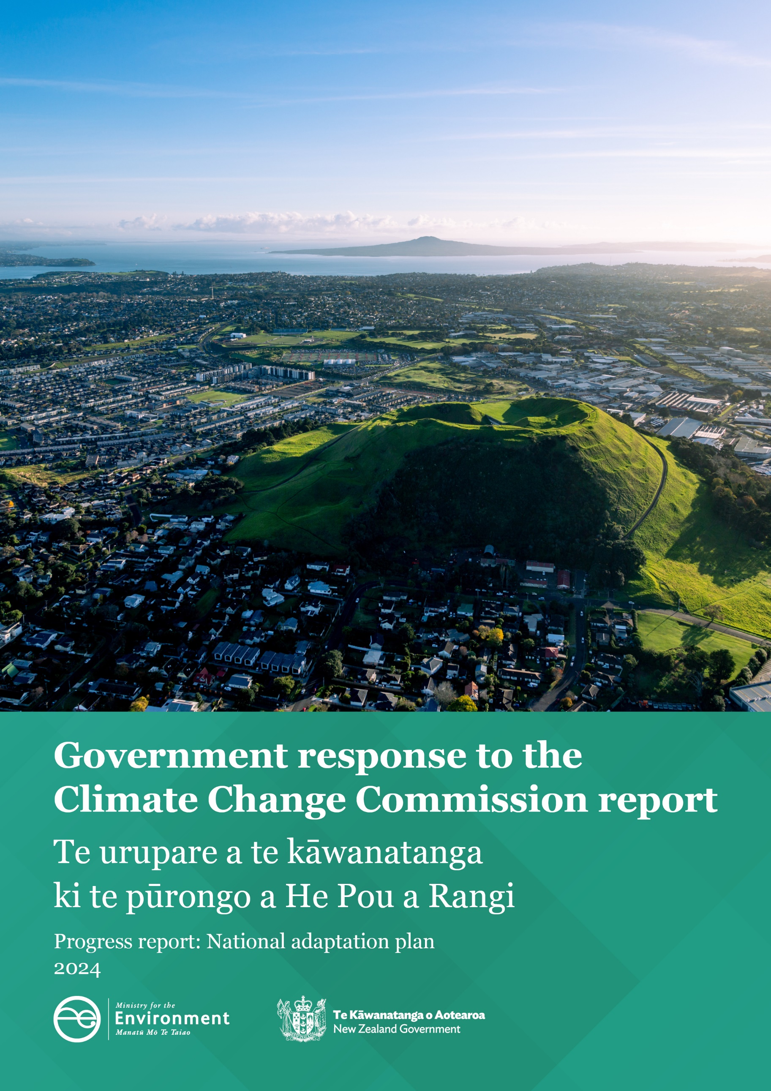

**Disclaimer**

The information in this publication is, according to the Climate Change Chief Executives Board’s (the Board’s) and Ministry for the Environment’s (the Ministry’s) best efforts, accurate at the time of publication. The Ministry will make every reasonable effort to keep it current and accurate. However, users of this publication are advised that:

* the information does not alter the laws of New Zealand, other official guidelines, or requirements
* it does not constitute legal advice, and users should take specific advice from qualified professionals before taking any action based on information in this publication
* the Board or Ministry do not accept any responsibility or liability whatsoever whether in contract, tort, equity, or otherwise for any action taken as a result of reading, or reliance placed on this publication because of having read any part, or all, of the information in this publication or for any error, or inadequacy, deficiency, flaw in, or omission from the information in this publication
* all references to websites, organisations or people not within the Board or Ministry are for convenience only and should not be taken as endorsement of those websites or information contained in those websites, nor of organisations or people referred to.

This document may be cited as: Climate Change Chief Executives Board and Ministry for the Environment. 2025. *Government response to the Climate Change Commission report: Progress report: National adaptation plan 2024*. Wellington: Ministry for the Environment.

**Presented to the House of Representatives pursuant to section 5ZV(b) of the Climate Change Response Act 2002.**

Published in January 2025 by the  
Ministry for the Environment on behalf of the Climate Change Chief Executives Board  
Manatū mō te Taiao  
PO Box 10362, Wellington 6143, New Zealand  
[environment.govt.nz](http://www.environment.govt.nz)

ISBN: 978-1-991140-64-7

Publication number: ME 1872

© Crown copyright New Zealand 2025

**Contents**

Introduction 4

The Government is committed to the adaptation process set out in its laws 5

Adaptation is a critical challenge and action is a priority 6

Delivering adaptation outcomes through the Government’s Climate Strategy 8

Infrastructure is resilient and communities are well prepared 8

Credible markets support the transition 11

Nature-based solutions address climate change 13

Work spanning the climate strategy 13

Implementing the first national adaptation plan 15

Knowing how we are tracking as a country is important 16

Developing future national adaptation plans 17

Appendix 1: Table of actions: Addendum 2025 18

# Introduction

In August 2024, He Pou a Rangi | Climate Change Commission (the Commission) provided the Minister of Climate Change with its inaugural progress report on the implementation and effectiveness of the first national adaptation plan (NAP1).[1]

The Climate Change Response Act 2002 (the Act) requires the Commission to provide a progress report two, four and six years after any plan is published, to evaluate the implementation of the plan and its effectiveness.[2]

The Government welcomes the first of these reports and the insights it provides on progress towards, and barriers to, implementation.

# The Government is committed to the adaptation process set out in its laws

The Government is committed to regularly assessing risks from the impacts of climate change, making a plan to address those risks, monitoring and reporting on progress, and making adjustments as needed. This process, as set out in the Act, enables New Zealand to meet its international obligations for adaptation under the Paris Agreement (see figure 1). These include obligations for adaptation planning and reporting on progress and, most importantly, the process means we are taking domestic action to address climate risks as identified in the national climate change risk assessment (NCCRA).[3]

Figure : Adaptation process as set out in the Climate Change Response Act 2002

|  |
| --- |
| New Zealand’s adaptation process as set out in the Climate Change Response Act 2002  **National Climate Change Risk Assessments**  The Act requires the Commission to prepare a National Climate Change Risk Assessment every six years.[4] These need to assess the risks to the economy, society, environment and ecology. They will also identify the most significant risks based on their nature, severity and the need for a coordinated response.  **National adaptation plan**  The next step is to prepare a national adaptation plan in response to the assessment, in which the Government must set out:   * objectives for adapting to the effects of climate change * strategies, policies and proposals for meeting those objectives * the timeframes for implementation * how the most significant risks are addressed * the measures and indicators to enable regular monitoring and reporting.   **Progress reports and adjustment**  He Pou a Rangi | Climate Change Commission (the Commission) will prepare two-yearly progress reports on the progress of the plan and its effectiveness. The Government must respond to the Commission’s report within six months, which allows the opportunity to adjust the plan so it meets intended outcomes. |

## Adaptation is a critical challenge and action is a priority

New Zealand is already experiencing the impacts of climate change. For example, the Auckland Anniversary floods and Cyclone Gabrielle in 2023 led to significant flooding, landslides, damage to housing and infrastructure, and loss of lives. The cost of asset damage from these two events has been estimated as between $9 billion and $14.5 billion,[5] and insurance claims were around $3.5 billion.[6]

Growing risks also mean growing costs, with the cost of emergencies to the Government increasing faster than government revenue. These costs are projected to increase by over 50 per cent per decade – from $0.7 billion in 2020 to $3.3 billion in 2050 – and most New Zealand regions face potential storm costs that are growing at a faster rate than their regional incomes.[7]

Property owners face increasing risks of climate-related losses due to inundation and soil erosion in some areas.[8] Changes in temperature and seasonality may also affect agriculture and horticulture productivity. Insurers are concerned about the rising losses attributable to climate change and are looking to leadership to reduce risk.[9] New Zealand’s long-term adaptation goals are set out in NAP1 and are to:

1. **reduce vulnerability to the impacts of climate change:** this means reducing the sensitivity and susceptibility of people and systems to climate impacts
2. **enhance adaptive capacity and consider climate change decisions at all levels:** this means helping people, institutions and systems to adjust to climate change by building their capacity to respond and embedding climate resilience across and through all levels of government
3. **strengthen resilience:** this means taking action that strengthens the way people and systems cope with immediate climate impacts, as well as building capacity for learning and transformational adaptation.[10]

These are also consistent with the global goal on adaptation under the Paris Agreement.

We are also committed to the four priorities for action in NAP1:

1. enabling better risk-informed decisions
2. ensuring our planning and infrastructure investment decisions drive climate-resilient development in the right locations
3. adaptation options including managed retreat
4. embedding climate resilience in all government strategies and policies.

Adaptation action is not just for the Government to take. It requires well-functioning markets, in which households, businesses and infrastructure providers (including the Crown) have access to the information they need to make good decisions. All parties should also be incentivised to take appropriate investments and actions to reduce risk. Climate risk will be managed efficiently and effectively when everyone understands their climate risks and takes responsibility for managing them.

# Delivering adaptation outcomes through the Government’s Climate Strategy

The goals in NAP1 align with the Government’s Climate Strategy, published in July 2024, which aims to reduce the impacts of climate change and prepare for its future effects.[11] The Climate Strategy is supported by the overarching principle of a least-cost, market-led approach to climate action, using effective and efficient policies that do not negatively impact on the productivity of New Zealand’s key industries. This approach is technology led and relies on a credible emissions trading scheme, complemented by policies that reduce barriers to investment.

Three of the five pillars of the Climate Strategy are particularly important to adapting to the effects of climate change, as shown in figure 2.

Figure : The three adaptation-relevant pillars of the Climate Strategy

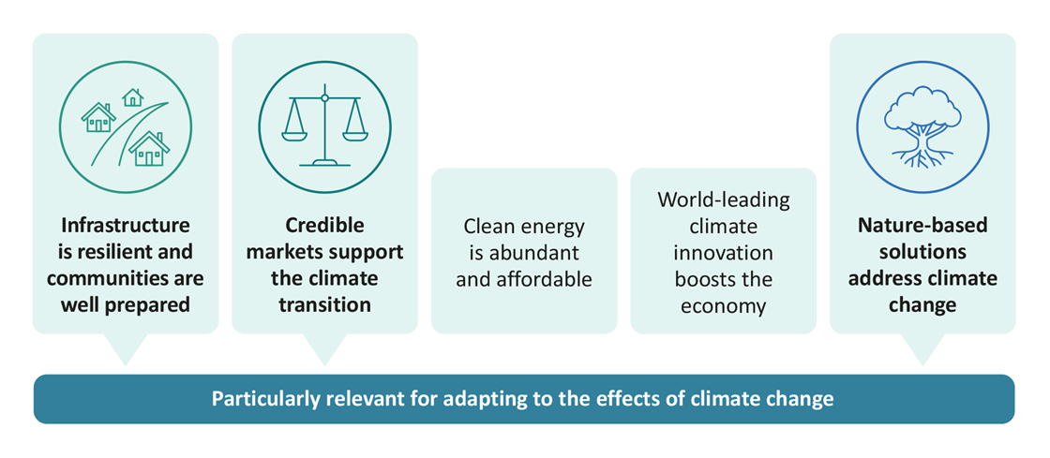

## Infrastructure is resilient and communities are well prepared

The first pillar of the Government’s Climate Strategy focuses on delivering a fair and enduring system that helps New Zealand be prepared for climate change and provides clarity on costs. This pillar is focused on ensuring that infrastructure, communities and properties are better protected from climate-induced risks and natural hazards, and the cost of repairs is minimised. It requires people to have easy access to information and guidance on potential future risks to property and community assets, so interruptions to business operations can be minimised during and after severe weather events.

As noted in the New Zealand Infrastructure Commission’s monitoring report,[12] extreme weather events continue to highlight the vulnerability of New Zealand’s infrastructure to natural hazards. The interdependencies between infrastructures mean that when one infrastructure service fails, it can have a cascading effect across the rest of the infrastructure system.

The Climate Change Commission has also found that preparedness for climate change among asset owners is currently backsliding. Only 6 per cent of New Zealand’s lifeline utility operators currently consider the impacts of climate change in their asset management plans, down from 12 per cent in 2020/21.[13] This highlights the need for climate change impacts to be considered in infrastructure planning and decision-making.

We agree with the Climate Change Commission that coordination is lacking between and across infrastructure service providers, and that better information on risks, and how best to manage them, would support better decision-making on risk reduction and resilience initiatives.

Key objectives in NAP1 that are relevant to adaptation of infrastructure include:

* reducing the vulnerability of infrastructure assets exposed to climate change
* using asset management renewal cycles to build resilience
* ensuring all new infrastructure is fit for a changing climate.

### What the Government is doing to support this pillar

To support the delivery of the “infrastructure is resilient and communities are well prepared” pillar of the Climate Strategy, the Government is:

* investing in flood resilience through the Regional Infrastructure Fund (RIF)
* improving the quality and resilience of New Zealand’s water services and infrastructure
* providing national direction on natural hazard risk management through the Resource Management Reform
* reforming the Emergency Management system.

#### Flood-resilience projects

The Regional Infrastructure Fund has made $200 million available to flood-resilience projects, recognising their importance. Such infrastructure protects the country’s economic security and may enhance the resilience of other infrastructure while helping keep families, businesses and communities safe.

Of the $200 million available, $101.1 million has been approved to support 42 initial projects that have already been identified as construction ready. The 42 approved projects include different types of flood projection and management infrastructure, such as stopbanks, pump stations, groynes and culverts.

#### Improving water services and infrastructure

The Government’s Local Water Done Well programme will enhance the Water Services Authority’s regulatory tools to develop national standards for wastewater and urban stormwater networks, alongside the Authority’s existing powers to ensure security of drinking-water supplies.[14]

The Local Water Done Well programme recognises the importance of local decision-making and flexibility for communities and councils to determine how their water services will be delivered in future. It will place a strong emphasis on meeting rules for water quality and investment in water infrastructure, which will increasingly be driven by climate-resilience needs, among other factors.

#### National Direction on natural hazards

The Government is also delivering a comprehensive, nationally consistent framework for addressing the risks posed by natural hazards to new development, including risks from climate change. This will be delivered via new National Direction on natural hazard risk management through the Resource Management Reform, to provide direction to councils on how to identify natural hazards and assess the risk they pose, and on how to respond to that risk through planning controls for new development. The National Direction on natural hazards aims to ensure new development is resilient.

The Natural Hazards Portal[15]will also more broadly support accessibility of natural hazard risks information for public use.

##### **Emergency management system reform**

Resilient infrastructure underpins effective emergency management. The Commission found that communities do not currently have equitable access to support before and after a climate-related hazard or extreme weather event. The Government Inquiry into the Response to the North Island Severe Weather Events (the Inquiry)[16] also recommended that the Government continue the work to enhance the resilience of New Zealand’s critical infrastructure system. In addition, the Inquiry identified a lack of focus on and investment in readiness planning, as well as a mismatch between community expectations about what the emergency management response should offer and what it is able to deliver.

In response to the Inquiry, the Government will deliver across focus areas to strengthen New Zealand’s disaster resilience and emergency management.

In particular, in its reform of the emergency management system, the Government will focus on:

* giving effect to a whole‑of‑society approach to emergency management
* supporting and enabling local government to deliver a consistent minimum standard of emergency management across New Zealand
* professionalising and building the capability and capacity of the emergency management workforce
* enabling the different parts of the system to work better together at the national level
* driving a strategic focus on investment and implementation.

The Government will also deliver an investment and implementation roadmap that provides more detail on how the actions under each focus area will be delivered over the next five years.

Broadly, these focus areas align with the long-term goals of NAP1, and they also support three of the key objectives for communities in NAP1: to enable communities to adapt, to support vulnerable people and communities, and to support communities when they are disrupted or displaced.

## Credible markets support the transition

Many of the Commission’s recommendations centre on legislative and policy changes needed to support adaptation planning. These include setting out clear roles, responsibilities and processes for adaptation planning, and clarifying how the costs of climate adaptation will be shared.

The Government agrees that such changes are necessary to enable credible markets, in which local government, households, banks, insurers, businesses and communities are clear on their roles and have access to information, including price signals, so they can make decisions that account for climate risk.

### What the Government is doing to support this pillar

A key government work programme that will support the pillar of a credible market that accounts for climate risk is the delivery of an Adaptation Framework.

#### Adaptation Framework

The Adaptation Frameworkaims to establish an enduring, long-term and integrated approach to adaptation in New Zealand. The Adaptation Framework will support well-functioning markets, incentivise appropriate investment in risk reduction, and provide a more affordable approach than the status quo.

The Adaptation Framework will set out the Government’s approach to sharing costs associated with natural hazard risk, and it aims to amend, clarify or strengthen roles and responsibilities under existing systems.

A bipartisan approach to these issues is important. In October 2024, the Finance and Expenditure Committee presented a cross-party inquiry into climate adaptation. The inquiry recommended the Adaptation Framework:

* establish an enduring and cohesive approach to climate adaptation
* clearly set out objectives, guiding principles, roles and responsibilities
* help New Zealand to adapt to climate change in a way that minimises overall long-term social and fiscal impacts while addressing issues of wellbeing, fairness and transition
* enable the Crown to uphold its partnership obligations under the Treaty of Waitangi | te Tiriti o Waitangi, recognising specific Māori interests
* incentivise and enable adaptation, risk reduction and market responses to occur during any transition period, while being flexible enough to respond to emerging information in an environment of inherent uncertainty.

Table 1 outlines the Government’s agreed in principle set of objectives for the Adaptation Framework.

Table : Adaptation Framework in principle objectives

| **Objective** | **Explanation** |
| --- | --- |
| Minimise expected long-term costs | Minimise the total cost to the Crown and society from the impacts of natural hazards where people live and work and the associated infrastructure. This will include managing the Crown’s fiscal exposure. |
| Ensure responses and funding support to property owners, if any, are predictable, principled and rules-based, wherever possible (ie, not decided after each event) | Give as much clarity and certainty to New Zealanders about the Government’s response to adaptation challenges and the roles of insurers, local government and other groups. |
| Improve climate risk and response information flows | Increase consistency and access to quality hazard and risk information to support sound decision-making. |
| Address market failures and support market efficiency | Contribute to maintaining effective and efficient housing, financial and insurance markets. Focus on areas where there is market failure but empower individuals and communities by taking a decentralised rather than top-down approach. |
| People have the incentive and the ability to manage risk | Central government should focus on ensuring others have the incentive and ability to reduce risk where they can. Decisions and resourcing for adaptation should sit at the lowest level that internalises costs. This will encourage a more efficient response and reduce moral hazard created when individuals or groups do not face the downside risk of their own decisions. At the same time, this objective allows for interventions to alleviate equity or undue hardship where necessary. |

The Commission’s report also recommended that the Government investigate options to pool and coordinate information and resources, to facilitate access to expertise and information to support local adaptation planning and action. The Government agrees this matter requires urgent attention and is focused on delivering an improved environmental data system, with improved access to high-quality natural hazards data.

An important component of the Adaptation Framework will be to encourage and incentivise people to reduce climate risk where they can. This will be facilitated by access to consistent and high-quality hazard information to support sound decision-making. This includes making natural hazard information available on Land Information Memoranda and the all-of-government Climate Data Infrastructure Initiative, which aims to collate and integrate New Zealand’s climate change data for easier access and use.

## Nature-based solutions address climate change

Nature-based solutions can buffer against climate impacts and help to better protect homes and communities against climate change, while also fostering wellbeing, improving the health of freshwater bodies and their ecosystems, sequestering carbon and increasing biodiversity. Nature-based solutions can deliver many co-benefits for adaptation and other areas including flood management. Prioritising the use of these solutions helps maximise the benefits of investment in climate resilience.

### What the Government is doing to support this pillar

Nature-based solutions are likely to be applicable in many areas vulnerable to increasing natural hazard risk because of climate change. The ‘right’ solution or mix of solutions will need to be determined in each affected area, with possibilities including:

* wetland restoration to increase water-holding capacity
* upper catchment afforestation to reduce peak flows in major events and reduce sediment infilling riverbeds and across floodplains
* room-for-river (strategically allowing rivers to reclaim parts of their natural flood plain) and re-wilding areas, to increase permeability and water-holding capacity.

The work programme for the Adaptation Framework includes consideration of who should be responsible for adaptation planning locally and how this should be done, as well as how to fund investment in solutions.

This work is ongoing, but an important design principle of the Adaptation Framework is that it should be able to consider a full spectrum of possible actions under the protection, accommodation, retreat, avoid (PARA) framework, including relevant nature-based solutions. Another important principle is that decision-makers should be incentivised and empowered to develop adaptation solutions that optimise cost-benefit ratios. This can only be achieved through the consideration and potential funding of nature-based solutions alongside more traditional engineering solutions.

The Government is also exploring opportunities for nature-based solutions through the second emissions reduction plan.

## Work spanning the climate strategy

The Commission presented three national-level metrics at the end of its report, to support a quantitative view of progress across different systems and the country. The metrics offer a high-level perspective on potential risks posed by climate change-related natural hazards.

The National Risk and Resilience Framework will support a national approach to managing risk consistently. Development of this framework aligns with and will contribute to all pillars of the Climate Strategy.

#### National Risk and Resilience Framework

TheGovernment is focused on strengthening resilience to national risks; those hazards and threats that could have serious immediate and/or long-term effects on New Zealand’s safety, prosperity and/or national security, requiring national-level intervention and coordination.

The National Risk and Resilience Framework[17] drives a proactive focus across government on reducing risk and building resilience to national risks, including those where climate change is a key driver and exacerbator. It aims to reduce New Zealand’s exposure to the harm and cost of crises.

It aligns with and supports New Zealand’s long-term adaptation goals and Climate Strategy, alongside other government resilience-building work programmes identified through this response.

# Implementing the first national adaptation plan

The Government is in the early stages of implementing NAP1, and many of the actions in the plan will help lay the foundation for long-term adaptation goals.

Key findings of the Commission’s report were that NAP1 is not driving adaptation to climate change at the scale and pace needed, and that action to create a stronger foundation for ongoing adaptation is urgently needed. We agree with the Commission that adaptation needs to increase in scale and pace, and we acknowledge the Commission’s recommendations on policy areas requiring urgent action or focus.

Adaptation is a process of understanding climate risks, making a plan to address the risks, implementing the plan, monitoring and evaluating the plan’s effectiveness, and adjusting as necessary. Progress is being made, with delivery underway on most of the actions intended to be active at this point in the plan. However, as the Commission has noted, actions are being delivered in a dynamic environment. Several actions are on hold or have been removed from the plan, including some that the Commission has commented on in its report. This is a result of changes in direction of government policy or because the actions no longer align with the Government’s priorities.

When published, NAP1 contained 127 actions, with 30 government agencies responsible for delivery. As part of delivering this response, we have updated the table of NAP1 actions to incorporate adjustments to actions. This has resulted in 3 new actions, 17 adjusted actions, 5 additional completed actions and 12 additional discontinued actions (many of these were sub‑actions, where the overarching action has been adjusted.) The revised table, included as appendix 1, contains 129 actions of which, 23 are complete, and 20 have been discontinued, and lays out the risks in the NCCRA that each action is intended to address.

# Knowing how we are tracking as a country is important

The Commission’s report provided recommendations for improving the monitoring and reporting of adaptation progress for NAP1. This includes updating the table of actions from the NAP every two years, to reflect changes in milestones and delivery status.

We agree that the NAP needs to remain up to date and should enable a dynamic response to climate impacts, which may include adding new actions or adjusting actions in the NAP. Since NAP1 was published in 2022, the context for adaptation action has changed. We agree the plan should be adjusted to reflect this changing context and to make sure it sufficiently mitigates the risks identified in the NCCRA.

The Climate Change Chief Executives Board (the Board) supports the Climate Priorities Ministerial Group. The Board is responsible for overseeing overall implementation of the NAP, periodically assessing its sufficiency, and advising where course corrections are needed. This includes adjustment of priorities and activities.

The Board will consider the Commission’s recommendations when delivering future reports, to provide Ministers with advice that focuses on opportunities to address the most significant risks and to give insights on progress.

We also thank the Commission for the national-level metrics included in its report. The adaptation data system is in early development, and the metrics provided by the Commission are a promising start in an area that many countries are grappling with. These data sets can be used to inform multiple work programmes, and progression over time will help to inform the national adaptation data set.

# Developing future national adaptation plans

The Commission’s report contained recommendations for improvements to strengthen national adaptation planning, including developing clearer targets and better communicating the adaptation package as a whole. These recommendations are welcome, and they will inform the development of future plans.

The next NAP is due within two years of the next NCCRA publication (due in 2026).

# Appendix 1: Table of actions: Addendum 2025

Read the updated table of actions on the [Ministry for the Environment website](https://environment.govt.nz/publications/new-zealands-first-national-adaptation-plan-table-of-actions-addendum-2025).

1. He Pou a Rangi | Climate Change Commission. 2024. [*Progress report: National Adaptation Plan*](https://www.climatecommission.govt.nz/public/Monitoring-and-reporting/NAPPA-2024/CCC-NAPPA_bookmarked2.pdf). Wellington: Climate Change Commission.
2. Climate Change Response Act 2002, [section 5ZU](https://legislation.govt.nz/act/public/2002/0040/latest/LMS282064.html).
3. The Government prepared the first national climate change risk assessment in 2020; the Commission will prepare subsequent risk assessments. Ministry for the Environment. 2020. [*National Climate Change Risk Assessment for Aotearoa New Zealand: Main report | Arotakenga Tūraru mō te Huringa Āhuarangi o Āotearoa: Pūrongo whakatōpū*](https://environment.govt.nz/assets/Publications/Files/national-climate-change-risk-assessment-main-report.pdf). Wellington: Ministry for the Environment.
4. The Government prepared the first national climate change risk assessment. Subsequent risk assessments are to be prepared by the Commission. Climate Change Response Act 2002, [section 5ZQ](https://www.legislation.govt.nz/act/public/2002/0040/latest/LMS282058.html).
5. New Zealand Government. 2023. [*Strengthening the resilience of Aotearoa New Zealand’s critical infrastructure system: Discussion Document*](https://consultation.dpmc.govt.nz/national-security-group/critical-infrastucture-phase-1-public-consultation/user_uploads/discussion-document--strengthening-the-resilience-of-nzs-ci-system.pdf). Wellington: New Zealand Government. p 14.
6. McLiesh C. 2024. [*Directions in fiscal policy: Speech to the 2024 New Zealand Economic Forum 16 February 2024*](https://www.treasury.govt.nz/publications/speech/directions-fiscal-policy). Wellington: The Treasury.
7. NZIER. 2020. [*Investment in natural hazards mitigation: Forecasts and findings about mitigation investment*](https://www.dia.govt.nz/diawebsite.nsf/Files/Central-Local-Government-Partnerships/$file/NZIER-Natural-hazards-mitigation-report-2020.pdf). Wellington: NZIER.
8. Around 750,000 New Zealanders, and 500,000 buildings collectively worth over $145 billion, are near rivers and in coastal areas already exposed to extreme flooding. Ministry for the Environment & Stats NZ. 2023. [*New Zealand’s Environmental Reporting Series: Our atmosphere and climate 2023*](https://environment.govt.nz/assets/publications/Environmental-Reporting/Our-atmosphere-and-climate-2023.pdf). Wellington: Ministry for the Environment.
9. Thirty per cent of the damages from the 12 worst flood events in New Zealand from 2007–2017 were directly attributable to climate change. Frame DJ, Rosier SM, Noy I, Harrington LJ, Carey-Smith T, Sparrow SN, Stone DA. 2020. [Climate change attribution and the economic costs of extreme weather events: a study on damages from extreme rainfall and drought](https://link.springer.com/article/10.1007/s10584-020-02729-y). *Climatic Change* 162: 781–797.
10. Ministry for the Environment. 2022. [*Aotearoa New Zealand’s first national adaptation plan*](https://environment.govt.nz/assets/publications/climate-change/MFE-AoG-20664-GF-National-Adaptation-Plan-2022-WEB.pdf). Wellington: Ministry for the Environment
11. For more information, see Ministry for the Environment. 2024. [*The Government’s climate strategy*](https://environment.govt.nz/what-government-is-doing/areas-of-work/climate-change/about-new-zealands-climate-change-programme/governments-climate-strategy/)*.* Retrieved 25 November 2024.
12. New Zealand Infrastructure Commission. 2024. [*How is our infrastructure tracking? Monitoring progress against New Zealand’s first Infrastructure Strategy*](https://media.umbraco.io/te-waihanga-30-year-strategy/evlebwwp/how-are-we-tracking-final.pdf). Wellington: New Zealand Infrastructure Commission | Te Waihanga.
13. He Pou a Rangi | Climate Change Commission. 2024. [*Progress report: National Adaptation Plan*](https://www.climatecommission.govt.nz/public/Monitoring-and-reporting/NAPPA-2024/CCC-NAPPA_bookmarked2.pdf). Wellington: Climate Change Commission. p 225.
14. For more information, see Department of Internal Affairs. 2024. [*Water Services Policy and Legislation - Local Water Done Well*](https://www.dia.govt.nz/Water-Services-Policy-and-Legislation)*.*
15. Natural Hazards Commission | Toka Tū Ake. [*Natural Hazards Portal: Home*](https://www.naturalhazardsportal.govt.nz/s/?gad_source=1&gclid=EAIaIQobChMIvuDgw-bFiAMV9dYWBR2iKhHTEAAYASAAEgKmafD_BwE&gclsrc=aw.ds). Retrieved 25 November 2024.
16. On 31 July 2023, the Government Inquiry into the Response to the North Island Severe Weather Events began, with the aim of ensuring the design of New Zealand’s emergency management system is appropriate to support readiness for, and responses to, future emergency events (landslides, tsunami, earthquakes, volcanic activity, floods and storms). In particular, the Inquiry identified lessons from three severe weather events that affected the North Island:

    Cyclone Hale (8 to 12 January 2023)

    heavy rainfall (26 January to 3 February 2023)

    Cyclone Gabrielle (12 to 16 February 2023).

    The Inquiry reported back to the Minister for Emergency Management and Recovery on 26 March 2024. See Department of Internal Affairs | Te Tari Taiwhenua. 2024. [*Report of the Government Inquiry into the Response to the North Island Severe Weather Events*](https://www.dia.govt.nz/diawebsite.nsf/Files/Government-Inquiry-into-Severe-Weather-Events/$file/Report-of-the-Government-Inquiry-into-the-Response-to-the-North-Island-Severe-Weather-Events.pdf). Wellington: Department of Internal Affairs.
17. For more information, see Department of Prime Minister and Cabinet. 2024. [*National Risk and Resilience Framework*](https://www.dpmc.govt.nz/our-programmes/risk-and-resilience/national-risk-and-resilience-framework)*.* Retrieved 11 December 2024.